Associate Teacher Name: | Date: Click or tap to enter a date.
Course: Choose an item. | Placement: Choose an item.
School: | Year Group: Choose an item.
BCU Lead Mentor: | Subject Placement Mentor:
Observer(s):

The BCU ITE Mentoring Model: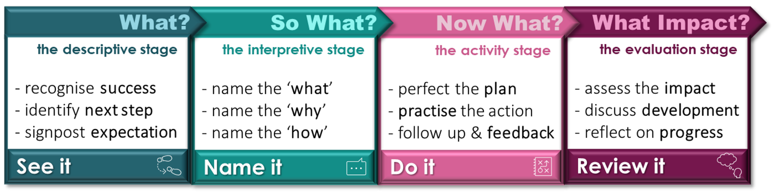
Review It: Current targets and focus of observation (taken from weekly meeting or LOR feedback) |  | BCU Theme:
Subject specific target: |  | Choose an item.
Professional target: |  | Choose an item.

See it:
Lesson Feedback: Comment on the Associate Teacher’s strategies and progress towards the agreed targets (above) | Impact on pupil learning – comment on the impact of these strategies on pupil learning.
Additional comments beyond the identified but related the curriculum themes (see end of this form)
Prompt questions for post lesson discussion: Link directly to above targets and/or related curriculum themes.
See it: Strengths  Following the observation, through professional dialogue, please identify what the AT did well to impact on pupils’ learning and progress. |  | BCU Theme:
 |  | Choose an item.
 |  | Choose an item.
 |  | Choose an item.

Targets:
Following the observation, through professional dialogue, please agree targets for the AT in the context of raising pupil achievement and supporting pupil learning.
Name it: |  | Do it: |  | BCU Theme:
What is the next step? (to support AT progress)  Why is this important? (impact on pupil progress) |  | How might this be achieved?  What actions are needed? |  | BCU Theme:
Subject Target |  | Action Points |  | Choose an item.
Professional Target |  | Action Points |  | Choose an item.
Professional Target |  | Action Points |  | Choose an item.

Signed (observer): | Signed (AT):

The BCU ITE Curriculum Themes:
Comment across all themes relevant to the session, and pertinent to the ATs ongoing targets.
 | Critical Enquiry and Research-Informed Practice: Theme A  Theme A underpins all activity across the session, and engagement with learners in the class. This might be used to unpack the rationale for using specific strategies and approaches. How did the activities link to contemporary cognitive science strategies? What research supports the use of specific activities and approaches in this subject area?
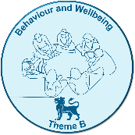 | Behaviour and Wellbeing: Theme B  How does the AT develop a positive, inclusive learning environment that fosters effort, perseverance, and a culture of trust? How does the AT maintain clear behavioural expectations and use a range of behaviour management strategies and manage low-level disruption?
 | Subject Knowledge and Subject Pedagogy: Theme C  Is the AT demonstrating accuracy, breadth, and depth of subject knowledge? How effectively is the AT able to apply level specific subject knowledge in the session? What impact does the AT’s subject specific pedagogy make on pupils’ progress?
 | Planning and Assessment: Theme D  How does the AT identify and plan for misconceptions, review and build on prior learning, break material into a logical sequence, check understanding, integrate assessment and questioning, provide feedback?
 | Adaptive Teaching: Theme E  How does AT use scaffolding and support for learners, encourage independent learning, use models/examples support progress, remove scaffolds as knowledge becomes more secure, challenge pupils, make effective use of teaching assistants, reframe questions for greater scaffolding or stretch, overcome pupils’ barriers to learning?
 | Professional Behaviours: Theme F  Akin to Theme A, this theme underpins all activity across the session and should be considered in context of how each of the themes above are attained through the lens of professional behaviour. How effectively do ATs uphold professional behaviours in this session?

