Developing educational resilience in Youth from Underserved Communities through engagement in community based Arts education.

UCET Travel Scholarship
Victoria Kinsella Birmingham City University.



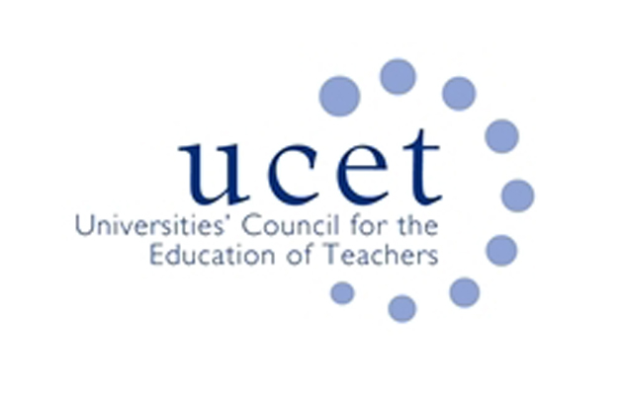

Contents

Acknowledgements. 2
Abstract. 2
YouthBEAT Research and Evaluation Study. 3
Berklee City Music. 3
Background to Exchanging Notes. 4
Research and Evaluation. 5
The Objectives. 6
Initial Findings from Exchanging Notes. 6
Travel Scholarship Aims. 7
Observations. 7
Focus group interviews and critical discussions. 7
Ethical approval. 8
The importance of the research visit according to the literature. 9
The Findings. 10
Gain insights into pedagogies within a US-based community based project. 11
Compare methodologies with a not-dissimilar research project in England. 15
To investigate the impact of community arts on educational resilience. 16
To utilise the research visit to further inform and impact analysis. 18
To develop mutually beneficial links with researchers for future collaborations. 19
Conclusion. 20
Acknowledgements. 21
References. 22

Acknowledgements.

I wish to offer my sincere thanks to Associate Professor Camara for her kindness and hosting this trip, Tufts University, Berklee College of Music, City Music Boston, all the music teachers, students I visited and spoke with, Birmingham City University and UCET.

Abstract.

The UCET travel scholarship supported a visit to Tufts University in Medford, Massachusetts with a focus on exploring the research processes, insights and outcomes of a research project directed by Dr Camara at Tufts University: the YouthBEAT Consortium for Research and Evaluation in Arts and Youth Development. This was also furthered through exploring how research methods are taught at Tufts University and the impact of research informed teaching.
The aim of the scholarship was to explore the effectiveness of a community based arts project for youth in an underserved community and its impact on educational resilience. This scholarship enabled me to investigate the pedagogies within these community settings and the socio-cultural-political structures that impact teaching and learning. The scholarship also permitted me to participate in teaching at the university with research active students and staff through presentations. This expanded my understanding of the importance of research active staff in HE environment.
The findings of this travel scholarship will directly inform and impact my current work on a Youth Music funded research project “Exchanging Notes”. Discussions with the research staff on the YouthBEAT project, the directors of Berklee college of Music and music leaders has aided my understanding of the structures and pedagogical processes involved in projects working with underserved communities. This knowledge will directly impact my own work at Birmingham City University through new analytical processes and synthesis of data. It is hoped that following this visit future collaboration will be sustained, with the potential for academic outputs.

YouthBEAT Research and Evaluation Study.

The overall purpose of the YouthBEAT study is to examine how participation in Berklee City Music is related to positive youth development, achievement, resiliency, leadership, and social skills; to identify best practices used to teach music to youth ages 9-19; and to identify area for further development. The study is measuring the impact of participation in music provision in disadvantaged (in US terminology ‘underserved’) community settings. This is a unique programme in the United States. The main question of the study is: How does participation in the City Music program influence youth development and how is it related to music, educational, and social outcomes for youth?
The research took a mixed-methods approach to exploring this question. The research collected data in various forms:
- 300 interviews were conducted with students, parents, teachers, staff, administrators, faculty and community partners;
- Questionnaires completed by the youth focused on habit of practice, perceived competence and attributions for success in music and academia;
- Observations of 47 youth ensembles.

Berklee City Music.

Berklee City Music is a non-profit program offered by Berklee College of Music that provides music education to aged 9-19 year olds in under-served communities. With year-round instruction, individualized mentoring, and a comprehensive curriculum, Berklee City Music combines the breadth of Berklee resources, facilities and available scholarships. Young people get the tools and support they need to flourish as students, musicians, and develop their confidence. The programme runs both summer and year-round interventions that provide contemporary music education to youth from underprivileged communities throughout the Unites States. There are a range of site across the United States which run thMagdalene1e program. Students attend the programme with no cost to their families, receiving scholarships and donations from community members.

Background to Exchanging Notes.

In 2011 the ‘Henley Review’ (DfE, 2011a) was undertaken at the request of the Secretary of State for Education in England on the understanding that ‘every child should receive a strong, knowledge based cultural education and should have the opportunity to learn and play a musical instrument and to sing’ (DfE, 2011a:4). Within this report it was recognised that there was a need for the providers of Music Education to work more closely in partnership. In his review of music education, Darren Henley observed that he had:

…always been mindful of the need for measures to be taken to increase the probability of children receiving an excellent Music Education and of decreasing the possibility of them receiving a poor one. In short, we need to eradicate the ‘patchiness’ ... (Henley, 2011 p.5)
Music education has for a while now recognised differences between what has come to be termed ‘formal’ and ‘informal’ pedagogies. Some of this ‘patchiness’ could be accounted for by different approaches to formal and informal learning in music. In schools, we know that there have been issues of engagement of pupils with curriculum music, and that to some extent the relentless performativity-driven education systems of the past few years have caused problems for teachers (Ball, 2003). Joining up practice, where the exploration of formal and informal pedagogies could be explored was highlighted as a key area needing development.
But what does ‘joined up’ really mean for music education? The exchanging notes program was motivated by the Communities of Music Education research also commissioned by Youth Music, which in March 2011 found that:
“There is a confusion amongst music education providers that stems from the discourse. Terms and labels are insufficiently precise or overlap. This is not a new phenomenon, but can hamper clarity in communication between partners” (Saunders and Welch, ‘Communities of Music Education’, 2012:39-40)
A key recommendation was for music education providers to work together, to ‘join up’ and co-ordinate their services to ensure that all children and young people could have access to high quality educational experiences and progress in music according to their talent and potential. This can also be seen in the Music Education Hub model administered by Arts Council England. These policy imperatives, however, need to be also enacted as practices in schools, and it is this which drives the need for this Youth Music project. It is against this backdrop that Youth Music created a new fund, Exchanging Notes, which offers an opportunity to explore how to join up approaches, reflect on pedagogy and hopefully eradicate this patchiness. The synthesis of this evidence led to the man aim of Exchanging Notes, which recognises the need to:
‘To ensure that young people at risk of low attainment, disengagement or educational exclusion achieve the best musical, educational and wider outcomes through participation in a pioneering music education project; and to develop new models of effective partnership working between schools and out of school music providers’

In April 2014, the National Foundation for Youth Music announced grants to support 10 Exchanging Notes projects across England. Since September 2014, each project (a partnership between a school and specialist music provider) has been working with young people at risk of low attainment, disengagement or educational exclusion to see how participation in regular music-making activities can enable achievement of musical, educational and wider outcomes. The 10 projects comprise a wide range of educational contexts, all developing innovative approaches and working with a variety of different musical approaches and styles. Birmingham City University is supporting the project, and over a four-year period will evaluate the educational, musical and other outcomes of these new models for the young people involved. The notion of raising attainment for young people at risk of disengagement or educational exclusion via music education raises significant opportunities to understand how music can be a catalyst for success for these young people. We know
…the introduction of informal learning in music education raises interesting questions regarding definition of the term ‘informal’ in pedagogic contexts in music…and the potential of informal learning to facilitate openness and democracy in classrooms (Wright & Kanellopoulos, 2010 p.73)
…and this, is key to understanding the need for this research. The notion of democracy in music education (Woodford, 2005) also opens up the real possibility of ownership, identity (Hargreaves & Marshall, 2003), and engaged participation for these young people. The implications of which have the potential to be significant.

Research and Evaluation.

The youth music Exchanging Notes initiative funds 10 projects across England comprising partnerships between a variety of schools and specialist music education providers. These ten projects are situated around England are taking part in a longitudinal action research study for four years which include the following requirements:
- To utilise the youth music quality framework for the delivery of activities, this is to help ensure commonality (http://network.youthmusic.org.uk/resources/do-review-improve-quality-framework-music-education);
- The collection of data related to participants’ educational engagement and attainment, which includes existing data held by schools;
- To partake in focus group conversations and interviews with music leaders, teachers, young people and any other participants in the facilitation of the project;
- To assist the action research cycle of reflection attendance at two national meetings per year.
At least 20 young people who are at risk of low attainment, disengagement or educational exclusion are taking part in sustained project activity. Risk factors faced by the target group for this include (but are not limited to) socio-economic background, special educational needs, profound and multiple learning difficulties, family difficulties or looked after young people. These young people form the core sample for the longitudinal research and will be tracked across the life of the project.

The Objectives.

The five objectives of exchanging notes are as follows:
- To improve young people’s engagement with education and wider developmental outcomes
- To develop the creative, expressive and musical ability of young people
- To develop sustainable partnerships between schools and out of school music education providers which share a collective understanding of quality music education practice and provide models that can be replicated
- To improve the quality and standards of music delivery for children and young people
- To embed learning and effective practice in host and partner organisations and share practice beyond the project.

Initial Findings from Exchanging Notes.

Key findings from the interim report include aspects related to music, educational and social outcomes for young people. Two key aspects associated to the interim findings include:
- The importance of conjoining formal and informal approaches for engagement;
- Effective partnership work which supports young people’s progression both as musicians and their engagement with formal schooling.
These two key aspects link closely to the community provision provided by the Berklee City Music Project. As one of the principle researchers for Exchanging Notes, I have become increasingly interested in these aspects of the research, and wanted to further investigate these notions. Research in this area in terms of local, national, and international understanding is still in its infancy. Therefore research and practice in this area would benefit from the opportunity, for those researching the field, to communicate and collaborate. Importantly, both research projects have the capacity to offer unique and important theorisations of community learning.

Travel Scholarship Aims.

Based on the early evidence provided by YouthBEAT, Exchanging Notes and the survey of literature, this travel scholarship sought to explore the development of educational resilience in youth from underserved communities through engagement in community based arts education. Throughout the visit I wished to create new partnerships, and new understandings of educational resilience and the importance of community provision for underserved youth. Research in this area in terms of understanding is still in its infancy. This research will help in the development of new understandings and theorisations, identify and evidence gaps in knowledge and facilitate new research and teaching collaborations.
The research had six aims:
- Gain insights into pedagogies within a US-based community based project (YouthBEAT);
- Compare methodologies with a not-dissimilar research project in England;
- To investigate the impact of the community arts provision on educational resilience;
- To develop mutually beneficial links with practitioners involved in the YouthBEAT project and university staff at Tufts University for future collaborations;
- To utilise the research visit to further inform and impact the analysis of research data on these projects and the teaching of research methods in HE environments.
The visit involved; observations, interviews, and researcher conversations all of which enabled me to explore the effectiveness of the program and the impact on teaching and learning. During the visit I was also able to partake and observe teaching at Tufts University with research students.

Observations.

Observation offered the opportunity to better develop an understanding of how knowledge was constructed. Cohen et al., (2007) have suggested that observations as a research process offers the researcher the opportunity to collect live data from a naturally occurring situation. In this manner, the researcher can observe behaviours which may ‘go unnoticed’, be ‘unexpected’ or ‘taken for granted’. It also ensures that the researcher can document what happens within the classroom and not just rely on what people say they do (Robson, 2002).

Focus group interviews and critical discussions.

Although observations allowed me to study the behaviours and activities, semi-structured interviews and discussions with the researcher, co-ordinators, music leaders and staff probed that which could not be observed. The aim of the interviews was to elicit the perceptions of teaching and learning and their thoughts and perspectives of the project. A semi-structured approach was chosen for the interviews which ensured that vital questions were explored but also gave space for the exploration of themes to emerge. I also engage in critical and reflective conversations with the director of the study Dr Camara. These conversations problematized issues surrounding community arts, educational resilience and the importance of engagement in music activities for underserved youth.

Ethical approval.

This research was approved by the Birmingham City University Ethics Committee. The research respects autonomy. The responses were carefully monitored so that any issues relating to diversity and equality were addressed. All participant names have been anonymised and changed. Every effort was made to ensure the research was experienced as an informal and equal sharing of opinions.

The importance of the research visit according to the literature.

The promotion of educational resilience among young people from conditions of social and economic adversity is an increasing educational agenda (Greene 2002). These young people are often defined as ‘at risk’ of academic disaffection due to a range of socio-cultural-economic conditions. There are continued concerns that not all students are well served by the current education system in both England and United States. In particular, there are widening educational disparities for learning within the field of arts education. Education discourse both within the UK and United States is increasingly focused on subjects and dispositions that increase economic productivity. The challenges posed by these discourses can be viewed as indicative of discrimination against creative and cultural forms of intelligence. The negative effects of these curriculums has majorly impacted arts provision for many public school students, especially those from ‘underserved’ communities.
The term ‘Underserved’ is used synonymously with terms such as ‘inner city’, ‘diverse’, ‘at risk’, ‘deprived ’and‘ low socio economic statuses. It is inclusive of a wide range of identities and situations. However, ‘underserved’ groups of youths can also be posed as “a source of social problems and as somehow at risk from wider social pressures” (Buckingham 2011). This is aligned with Giroux (2009, 2011) who suggested that viewing underserved youth merely in terms of their deficits reflects a political neo-liberalism ideology that promotes a market driven educational system. This positions youth in disadvantaged communities as part of class system outside neo-liberal values and thus become portrayed as problematic (Bunyan 2012).
It is against this backdrop that the YouthBEAT and Exchanging Notes programmes offers significant hope. The notion of raising attainment for young people at risk of low attainment, disengagement or educational exclusion via music education raises significant opportunities to understand how music can be a catalyst for success for these young people.

The Findings.

The research had six aims which will be discussed in this findings section. The six aim were:
- Gain insights into pedagogies within a US-based community based project (YouthBEAT);
- Compare methodologies with a not-dissimilar research project in England;
- To investigate the impact of the community arts provision on educational resilience;
- To develop mutually beneficial links with practitioners involved in the YouthBEAT project and university staff at Tufts University for future collaborations;
- To utilise the research visit to further inform and impact the analysis of research data on these projects.

Gain insights into pedagogies within a US-based community based project.

Throughout the Exchanging Notes project it has become evident that a successful pedagogical approach moves beyond merely acquiring skill and knowledge of music, but includes the social aspects of learning, cultural understanding, thinking processes and creativity.
It is important for the learners to be aware of the thought processes involved in learning. The role of the teacher therefore is to help the learners become more metacognitive; to be aware of how they go about learning and thinking. Skill and knowledge are not enough; learners need to be helped to achieved mastery but also reflect on how their learning approaches can be improved.
As part of the travel scholarship, I wanted to explore the pedagogical approaches, in a not too dissimilar project, to Exchanging Notes. As part of Exchanging Notes, all observations are conducted using the Youth Music quality framework (please see the website link for this above). This helps the observer understand, measure and evaluate pedagogy and practice. Five key areas are explored: learning outcomes; the environment; musical content; young people centred and professional practice. To explore pedagogical approaches in YouthBEAT, I kept these five areas of pedagogy and practice in focus.

Young people centred.
My understanding and knowledge of the pedagogical approaches in YouthBEAT were shaped by this reflection from the vice president of the program:
We believe that especially when dealing with underserved students, you need to start with where they are at and to reach them through the music that they love and listen to. We are not trying to change the cultural landscape on them … the idea was let’s use the music that they want to play as a way of attracting them in. Along the way we can teach them the tools and skills to play not only the music they listen to but explore other routes in other musics. If you are feeling a sense of accomplishment in what you really like you are much more open to learn about the things you don’t know about, rather than being thrust into something that is socially and culturally not where you’re from and suddenly expecting this to make a difference in your life. Representative, Berklee College of Music.
Because this project aims to provide music education for underserved youth, the project focuses on a student centred approach to increase engagement and motivation for learning. The young people are described as those who:
… may have a different learning trajectory or different path. Researcher, Tufts University.
Therefore, as evidenced from the quote from the senior vice president, learning is placed within the wider context of the young people’s lives. This begins through a discovery of their interests, working with their prior experiences, and building on them over the lifetime of their involvement in the program. This is different to in school music programs.
Much in school music education is focused on specific outputs linked to core academic subjects. The music teachers/musicians in YouthBEAT however are not restrained by league table or prescribed outputs. They can create and plan a program best suited to these young people. This changes the incentive and involvement in the program for the young people:
You have teachers who are not worried about academic subjects they are only thinking about music. The incentive to do well in this is different to school. In school you may feel that there are aspects they you don’t have meaning to you, your family or life right now. This is centred on making it relevant to the young people. Researcher, Tufts University.

Young people’s musical identities.
Throughout the project young people’s musical identities continue to be re-negotiated and refined. These are shaped by the social, cultural and musical interactions that they encounter as part of the program. This creates a new language for them, a new sense of belonging, one which is different to their musical identity at school:
Students have a language that is expressed through music. This is a different language and a different kind of expressivity. These students don’t always show the high level of interest or ability in math, science or reading but our school culture values those things. Schools don’t place music as high value and so we are denying part of the human potential by saying you are not up to par. Researcher, Tufts University.
A key aspect of the musical and learning process is choice. Through the choices of music they learn and ensembles they join (which range from pop, jazz, big band) the young people develop a sense of personal identity as well as one belonging to a community:
In addition to study your own instrument you also have the opportunity to collaborate with other students in an ensemble. These were all things we felt were important. Representative, Berklee College of Music
For some of the young people this sense of belonging and being part of a musical community is crucial to their development. The young people self-reflect and identify with others. The program is not a place where the young people are inhibited, but that they are offered a space of safety, support, learning, opportunity and friendship.

Learning Outcomes.
Prior knowledge was a key aspect of the project, this was strongly linked to the young people’s personal personal interest in music and motivations.
We don’t start from square one. Most of the student have music interest through family members, through church and or some other social interaction. Representative, Berklee College of Music
This was one of the key difference between YouthBEAT and Exchanging Notes. These young people came with a prior interest and passion for music, whereas Exchanging Notes aims, through music, to engage young people in school. Music is therefore a catalyst in Exchanging Notes. This has brought into focus some key area for further consideration. Should young people have a prior interest in order to engage or can an interest be developed if a suitable approach and pathway is offered.
Musical competencies were therefore central but ones which could be development and progressed:
In the design for the curriculum, we looked at what is the input we are looking for and where are the students starting from and how do we develop a curriculum, support and materials needed. Representative, Berklee College of Music

Environment.
Another key difference between this YouthBEAT and Exchanging Notes are the locations for the sessions. Exchanging Notes is predominately delivered in school environments, as the aim is to bridge in-school with out of school provision. YouthBEAT however functions in out of school settings, with the Boston City Music program being held in the Berklee College of Music. Working and sharing a space with college students plays a central role in developing the young people’s perceptions of progression routes. The college students provide inspiration, a space of continued musical communication and aspiration for further education:
These students are achieving and it seems likely that being part of a program like this assists that because it gives them exposure to musicians, to college students and those who have attained at higher education. And the prospect of going to a good school becomes exciting. Researcher, Tufts University.
This link between school and higher education is important for motivation.

Musical Content.
Although there were many aspects of the project that aligned with an informal pedagogical approach including: using music they choose themselves; learning with friends by listening and copying recordings; engaging in personal, often haphazard learning without structured guidance; and integrating listening, performing, improvising and composing in the learning process (Green 2002, 2008). There were also aspects of formal approaches such as; instrumental teaching, notation, audiation processes and integration into formal college music education. As part of the formal aspects of the program young people gained knowledge, skills and competences that enabled them to perform at the highest level. However, alongside these formal competences the young people were still given ownership of their musical learning and intentionality. Appropriate and differentiated tasks were planned for. Tasks were achievable and suitable for the stages of learning. Learning was split between a variety of tasks; peripatetic one to one sessions and ensembles. Because of this, self-esteem remained high:

Music was very important for them. This was not a school music program, these are students who they and their parents were very supportive of them engaging in music. They were very willing and exited. They come to the program with good skills. Music plays an important role in their lives but it doesn’t always mean that they go into music for a profession. But it is something that they continue to enjoy. Researcher, Tufts University.

This interplay opened up a new space for exploration of formal and informal pedagogies, it neither is one nor the other but a combination of both. Central to this however is the young people’s motivation for making music and the space and environment in which the sessions take place. It is this difference in motivation for learning that separates the work on YouthBEAT to Exchanging Notes. Alongside this, although YouthBEAT does explore an interaction between formal and informal, the lack of performative restraint means that the music teachers/musicians can plan a curriculum. This is different to the music leaders in Exchanging Notes who have to work with in school practices and bridge gaps between formal and informal.

Professional practice.
The identity of the professional musicians plays a key role in teaching and learning. Instead of viewing themselves as teachers or music leaders, they describe themselves as professional’s musicians. These musicians were more than teachers or facilitators but role models:
They need to have good role models, goals they can achieve and measure themselves against. Representative, Berklee College of Music
Because of this, their approaches to music making was skill driven; learning was focused on becoming and working like a musician through improvisation, listening and performing. This has a strong impact on how the young people see themselves:
There has got to be a pedagogical content interaction – they have to know how to teach but they also have to know their stuff. Sharing knowledge. Researcher, Tufts University.
Like the musicians the young people experienced many aspects of a working musician from performances to auditions, all of which were seen as vital aspects of learning:
We put a strong focus on performance and an audition process. This is the same as students coming into Berklee college of Music. Representative, Berklee College of Music
Beyond the music, the musicians often became mentors to young people. They helped shape and provide support for progression beyond music and into future career plans and educational aspirations:
Mentorship is important in this work. How we foster the trusting collaborations. We like to consider City Music as a youth development program focused on music, but it’s about youth development. Representative, Berklee College of Music.

Compare methodologies with a not-dissimilar research project in England.

Mixed methods.
There are many challenges when trying to understand learning and behaviour in spaces where history and context are central to the environment. Meaning is created individually and collectively but also governed by structural contexts of the institutions. Engaging therefore in this complex environment requires not just one way of knowing and valuing but methods that take into account diversity and difference (Greene et al., 2001). Both projects therefore identified a mixed-methods methodology as most suitable for this research; to gain insight, hear student and teacher voice and speak to the variety of groups (academic, music education, parents, young people) impacted by the work.

Reflection.
Although both research projects aim to evaluate teaching and learning, there was a focus in both projects on the continual joint thinking between all those involved in the research to aid a deeper understanding of learning:
We decided that we needed an evaluation group to help us figure out how we develop assessment tools, to understand how we are positively impacting the pupils. Representative, Berklee College of Music
This was facilitated by the researchers who acted as ‘critical friends’; non-threatening professionals who could ask difficult questions supportively. The role of the researcher therefore went beyond ‘researching’ and provided participants with a balance between challenge, support and reflection. These reflections would help define the impact of the work on teaching and learning:
We knew that our funders wanted to have evidence. We felt that we needed to go to experts to do this, so they can give honest feedback. Representative, Berklee College of Music
Role of reflection is highlighted as a paramount process. Schon (1983:68) identified reflective practice as ‘reflection on and in action’, where inquiry is focused on the practice of teaching and activity. This is important for both Exchanging Notes and YouthBEAT, where the teachers are encouraged to explore teaching and learning. We know from the work in Exchanging Notes that participants find it valuable to receive feedback, the opportunity to discuss their work and reflect in and on practice. Learning therefore does not remain in a final report but is continual throughout. This was also the same for the YouthBEAT project. Knowledge was collated and analysed but it also became part of the learning process and strategic movement of the projects. By being more critical the potential for future change is increased. Reflection needs a mirror to take place. Asking people to reflect without one does not produce anything. In this research we were an ‘active mirror’!

To investigate the impact of community arts on educational resilience.

Through observations of the sessions and talking with teachers, co-ordinators and directors it was clear that the young people involved in the Berklee City music program were committed to music making, had a strong interest in music and viewed music as having a positive impact on their lives. This often went beyond music making impacting; social interactions; confidence, team working, focus, listening skills, working within parameters, relating to others, making positive relations with peers and staff and making friends.
Notably, the young people acted and were treated like musicians. This was cultivated by the environment in which there after school sessions were taught. Sessions were held in the Berklee College of Music. Within this environment the young people were exposed to students attending the college, engaging in higher education and developing their identities as professional musicians. Unlike Exchanging Notes where schools and out of school music providers collaborate, this program existed separately to the young peoples in school musical pathways. This meant that learning did not overlap. For these young people, the alternative environment and the practical performance led approach was engaging. It detached formal constraints such as assessments and examinations, and allowed them to focus on their musicality. This approach was identified as the most effect way of balancing in school and out of school provision for these underserved young poeple:

In the early 90s Boston had ended all music education in all but three schools. We realised that our own community had no music education. Not believing we could change the direction of public education we thought we could make a difference for these young people. And so we settled on after school programing. Our current director was impressed with what the after school program was achieving in the Boston area and so wanted to see if we could do this on a larger scale. We decided to partner with existing outside of school community music programs in centres of economic need. We looked at the governments empowerment zones and partnered with projects in these areas. We therefore found projects around the country that shared our mission, running contemporary music programs for underserved communities, at no cost to them. Representative, Berklee College of Music.
However, as the young people progressed through the program, towards school leaving age, the project further assisted them through workshops focusing on application writing, interviewing and referencing. The program recognised that in order for the young people to continue their music journey they would need further support with their academics.
Through the program the young people fostered a positive musical identity. The provision provided by the program enabled the young people to view themselves as learners and understand their ability to learn. The motivational aspects of this developed their self-efficacy, they began to view themselves as successful which then for many impacted their educational resilience and progression in school:
For most of them music is a way to express themselves in a way words cannot. When everything else fails music is the thing that’s goes beyond words. To be with peers who like music as well, for them was like finding their people. Hearing a fourteen year old talk about musicianship I get astounded by what they say. One student said to me ‘I have friends at my middle school but here I really have met people who understand me, and I learnt so much more about music. There is so much more to music than singing’. Representative, City Music.

To utilise the research visit to further inform and impact analysis.

Since the travel scholarship to Boston, I have been left with some analytical themes and reflective questions to further consider. These areas include:
Social Justice.
Music education in England has often failed to “hear” the student voice in the discourse of curriculum, pedagogy, and musical value, resulting in the disengagement of many young people from music education in school. YouthBEAT and Exchanging Notes are both exploring pedagogy through a combination of formal and informal approaches. Student voice is central to both projects but what is a socially just pedagogy in music education? What is a socially just music education for these young people? What is a socially just pedagogy in Exchanging Notes?
Democracy and agency.
In the English context, education policy has narrowed its focus of education to the detriment of arts based subjects. In school, music teachers are being asked to demonstrate how, through their pedagogical practices, they meet the needs of all their students. Through self-reflexive and self-referential learning practices Exchanging Notes is beginning to explore ways in which agency can be offer to young people in an in-school environment, through a collaboration of formal and informal approaches. But what are the defining features of a democratic space for musical learning? Does Exchanging Notes offer student agency?
Measuring success.
Although Exchanging Notes utilises the quality framework as a way to explore quality in music education the wider implications of music education need further consideration. Both Exchanging Notes and YouthBEAT extends beyond quality in music making to the social, emotional and wellbeing factor impacted engagement and learning. In particular for those young people who are underserved or at risk of exclusion from mainstream education. So, what are the wider measures of successful learning? Is there a shared understanding of what these look like between the projects?

To develop mutually beneficial links with researchers for future collaborations.

Growing out of the mutual interest between Birmingham City University and Tufts University we aim to sustain and build on this work through a long term relationship building our collaboration and research capacity. We aim to identify and evidence gaps in knowledge and facilitate new research and teaching collaborations. This work further supports both our sets of students within the universities through courses such as the PhD, EdD students working within the field of arts education and community based projects, teacher educator courses such as the PGCE Secondary courses, Teach First and the Primary PGCE. The impact on teaching and learning will also be within the wider CPD offer that the university providers for our partnership school alliances. It is hoped that collaborative writing will emerge from the travel scholarship so that learning can be shared with the wider education community.

Conclusion.

Both Exchanging Notes and YouthBEAT through music are providing an approach to education which fosters and develops engaged citizens. They are achieving this by encouraging young people to see how social and cultural experiences shape learning. For YouthBEAT these learning experiences occur outside of school, and can be defined as community-based art education. There is a strong focus in this work on fostering dialogic encounters as spaces for social change. In this community, a curriculum is not just enacted, it is a practice in which community life, learning activities, and educational aspirations interconnect. This community has a meaning, purpose and symbolic role in the young people’s sense of belonging.

As Exchanging Notes is entering its final year, many of the young people have developed their skills and motivation for music making. New language and discourses between in school music teachers and music leaders are being developed, understanding and knowledge is growing, pedagogical processes and connectivity between formal and informal approaches and assessments are becoming more defined. This travel scholarship has enabled deep reflection in and on musical process and products, music discourse and the centrality of the arts for young people at risk or underserved. It has stimulated new considerations for the analysis of this work and how to disseminate its complexity with an international audience.

Sharing knowledge to impact teaching and learning within the university.
As well as observing and talking to those involved in the YouthBEAT project I was also able to observe and take part in teaching sessions at Tufts University with students embarking on community based research projects. As part of the teaching, learning from both projects was shared and disseminated. Both methodologies and findings were explored, debated and critiqued.
As my role as a Research Fellow at Birmingham City University, I work with a number of music education students on the PhD, EdD and PGCE courses. I aim to share knowledge with these students and staff at the university in a variety of ways; seminars, informal discussions and workshops. It is hoped that these events will develop shared knowledge impacting both teaching and research.

Acknowledgements.

I would like to that UCET for this opportunity and Dr. Camara at Tuft’s University for hosting my visit. This study was also made possible due to the consent of all those involved in the YouthBEAT project. I am very grateful for their time and warm welcome.

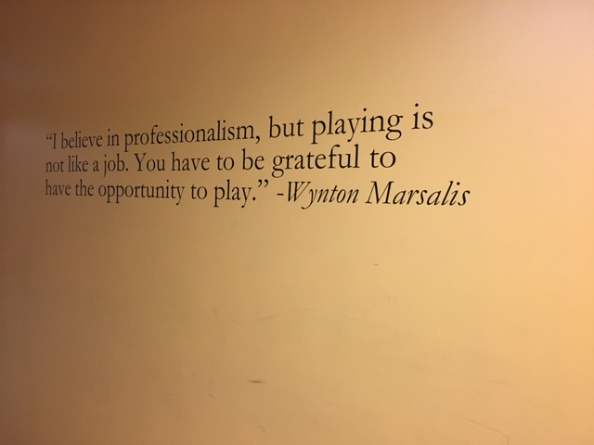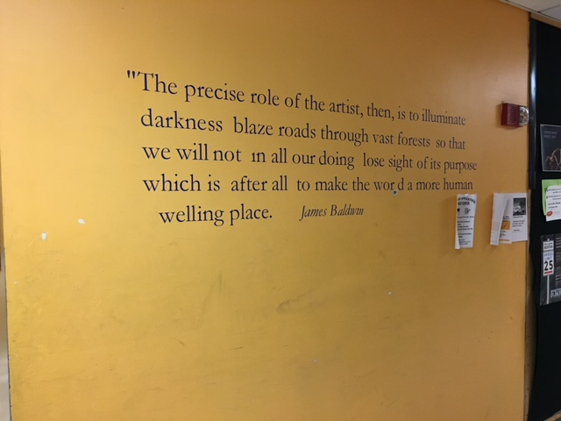

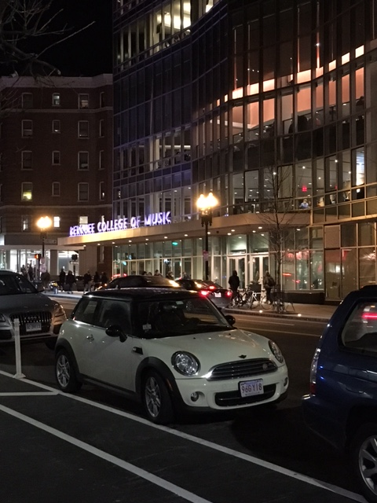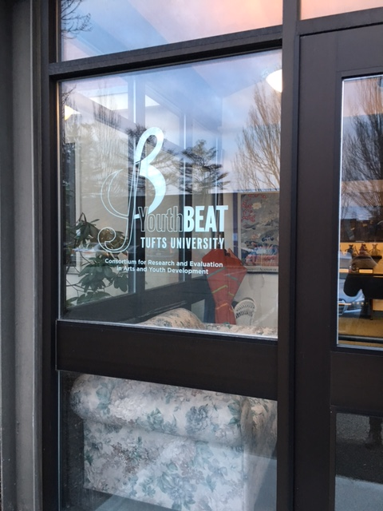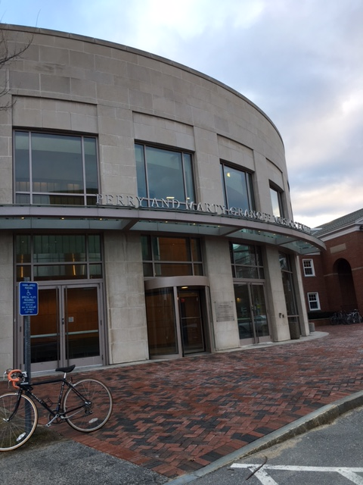

References.

Buckingham, D. (2011). Youth media production in the digital age: Some reflections—and a few provocations. In J. Fisherkeller (Ed.), International perspectives on youth media: Cultures of production and education pp.275-379. New York, NY: Peter Lang.

Bunyan, P. (2012, April 27). Partnership, the big society and community organizing: Between romanticizing, problematizing and politicizing community. Community Development Journal, 1-15.

Cohen, L., Manion, L. & Morrison, K. (2011) Research Methods in Education, (7th Edition). London: Routledge.
DfE & DCMS (2011) 'The Importance of Music - A National Plan for Music Education'. London, Department for Education and Department for Culture, Media, and Sport.

Giroux, H. (2009). Neoliberalism, youth, and the leasing of higher education. In D. Hill & R. KumanI (Eds.), Global neoliberalism and education and its consequences (pp. 30-53). New York, NY: Routledge.

Giroux, H. (2011). Neoliberal politics as failed sociality: Youth and the crisis of higher education. Logos: A Journal of Modern Society & Culture, 10(2).

Greene (2002) How Popular Musicians Learn: A way Ahead for Music Education. Ashgate.
Hargreaves, D. & Marshall, N. (2003) Developing identities in music education. Music Education Research, 5, 3, 263-73.

Henley, D. (2011) 'Music Education in England'. London, DfE/DCMS.
Robson, J. (2002) Commentaries and post-beginners’ language teaching. In Fitzpatrick, D., Hardwick, L., Ireland, S. & Montserrat, D. (Eds) Old wine, new bottles: texts for classics in a changed learning environment at university. Milton Keynes, UK: The Open University, pp. 51–60.
Saunders, J. & Welch, G. (2012) Communities of Music Education, London, Institute of Education.

Wright, R. & Kanellopoulos, P. (2010) Informal music learning, improvisation and teacher education. British Journal of Music Education, 27, 1, 71-87.
Woodford, P. (2005) Democracy and music education: liberalism, ethics, and the politics of practice, Bloomington, IN, Indiana University Press.

