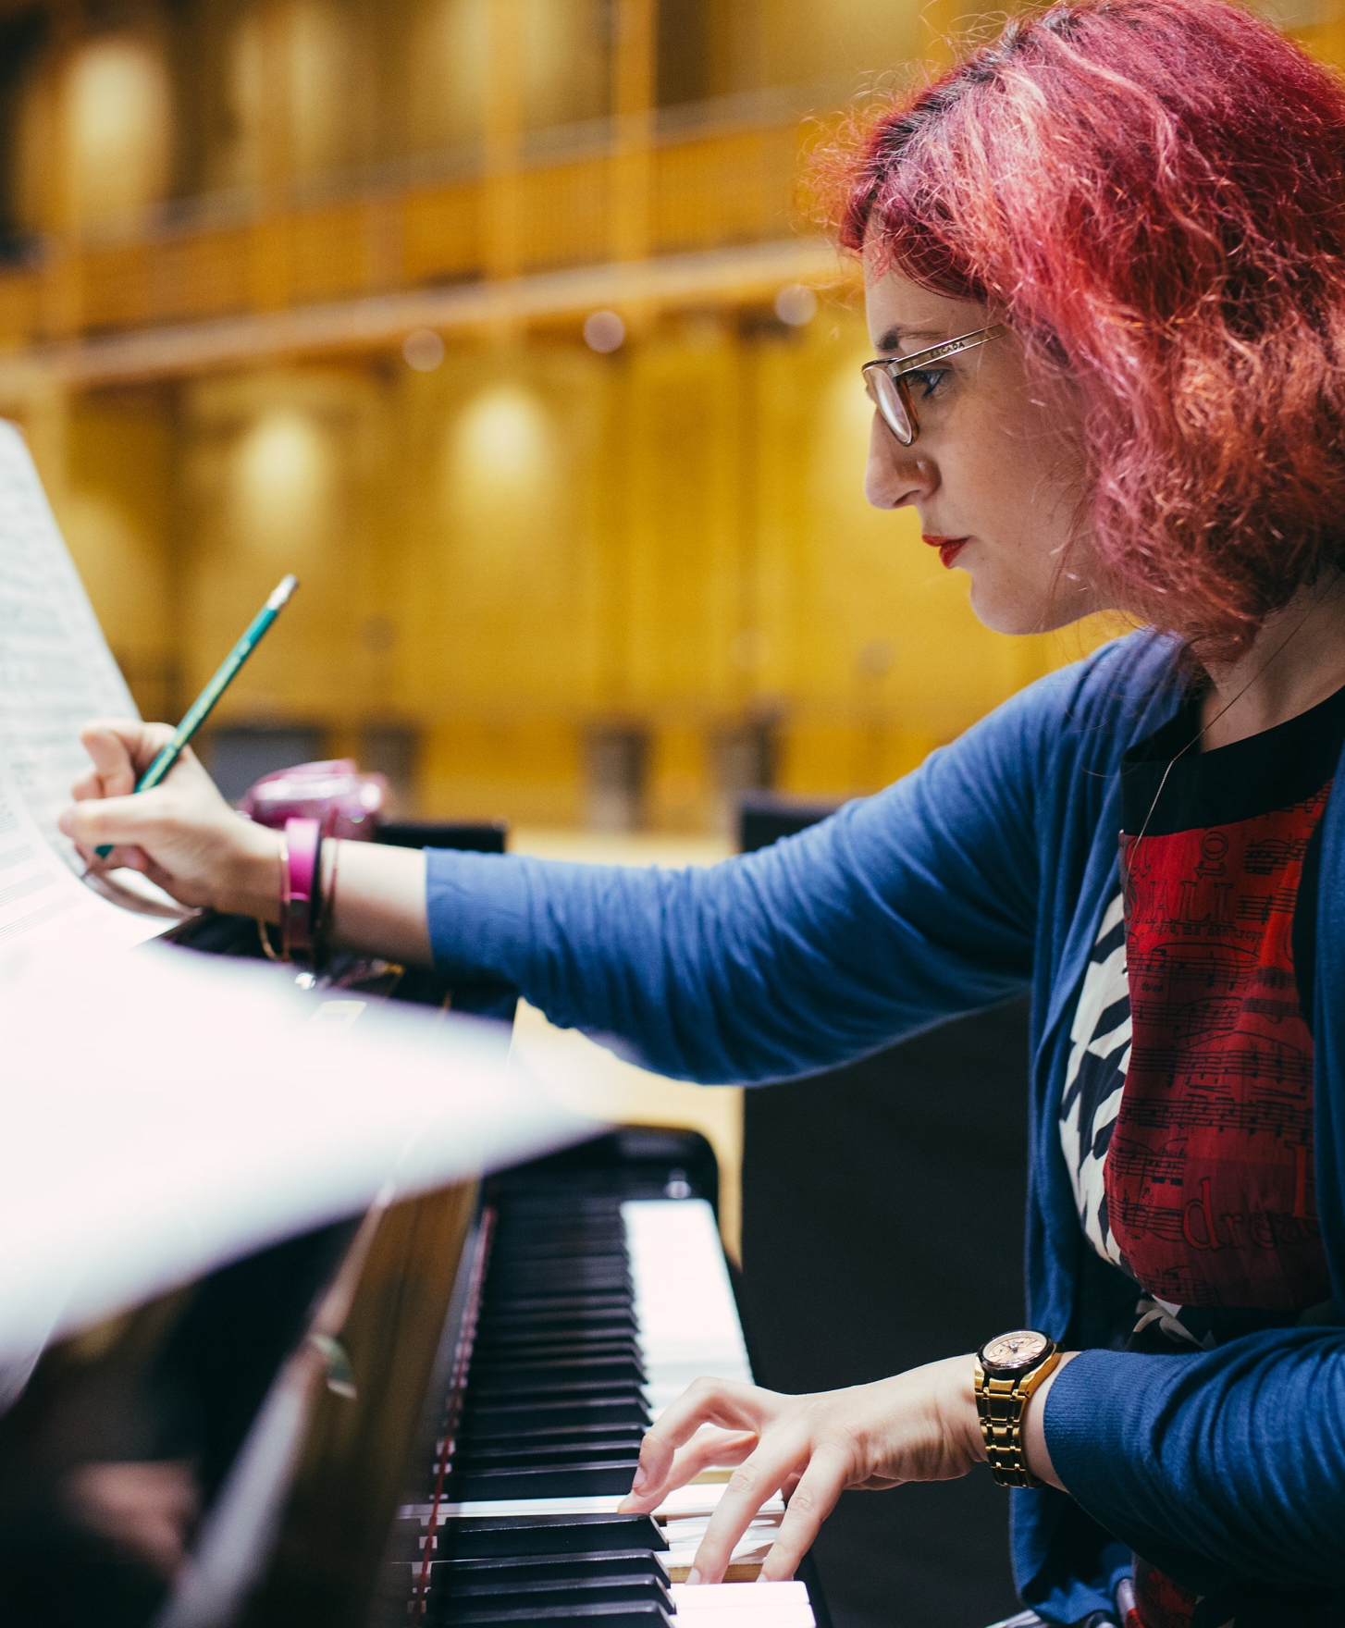


AUDITION FAQs

Birmingham City University

INTRODUCTION

We understand that attending a live or virtual audition will be a new experience for many of our applicants so we want to help. We have prepared a list of frequently asked questions (FAQs) to help you prepare for your music audition.

In addition to this document, we have also prepared a separate guide to help you make an audition recording. Please refer to our Audition Recording Guide on our website for advice and guidance on making an audition video.
If you are auditioning via recording, the most important thing to remember is that we are looking for potential and not perfection in your audition. We are highly skilled in assessing potential through audition videos and will make allowances for differences in recording quality.

If you still have questions after reading, please contact us: conservatoire.admissions@bcu.ac.uk

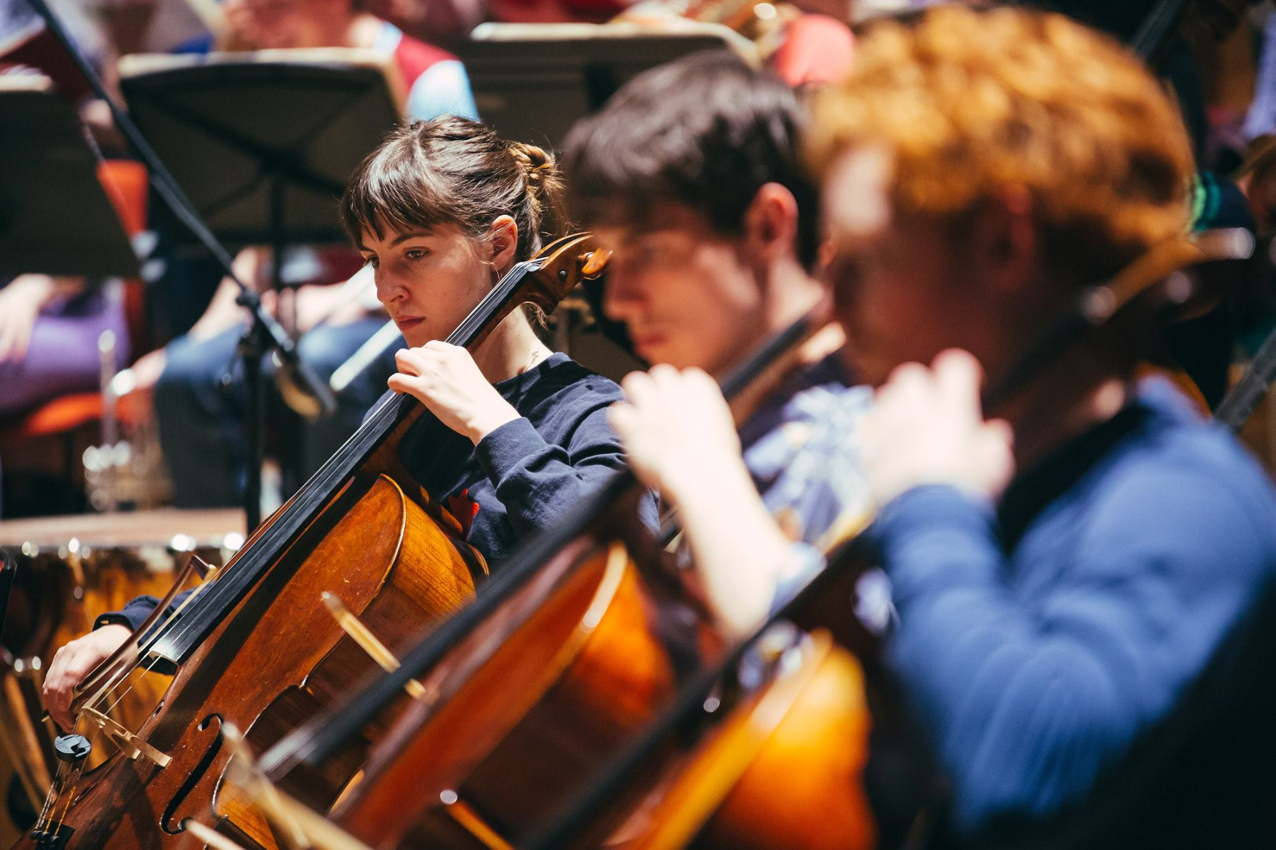

DEADLINES

Q. When do I need to submit my audition video or portfolio?
A. For music applicants who apply by the 1 October UCAS Conservatoires deadline, please send us your audition video as soon as possible after you apply in order to be considered during our main audition period. Please visit our website for the most up-to-date deadline.

For all applicants who apply after the 1 October deadline, please submit your portfolio or audition video links by as soon as possible after applying.

Q. What if I miss the audition submission deadlines above, will I still be considered?
A. Where there are still vacancies after our late auditions in February, we will consider your audition submission. Please contact us for more information: conservatoire.admissions@bcu.ac.uk

RECORDING YOUR AUDITION

Q. Will I be at a disadvantage if the only technology I can record with is a smartphone or tablet?
A. No. We are looking for potential and not the perfect recording. We are highly skilled at assessing potential through audition videos and will make allowances for different recording quality.
However, if you are still concerned about the technology you have access to, please contact us: conservatoire.admissions@bcu.ac.uk

Q. Do you have any advice on how to record my audition?
A. Yes. Please read our Audition Recording Guide for advice and guidance on how to make an audition recording for audition purposes.

QUICK REFERENCE GUIDE

Here is a summary for you to use as a quick reference:

- Prepare recording space
- Setup recording device(s)
- Test record each piece
- Review test with headphones
- Adjust equipment if needed
- Test record and review again
- Record Piece
- Backup and send files



RECORDING YOUR AUDITION (continued)

Q. Do I need to record the whole performance in one take?
A. You do not need to record your whole performance in one take but each piece or movement should be done in a single take.

For Strings applicants, however, we encourage you to record your audition in one take where possible.

Q. Can I use a pre-existing video recording?
A. You may use a pre-existing video recording if the performance meets the audition requirements for your instrument, department or course.

Pre-existing video recordings should have been made within the last 12 months and should demonstrate your current level of skill and ability. Any pre-existing video recordings should also feature you as the prominent performer (i.e. the lead guitarist or solo pianist).

Q. Should I announce my programme?
A. You should either announce the full details of your programme at the start of your recording (i.e.
composer/title of each piece) or announce each piece (or set of pieces) before you perform it.

If you are submitting some pre-existing video material as part of your submission you should record a separate verbal announcement, stating the composer/title, as well as where and when the recording was made.

Q. How much editing is allowed?
A. The recording/recordings submitted should not be edited. If any editing is suspected, we may ask you to submit an additional audition recording.

However, if you are using an accompaniment track, you are free to edit that before the performance. An example could be if your accompaniment comprises more than one instrument, and those lines have been recorded separately.

Q. Can I perform unaccompanied?
A. We strongly encourage applicants to perform all pieces requiring accompaniment with accompaniment. Where this is not possible, an accompaniment track can be used. This can either be created for you by an accompanist/ band or one that you have purchased. If you’re really unable to arrange accompaniment please get in touch. We’ll do what we can to help.

For Classical applicants there are a range of accompaniment tracks on piano-accompaniments.com

For Jazz applicants, iReal Pro or Jamey Abersold are good sources if you are unable to put together a jazz small band for your audition recording.

Q. How much of the performer should be in shot?
A. Please see our Audition Recording Guide for more information.

Q. How long should my audition recording be?
A. Please visit our Audition Requirements page for more information.

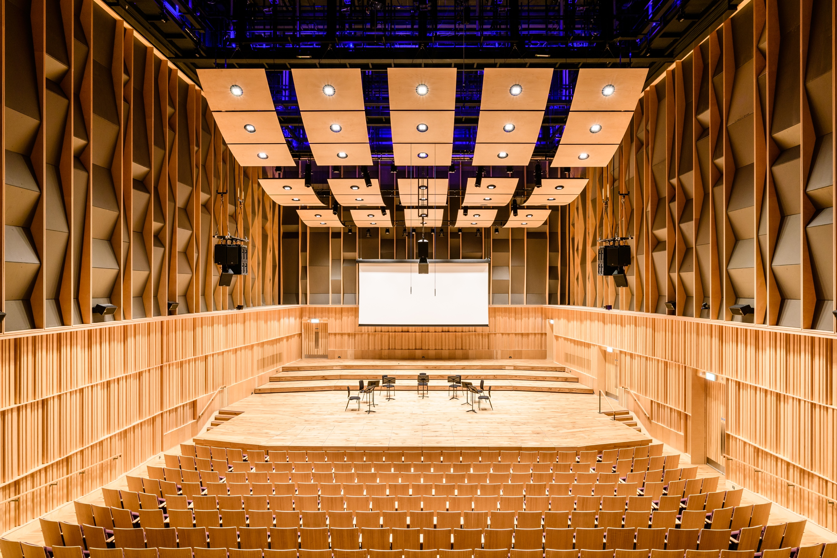

SUBMITTING YOUR AUDITION

Q. How should I submit my audition recording/portfolio?
A. Please send us links to view or download your recording or portfolio online. We advise uploading the file(s) on a cloud storage service you are familiar with – a private YouTube channel, SoundCloud, Dropbox, OneDrive, GoogleDrive etc.
For audition videos, we advise uploading your recording to a video sharing platform such as YouTube or Vimeo. There is a short guide on how to set up a YouTube channel and share an unlisted video on the bottom of this guide.

Q. What format should I follow for my portfolio submission?
A. We request that Composition and Music Technology portfolios are submitted as one folder following this
format:

Folder title: First Name_Surname_UCAS Applicant ID
Subfolder I – Scores
Subfolder II – Recordings

VIRTUAL INTERVIEWS
If you have chosen a Virtual Audition as your preferred method of audition and make it through to the second stage, you may be invited to attend a virtual interview. To help you prepare, we have outlined a few FAQs below:

Q. Do I need my instrument during my virtual interview?
A. If you are applying for one of our performance courses, please bring your instrument with you to your virtual interview. You may be required to perform technical assessments such as sight reading or scales.

Q. What if I don’t have access to an instrument for my virtual interview?
A. Please contact us if you do not have access to an instrument for your virtual interview: conservatoire.admissions@bcu.ac.uk

Q. How will I hear about my virtual interview?
A. Please keep an eye on UCAS Conservatoires Track for an invitation to your virtual interview.

For overseas applicants from outside of China, Hong Kong and Taiwan, we will be in touch with you via email should we need to arrange a virtual interview for you.

Q. When will virtual interviews be held?
A. Our main audition period is in November and early December. This is when most of our virtual interviews will take place. If you have applied after the October deadline or submit your audition video/portfolio after the deadlines above, you may be invited to a virtual interview during our late audition period in February.

Q. How long will my virtual interview be?
A. Virtual Interview times will vary slightly by instrument, department and course but will be about 20minutes long.

Q. What do I have to prepare for my virtual interview?
A. Each of our departments have prepared a bit of guidance on what you can expect during your interview. Please visit our Audition Requirements page for more information.

Q. What technology will I need?
A. All applicants invited to a virtual interview will need access to a device with a screen, microphone and a webcam. A tablet or laptop with an inbuilt microphone and webcam will work well but you can also use a computer with an external webcam and microphone for your virtual interview. A smartphone with an inbuilt webcam and microphone can also be used by any applicant who will not be required to perform sight reading.

For performance applicants, you will be asked to review a short study/ sight reading to perform to the panel and so you will need access to a device with a screen 7inches (17cm) or larger for your virtual interview.

If you are concerned about the technology you have access to in order to participate in a virtual interview, please contact us:conservatoire.admissions@bcu.ac.uk

Q. What if I don’t have access to a screen larger than 7in (17cm)?
A. If you are a performer, please contact us if you do not have access to a screen larger than 7in (17cm) for your virtual interview: conservatoire.admissions@bcu.ac.uk



VIRTUAL INTERVIEWS (continued)

Q. I’m a Jazz applicant, will I need my small band for the virtual interview?
A. No, you won’t need your small band for the virtual interview.

Q. I’m a performance applicant, will I need my accompanist for the virtual interview?
A. No, you won’t need your accompanist for the virtual interview.

STILL HAVE QUESTIONS?

We hope this FAQ answered a lot of the questions you might have about your audition and virtual interview.
If you still have questions, we’ll be happy to hear from you so please get in touch: conservatoire.admissions@bcu.ac.uk

Uploading Videos to YouTube

Introduction
You may have to present a video of yourself performing to examiners or an audition panel. The YouTube platform is an almost globally available video distribution service, with the functions to easily share videos, whilst keeping them private. The Scope of this guide is to educate you on how to create a YouTube channel and upload a video to it that can then be accessed and assessed externally.

Creating a Channel
If you do not already have a YouTube channel, or would like to create a separate one for audition purposes, go to https://www.youtube.com/ and on the top right corner click Sign In.
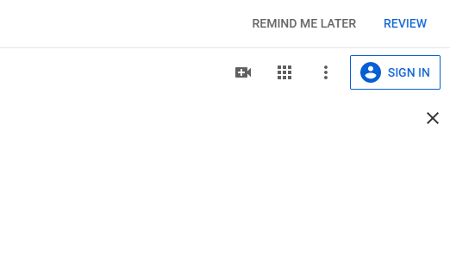

You will then be directed to a login screen. To the left of the Next button there is the option to create an account. Select ‘Create Account’ then choose ‘for Myself’ from the option list.
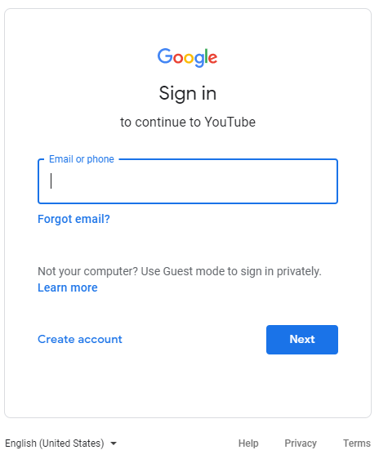

In the next screen, fill in the form and select next or create a new Gmail address for the new account. After Creating a new account, you will need to Sign In. Go back to the sign in screen and enter in the details that you signed up with.

Verifying a Channel
If you are uploading a video of over 15 Minutes you will need to verify your account. Failure to do this before uploading will result in YouTube refusing to process the video.
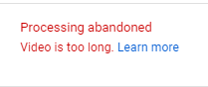
To verify an account, you will need to sign in, then go to https://www.youtube.com/verify. Enter your phone number then follow the instructions on screen. After verification is complete then you may upload your video.

Uploading a video

- After you have signed in, on the top right corner select the Camera Icon and select ‘Upload Video’.

- You may be presented with the option to use your name on the account or a custom name for the channel. Choose one and continue. Fill in the next form or choose to skip later.

- Click Upload Video, and you will be directed to a page that will allow you to select the video file of your choice.

- Click the select files button and navigate to the video file you wish to upload and select it.

- Fill in the details form for the video and click next.

- Add any video elements that you want, then click next.

- Visibility. We recommend that you choose ‘Unlisted’ when uploading for assessment as it limits visibility to only those with the like to the video. After the piece has been graded you can then change the visibility to however you please.

- Click Save.

- Keep the browser tab open while the video uploads, if you navigate away from the tab, the upload will stop and you will have to start the upload process again.

- After the upload is complete, YouTube will need to process the video. You can now navigate away from this page.

- After the video is processed you can then copy its link, by clicking on the options button of the video and selecting ‘Get Shareable Link’.

- Send the link to whomever needs to see your video.

