Associate Teacher name: |  | Date:
Course: |  | Placement: | 1 2 3
School: |  | Subject / area: |  | Year Group:
Personal Academic Tutor: |  | Observer name(s):
Observer role(s): | Lead Mentor Placement Mentor Professional Mentor Joint

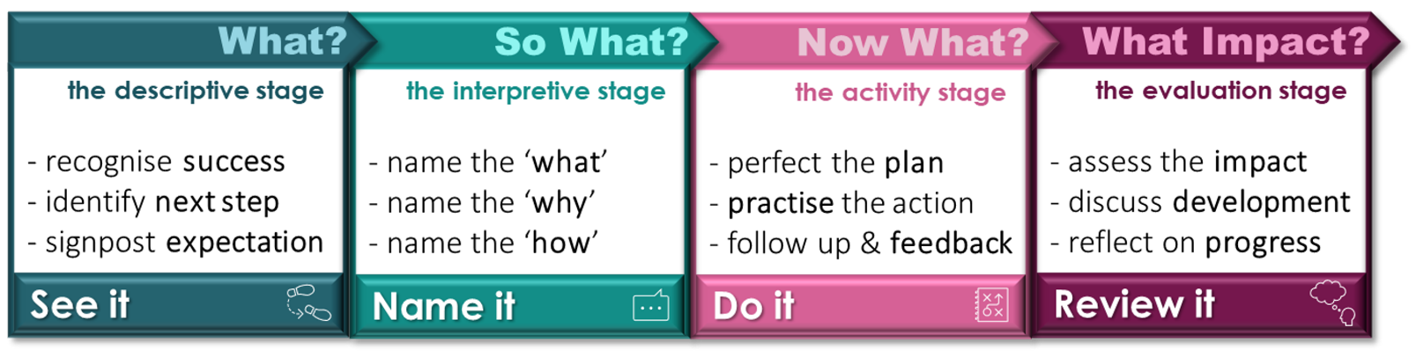

Review It: Current targets and focus of observation (taken from weekly meeting or LOR feedback) |  |  | BCU Theme
1.
2.
3.
See it:
Lesson Intent: How does the Associate Teacher review learning at the start? Is pupil’s prior learning built on? Is the lesson intent made clear?
 | Subject Knowledge: Theme C - How is the Associate Teacher demonstrating accuracy, breadth and depth of subject knowledge?
 | Planning and Assessment: Theme D - How is the Associate Teacher presenting new knowledge in small steps? How does the Associate Teacher check for understanding? How is questioning used to good effect?
 | Adaptive Teaching: Theme E - How does the Associate Teacher use scaffolding and support for all learners? How is independent learning encouraged? How are models and examples used to support pupil progress? How are pupils challenged?
 | Behaviour and Wellbeing: Theme B - Classroom practice – How does the Associate Teacher maintain clear behavioural expectations and use a range of behaviour management strategies and manage low-level disruption?
Impact on learning: What have the pupils learned? Is the learning related back to the Lesson Intent?
Key Strengths: Following the observation, through professional dialogue, please identify key strengths and targets for the Associate Teacher in the context of raising pupil achievement and supporting children’s learning. |  |  | BCU Theme
1.
2.
3.
Target: Name it:  At least one subject specific target should be set. |  | Do it: | BCU Theme
What is the next step (to support Associate Teacher progress) Why is this important (impact on pupil progress) |  | How will this be achieved (what actions are needed?)

