BCU Associate Teacher Code of Conduct –

Postgraduate and Undergraduate Teacher Training Courses

Statutory Professional Expectations and Conduct
- I understand that, as successful completion of this course leads to awarding of Qualified Teacher Status, I am required, during my studies to adhere to the expectations of conduct endorsed by the teaching profession (Teachers' Standards, DfE 2021). I understand that breeches of these expectations may lead to disciplinary action including my exclusion from the course and/or the inability of the BCU ITE Partnership to provide me with a supportive professional reference.
- I understand that once I am registered with the Teaching Regulation Agency (TRA), I will be subject not only to BCU policies and procedures but also to those of the Teaching Regulation Agency. Please note that registration with the TRA is a requirement of being able to achieve Qualified Teacher Status.
- I understand that if I need reasonable adjustments to be made to enable me to fulfil the expectations of the teaching profession, I will make these needs known to the course team. If appropriate, I will meet a Disability Support Advisor to create a Disability Support Summary (DSS) and, if appropriate, a Placement Action Plan (PAP), which will be approved by the course leadership team. I will then take responsibility for sharing this with mentors in school.
- I am aware that I will be placed in an appropriate teaching practice placement, as set out in the Initial Teacher Training (ITT): Criteria and Supporting Advice – Statutory Guidance for accredited ITT providers, and to avoid any conflict of interest.
- I understand that I am responsible for disclosing any changes in my health or circumstances that may impact on my fitness to teach or study.
- I agree to behave in a manner appropriate to my position as an Associate Teacher and understand that behaviour, including for example, dishonesty, indecency, harassment, bullying, violence, abuse of drugs or alcohol, will lead to disciplinary action (usually Fitness to Practice), which may include consideration of any criminal conviction, where the offence(s) are directly related to my position as an Associate Teacher and upholding the Teachers’ Standards (DfE, 2021).
- I understand that I will be required to show academic integrity through engagement with the academic aspects of my course. If I behave dishonestly during the assessment process (including plagiarism or other forms of cheating, including inappropriate use of AI), or in relation to my engagement and attendance, this means I will be subject to the Fitness to Practice procedure and I may be removed as an Associate Teacher from my course.
- I understand that I should recognise my own personal and professional abilities and be self-aware and reflective.
- I will respond appropriately to feedback from both school mentors and BCU staff, and I understand that feedback provided is intended to support my development and progress as a trainee teacher.
- I agree to be open to learning from different viewpoints and to engage in open and constructive discussion that facilitates the learning of others as well as myself.
- I understand that a lack of insight into health or professional concerns may bring my fitness to practise into question and may lead to a referral to Fitness to Practice.
- I will ensure that I maintain, both in both training environments and in schools, a standard of business dress. This includes the removal of outdoor clothing and headphones in university-based sessions and as appropriate on the school site.

Disclosure of Criminal Convictions and Cautions
- I agree to inform my Course Leader, without delay, should I be subject to a criminal conviction, caution, arrest, investigation or any change in circumstance that would have a potential impact on my ability to uphold part 2 of the Teachers Standards (DfE, 2021), after the submission of my application for DBS Enhanced Disclosure – which in effect includes any time during my training year/s. I understand that a criminal conviction, caution, arrest or investigation may lead to my suspension or expulsion from some or all aspects of the course and that this may lead to the need for my studies to be extended or terminated. This also extends to association with any persons who could be considered a safeguarding risk.
- I understand that the Rehabilitation of Offenders Act (1975) does not apply to the teaching profession and that should I be subject to a criminal conviction or caution it will never be considered “spent”.
- I recognise that during my studies I will be placed in a position of trust and that as such I am subject to the requirements of the Sexual Offences (Amendment) Act 2000.
- I understand that the University may share with the Teacher Regulation Agency, relevant information in connection with or arising from misconduct and fitness to practice proceeding taken by the University against me.
- I understand that if information in connection or arising from misconduct and fitness to practice proceedings taken by the University against me is shared with the Teacher Regulation Agency, it may impact my ability to register successfully with the Teacher Regulation Agency.

Child Protection and Safeguarding
- I will abide by the current guidance of Working Together to Safeguard Children and Keeping Children Safe in Education.
- I will always treat children, colleagues, staff, and any other members of the BCU ITE Partnership with due respect and conduct myself in a professional, honest, decent, and courteous manner. I will use language appropriate to the situation and people involved.
- In schools I will always work in a place which is accessible to others and in which I can be observed working. I will not take or agree to meet, children/pupils outside school premises without another responsible adult present.
- I will not make unnecessary physical contact with children/pupils.
- I undertake to ensure my communication with children/pupils, including electronic communication, is appropriate and through partnership approved school systems.
- I will report any suspicion that a child/pupil is being abused to the school’s Designated Safeguarding Lead.
- I will acquire an understanding of working with diversity, including gender, race, and culture, in order to work with children/pupils, staff and parents appropriately. I will be mindful of the difficulties some groups may face and ensure personal prejudices and stereotypical views to not influence my judgements or actions.
- I will ensure that I adhere to the safeguarding policies and processes within the school (this includes processes for signing in and out of the school site and the use and return of visitor lanyards, attendance at school-based safeguarding training sessions, etc.)
- I will ensure I know and adhere to the school behaviour management policy and consistently apply rewards and sanctions, recognising that it is illegal to use physical means of punishment.

Health and Safety
- I understand that Associate Teachers have responsibilities for safety at their place of study and placement under Health and Safety legislation.
- I will follow the Health and Safety at Work Act (1974), which requires me to take care for my own health and safety and that of others, including a responsibility in loco parentis for the safety of children/pupils in my care (as outlined in Section 7 of the Health and Safety at Work Act).
- I understand that there may be specific health and safety requirements for specific subjects (e.g. Physical Education, Design Technology, etc.) that I need to adhere to as per school Health and Safety policies.
- I will avoid the consumption of food and drink in areas where this is restricted, e.g. science laboratories on both University campuses and on school sites.

Attendance and Absence from the Course
- I understand that that the content of the course meets the requirements of Qualified Teacher Status accreditation and I will pursue my studies with due diligence, ensuring that I avail myself of the educational opportunities made available. I will take responsibility for my own learning through attendance at sessions, workshops and periods of school-based training and through being suitably prepared for them.
- I understand that 100% attendance is expected and any absence should be authorised by the Course Leadership Team.
- I understand that, for the Course Leadership Team to authorise any absences, I may be requested to provide appropriate evidence to support my request. Additionally, evidence may be requested to support reasons for absence retrospectively.
- I am absent from university-based teaching sessions, I will log my absence via MySRS as well as notifying my personal tutor and the person leading the session I am absent from.
- I understand that if I am late to a university-based session within 15 minutes of the start time, I will be registered as ‘late’. I understand that if I am late beyond 15 minutes of the start time; I will be registered as ‘absent’.
- If I am to be absent from any part of the course, due to illness or other reasons, I will complete the required tasks set for me to catch up with the required learning for university-based sessions.
- I will immediately inform my Course Leader if I am suffering from an infectious disease such as Covid-19, chicken pox, German measles (Rubella), impetigo, measles, scarlet fever and slapped cheek disease (Parvovirus).
- I understand that my attendance will be monitored and actions taken if my attendance falls below the expected standard:

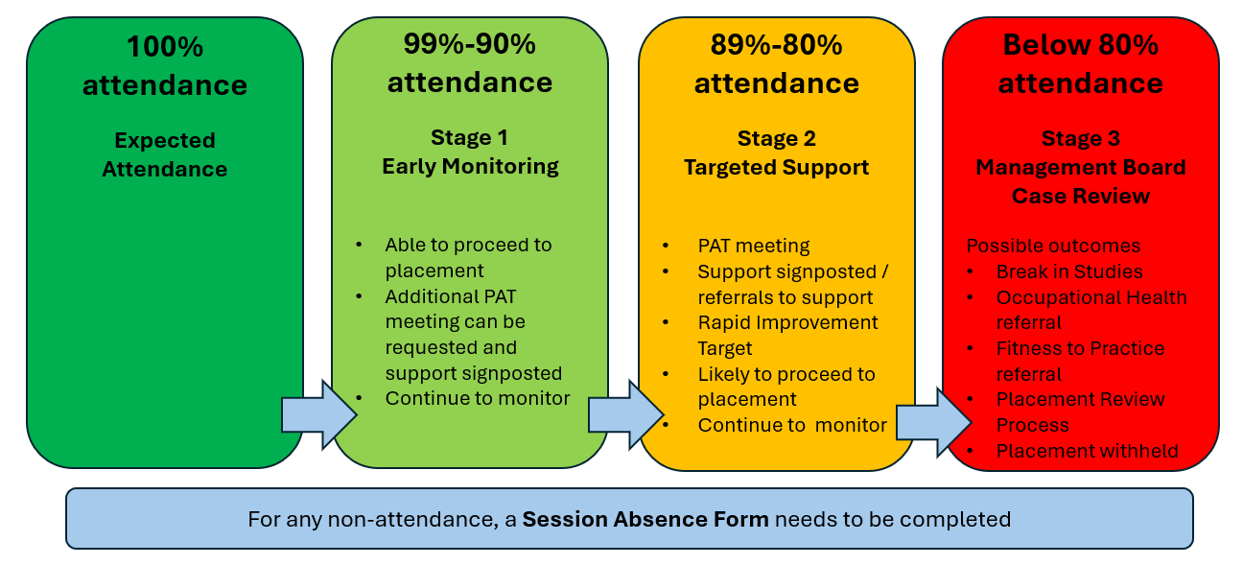
- If I am absent from my school placement, I will contact the school in accordance with school policy for staff (recommended to be no later than 7.30am if a time is not stated in the school policy). I will also log my absence via MySRS and will inform my personal tutor. This must be done for every day of absence.
- I understand that absence from school placement will result in the need to extend the end date of my placement. I understand that this may have implications for the date of completion of my course as well as wider consequences such as the need to extend time in student accommodation and employment start dates.
- I understand that holidays are not to be taken during term time and cannot be authorised.
- I understand that I must adhere to and meet all deadlines. I understand that I will need to follow the Extenuating Circumstances policy and procedure if something unexpected happens that will prevent me submitting work on time. For more detailed guidance visit Extenuating Circumstances Procedure.

Personal Information, Data Protection, IT, Internet and Telephone Usage
- I understand that during school placements I will have access to confidential personal information and that I am required to comply with the Data Protection Act. I understand that I may not disclose this information to any third party, other than in accordance with the conventions regarding use of personal information for us in research for the purposes of completing assignments or in accordance with the law.
- I understand that I am not allowed to record, using any mobile device, school lessons or BCU lectures/sessions without prior permission.
- I understand that mobile phone use should only take place in BCU sessions where this has been authorised by the person leading the session (i.e. when use of a phone is appropriate to the activities within the session).
- I understand that mobile phone use in school placements will be in line with school policies for staff.
- I understand that the use of the placement school telephone, IT equipment, email and internet systems are monitored by the school, and I therefore do not have any expectation of privacy. Such monitoring will be for legitimate purposes in accordance with the Data Protection Act 1998 and the Telecommunications (Lawful Business Practice) (Interception of Communications) Regulations Act 2000.
- I understand that the internet (both via university and school systems) is to be used to support my studies and as an Associate Teacher in training. I will ensure that I do not infringe any copyright restrictions on materials accessed or transmitted via the internet.
- I understand that all use of the internet is logged and that these logs are periodically inspected.
- I will avoid deliberately accessing material on university or school systems that might be considered offensive or inappropriate. This includes all racist, sexist and discriminatory information together with any material that might be pornographic. It also includes sites promoting violence, offensive language, and unlawful conduct.
- I am aware that my social media presence should remain professional at all times as this can be seen by children/pupils/peers/professional colleagues, parents and school placements.
- I am aware that concerns about my social media presence could result in a referral to Fitness to Practice.
- I will report any accidental accessing of inappropriate material to the BCU ITT help desk or my mentor in school as appropriate, so that it may be noted, and the fact recorded.
- I will ensure files downloaded from the internet are checked for viruses before being used and will ensure that appropriate action is taken if a virus is detected.
- I understand that I should only use my university student email address, not a personal email address, for contact with university and school staff in relation to the course and my school placements. The exception to this is in the early weeks of the course prior to being allocated a university student email address. As soon as a university student email address is provided, it should be used for all further communications.
- I understand that if I am assigned a school email address, I will use this in accordance with school policies.
- I will ensure that any use I make of email facilities will not contain illegal, lewd or offensive materials or language, or be used to send bulk emails apart from those which may be necessary to support my work as an Associate Teacher in training.
- I will ensure that I do not send emails that are defamatory or libellous in nature and acknowledge that could result in legal action being taken against me.
- I will not allow access to internet facility at university or school placement to external users.
- I understand that abuse of the internet facilities available to Associate Teachers in training will be managed under the provision of Fitness to Practice procedure and the circumstances encountered will be fully investigated by senior BCU staff. Such abuse it viewed as a very serious violation of the BCU disciplinary chose which may, subject to circumstances, be categories as acts of gross misconduct, i.e. the misconduct is deemed to be of such a nature that it fundamentally breeches the contractual relationship between the Associate Teacher in training and BCU and in such situations the Associate Teacher in training will be dismissed without notice. Some circumstances could further lead to criminal proceedings being taken against the Associate Teacher.
- I will not misuse the use of personal emails and/or email attachments by downloading information onto BCU or school-owned equipment.
Partnership School Property
- I will take due care and attention to look after any equipment and resources loaned to me and report any damage to the equipment or software issues immediately to the relevant IT support team. There should be no attempt to repair the equipment, and any damage deemed to be caused by negligence, or misuse will be charged to the Associate Teacher.
- I will return all loaned equipment and resources as provided by the partnership school as soon as possible and no longer than one week of the placement ending.
- On termination of my course/placement for any reason (or earlier if requested), I acknowledge that I must immediately (and not longer than one week) return to the school or BCU:
  - All originals and copies of any documents or information, however recorded and whether retaining electronically or on paper or otherwise.
  - All other property in my possession or control which belongs to, or relates to the BCU ITE Partnership, including, but not limited to, identity/security passes, keys, safety equipment, protective clothing, uniform, credit/charge cards, laptops/computers and other computer hardware, memory sticks and similar.

I have read, understood and agree to abide by the BCU Associate Teacher Code of Conduct

Signed: [Associate Teacher]
Date:
Print name:

Please mark with an X to indicate the course you are following:

BA (Hons) Primary Education with QTS
BA (Hons) Secondary Physical Education with QTS
PGCE Primary and Early Years – Core and Lead School Partner Routes
PGCE Secondary – Core and Lead School Partner Routes

