How to Download and Access Island Browser Guide

Staff who are not entitled to a BCU-issued laptop will need to use Island Browser to access BCU services. ‘BCU services’ includes any applications or services that require a BCU login, such as Outlook, Teams, SharePoint, OneDrive, Microsoft 365 apps, Moodle, ERP and iCity.
The Island Browser is an internet browser, similar to Google Chrome or Microsoft Edge, that can access BCU services securely. Island browser can be downloaded onto any personal Windows or Mac laptop or PC that meets our security requirements. Please note, Island Browser is only for BCU related work. Please use a different browser for non-work related internet access.
This guide will assist you in downloading and accessing Island Browser. There is a separate guide on how to navigate Island Browser.
Staff can also access BCU services from your personal mobile phones and tablets, provided you download and enrol into the Microsoft Intune Company Portal, and your device meets Microsoft’s security requirements. For guidance on enrolling your personal phone and/or tablet to access BCU services, please refer to the following resources:
- How to enrol your personal Android device
- How to enrol your personal iPhone or iPad
For more information on using your personal devices at BCU, see our iCity page.

Contents
Downloading Island Browser 2
Requirements 2
Downloading Island Browser 2
Accessing the Island Browser 4

Downloading Island Browser

Requirements
Only supported Apple and Windows operating systems and up to date malware protected systems will be able to download and access Island Browser. Island will prompt you if your device needs to be updated.
Staff who cannot download and use Island Browser on a personal laptop or computer will need to use a BCU computer on campus. Alternatively, you can also access BCU services on your tablet and/or mobile phone, provided you download and enrol in the Microsoft Intune Company Portal, and your device meets Microsoft’s security requirements.

Downloading Island Browser
Go to https://download.island.io/ to begin the download process, and enter your BCU email address.
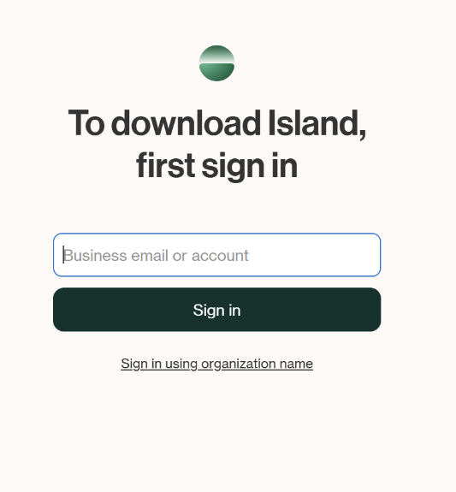
You may be directed to the BCU MFA screen. If so, enter your BCU email and password, then verify via your chosen MFA option.
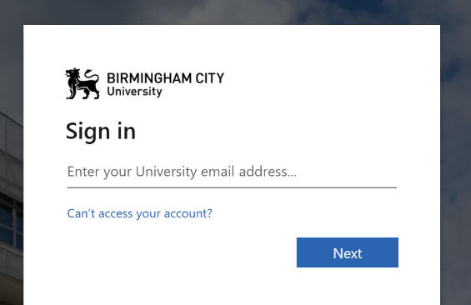

You will now be able to see the download page for your device. Click Download for XX [XX = your device].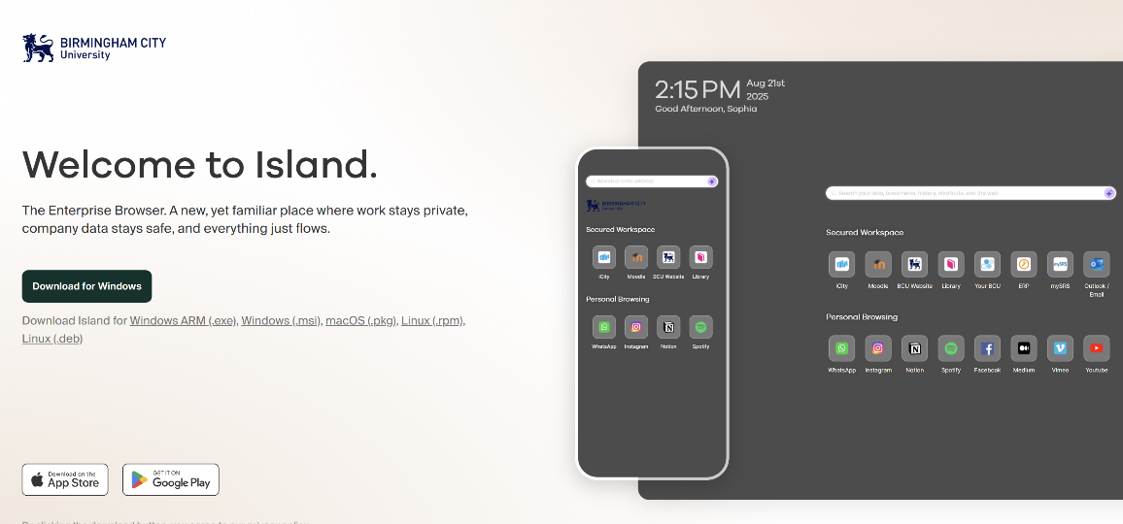
If prompted, choose the location you would like to save the IslandSetup file - this might automatically download if you have this set-up. Open the file. If using Chrome, you can go to your recent download history by clicking the downloads icon in the toolbar
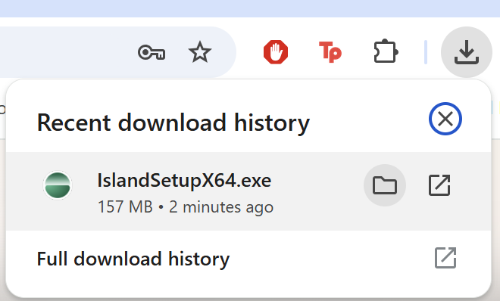
Click Yes on the prompt to allow Island Installer to make changes to your device. 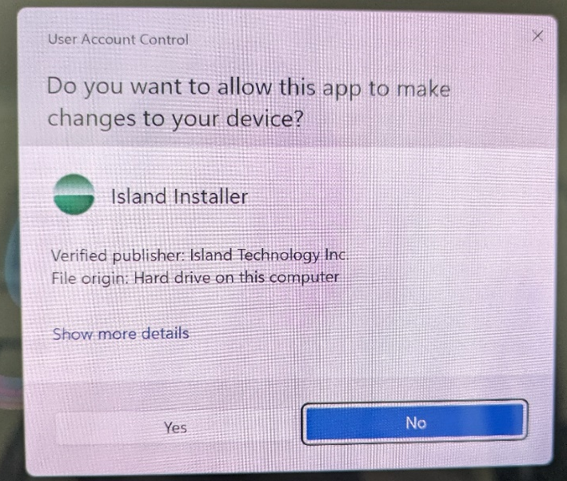

The Island app will now install.
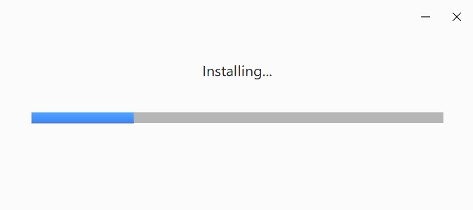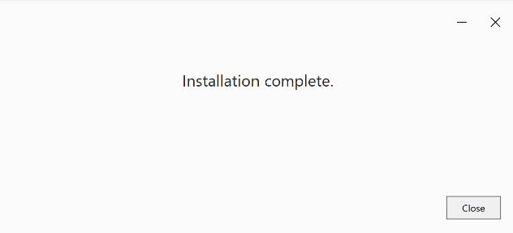
Once complete, if downloading onto a Windows device, Island will add a shortcut icon to the desktop. If downloading on a Mac, the icon will be added to the Launchpad.

Accessing the Island Browser
To open Island Browser, double-click the shortcut icon on your desktop. On Windows devices, it can also be accessed from the Start menu or pinned to the taskbar. On Apple devices, you can open Island from the Launchpad. You can also drag Island to the Dock for fast access.

In the window that opens, click Start using Island.
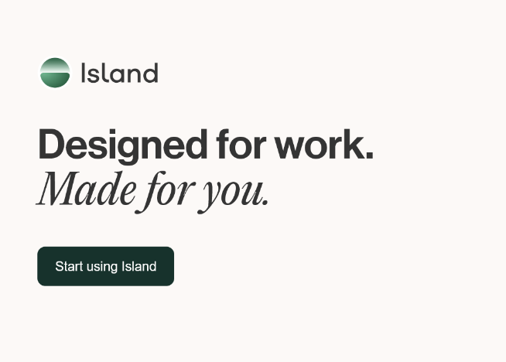
Enter your BCU email address if prompted. You may be taken to a window to login to your BCU account and verify via your chosen MFA method. 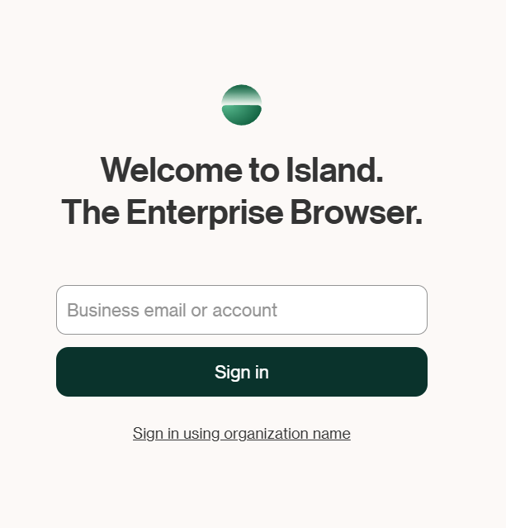

Once logged in, you will see the Homepage for the Island Browser.
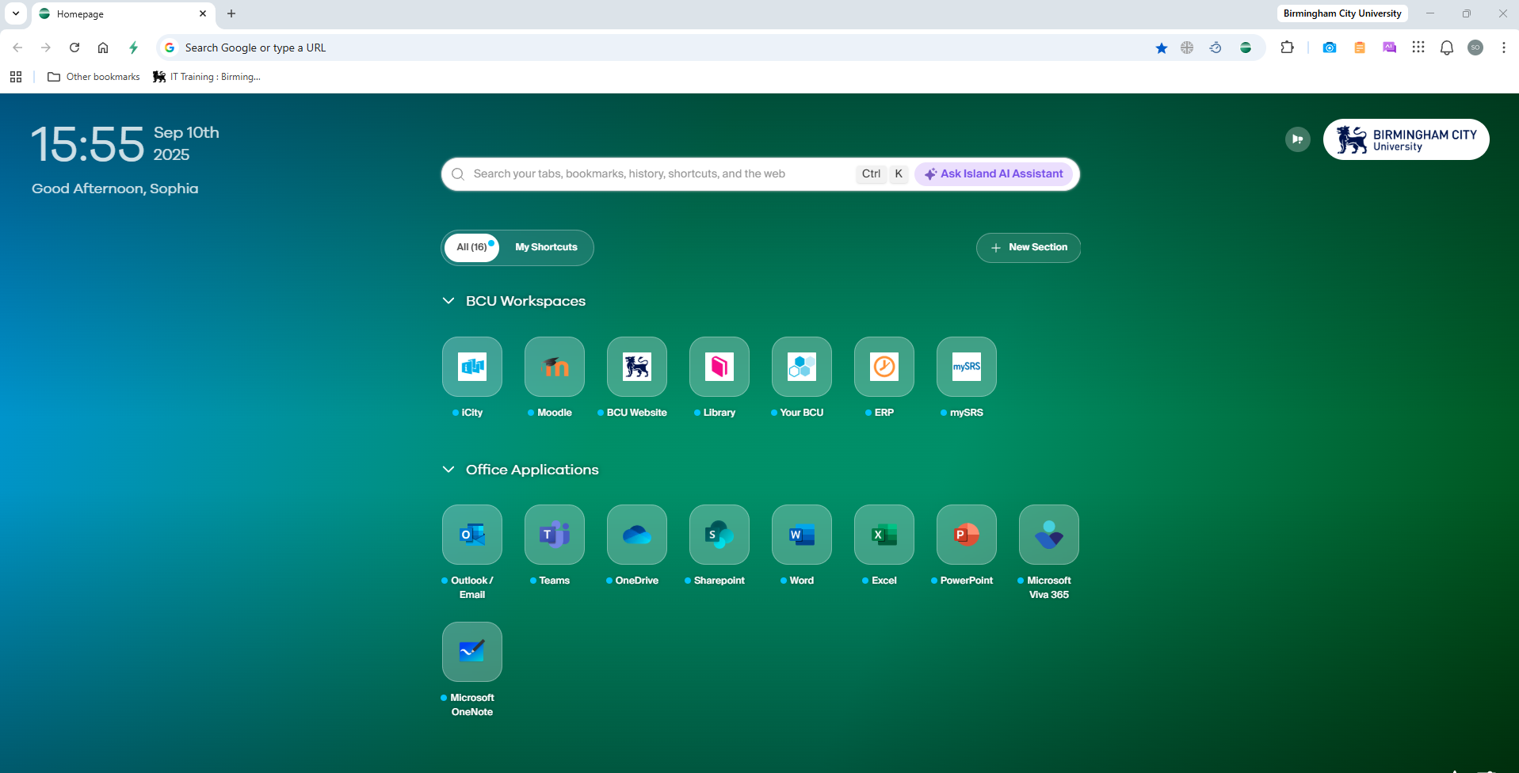
For more information on how to navigate the Island Browser see this guide. If you have any questions or issues while downloading and accessing Island Browser, please contact the IT Help Desk via email on ITHelp@bcu.ac.uk or phone on 01213316543.

