

Social Work Education, Policy, and Practice (SWEPP) Research Group
Newsletter October 2025
Introduction
Welcome to the October Edition of the newsletter from the Social Work Education, Policy, and Practice (SWEPP) Research Interest Group. The aim of this newsletter is to let you know about our work, and we hope you find it interesting and informative.

Our work is centred on the International Federation of Social Work (IFSW) definition of social work. Although individual group members have differing and diverse areas of interest, our common focus is found in particularly marginalised groups and areas of practice. As such, SWEPP aims to promote social justice, human rights, and emancipatory practice in these domains, through its research activities and dissemination of findings.
It has been a very busy year for us, and we are delighted to introduce three new members of our group to you.

Dr Shian Yin joins us as a Lecturer in Social Work, having previously worked at Coventry University. He holds a PhD in Social Work from the University of Nottingham. His research focuses on care-experienced young people, child and adult social care, youth transitions, and social policy analysis, with a particular interest in the Chinese context and beyond. Shian has published widely in SSCI-indexed journals and specialises in qualitative research methods and thematic analysis. He is committed to bridging academic research with practice to promote social policy reform and improve the wellbeing of marginalised groups.
A full list of his publications can be found here


Dr Shian Yin
Claire has just completed her PhD at Anglia Ruskin University, aiming to raise academic and social success for deafblind learners. Claire’s PhD follows a 20-year teaching career, most of which was spent working for a local authority as a Qualified Teacher for Children with Multi-Sensory Impairment (QTMSI).
Claire’s research has focused on working with children to promote the child’s voice throughout her research. Claire joins the Deafblind UK Centre for Education and Research as a Research Assistant and she is keen to continue to develop her skills as a researcher and work with the deafblind community. Outside work Claire enjoys an outdoor, family life including spending time with her two children and labradoodle.

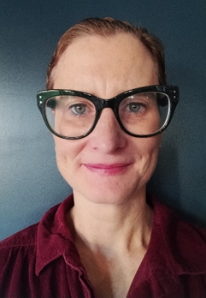
Claire Manford
Dr Vyda Hervie joins us as Lecturer in Social Work from the University of Ghana. Prior to working in Ghana, Vyda was a Senior Lecturer in Social Work at the University of Ghana and Senior Researcher in Childhood, Family and Child Welfare at the Norwegian Social Research (NOVA), Oslo Metropolitan University, Norway. She is a researcher in gerontology, and her research interests include adult social care/ageing, disabilities, children, young people and families, gender, labour migration and healthcare workers. She has especially studied the experiences of immigrant health care assistants in Norway and developed interest in intersectional perspectives

Dr Vyda Hervie

Establishing the Deafblind UK Centre for Education and Research at BCU

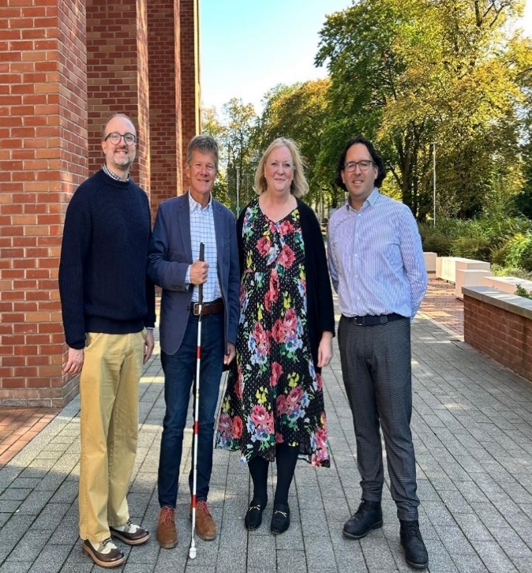
The Deafblind UK Centre for Education and Research at Birmingham City University is the UK’s only academic hub that focuses solely on deafblindness. It will be led by our own Dr Peter Simcock, Associate Professor in Social Work.
Together with researchers, academics and the deafblind community, the centre will work on a range of studies that will deepen our understanding of deafblindness/ dual sensory loss and help people who are deafblind to be seen, heard and supported.
Recognising the need to build capacity in the field, the Centre will also equip junior researchers and the workforce with the knowledge and skills to become future leaders in deafblindness research and practice. This work has already begun with the establishment of two PhD studentships; the successful applications will be supervised by Peter and SWEPP Co-Lead Dr Colin Watt.

Congratulations, Peter, on such an achievement!

The formal launch of the Deafblind UK Centre for Education and Research will take place on 23rd October 2025. There will be a keynote presentation from Hannah McPierzie, a globally respected speaker and advocate from Australia, who lives with deafblindness. We will also be joined by Deafblind UK Ambassador, captain of the England Blind Lionesses team and rower on the GB para pathway, Samantha Gough, who will formally launch the centre. There will then be refreshments, networking, and a chance to view a small art exhibition, featuring work by Alberto Camacho, artist and recently retired Professor of Fine Arts at the University of Pamplona, Colombia, who lives with deafblindness.

BCU International Week April 2025
In April 2025, Social Work and Early Childhood Studies hosted its third International Week. We welcomed a number of international guests for a three-day event, including visits to social welfare agencies, cultural events and a one-day conference. Among our guests were Dr Peter Gramberg and Dr Astrid Altena from Saxion University (Netherlands) with 15 Health and Social Work Masters students, and Dr Tracey Bone, Associate Professor from the University of Manitoba, Winnipeg (Canada).
The conference was attended by over 120 students, staff and people with lived experience and focussed on Contextual Safeguarding. BCU Alumni Claire Graham, Head of Services for Contextual Safeguarding at Birmingham Children’s Trust, was the keynote speaker and inspired delegates with her experience and knowledge. Workshops were presented from our international guests, and colleagues from Southern Cross University, Australia (Dr Oliver Kamenarac) and Amani Tanzania, an organisation supporting street children in Tanzania, Africa.

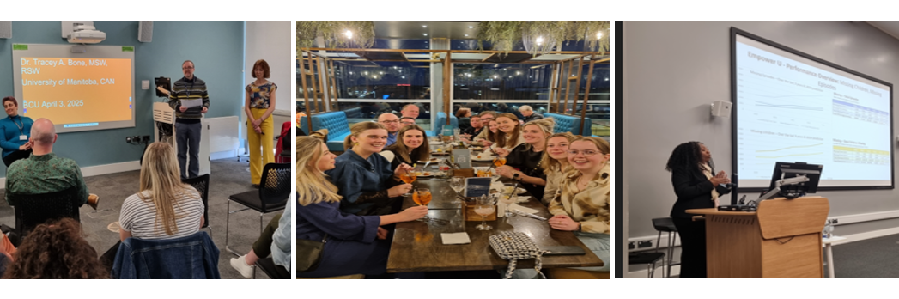
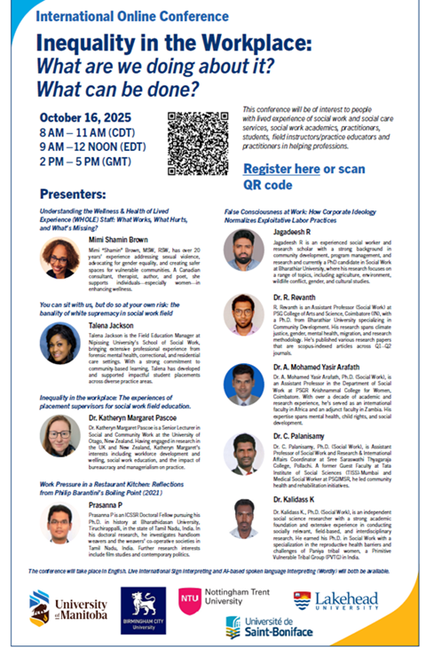
SWEPP working in partnership with Colleagues in Canada
Peter and Jess continue to work with partners at University of Manitoba and Université de St-Boniface, Winnipeg, Canada. The partnership has grown and now includes Lakehead University, Ontario and Nottingham Trent University.
This year the partnership facilitated two free online conferences on Intersectionality: Is poverty the missing link? The conferences were well attended, with 100 delegates from across the globe, and included speakers and from Canada, UK, India and Jamaica.
Jess and Peter have since secured a £12,000 grant from the British Association of Social Workers (BASW) to build on this partnership’s work. The monies will fund two further conferences and a visit to Winnipeg in October 2026.
The next conference will be online on 16th October 2025, 3pm and focusses on inequality in the workplace. A link for registration can be found here.

Current research Activities
- Congratulations to Dr Peter Simcock on his recently was awarded grant from BA/Leverhulme SRG for his study Wellbeing in Wales, is it for all? An exploration of the social care experiences of deafblind adults in Wales, post implementation of the Social Services and Wellbeing (Wales) Act 2014. (October 2025 – date). The study will determine how social services in Wales are delivered to deafblind adults and illuminate their experiences of using social care. It will identify barriers in the social care system and offer insight into how it can better meet the needs of the 29,000+ deafblind people in Wales, ultimately promoting their well-being.

- Dr Peter Simcock is also co-PI on a Canadian Hearing Services Global Partnerships for Research & Innovation (CAN$100,000) and Quebec Vision Sciences Research Network (CAN$50,000) funded international project: Growing up & Being Deafblind: Analysing comparative case studies from the Global South and North to illuminate enablers that lead towards the achievement of the UN Sustainable Development Goals (2025-date). This study explores the experiences of adults with congenital or early-onset deafblindness, who may have finished compulsory/formal education, and/or might have had some experience of employment, and/or further.

Conferences, Keynotes and Presentations
- Simcock, P. (October 10, 2025). Giving Voice by Doing With not Doing Through: Collaborating with Tactile Sign Language Interpreters in IPA research involving deafblind people, Social Work IPA Research Network Symposium, online.
- Simcock, P. (October 9, 2025) Deafblindness Research: Past Foundations & Future Directions, Inspiring Change, Deafblind UK Conference, online.
- Boie, N.R., Kamenopoulou, L., Simcock, P., Prain, P., Dumassais, S., & Wittich, W. (September 11, 2025). Expressive and receptive communication strategies when conducting remote research with individuals living with deafblindness, poster P191, Vision 2025 15th International Conference on Low Vision Research and Rehabilitation, Florence, Italy
- Wittich, W., Dumassais, S., Kamenopoulou, L, Simcock, P. & Prain, M. (September 10, 2025). Comparing education pathways for deafblind children in the Global South and Global North, Vision 2025 15th International Conference on Low Vision Research and Rehabilitation, Florence, Italy
- Wagner, J. (September 03, 2025) Factors promoting resilience and strengths in nonviolent men, who were exposed to domestic abuse as children: initial and emerging findings. European Conference on Domestic Violence, Barcelona, Spain
- Wittich, W., Boie, N.R., Kamenopoulou, L., Simcock, P. & Prain, M. (May 8th, 2025). Conducting remote research with individuals living with deafblindness, Uncommon Senses V - Sensing the Social, the Environmental, and Across the Arts and Sciences, Concordia University, Montreal, QC,
- Simcock, P. (April 28, 2025). “It is getting harder and… it’s closing in on me”. The Experiences of Adults Ageing with Deafblindness. Conferences in Vision Series, School of Optometry, University of Montreal, Canada
- Govan, R. (June 10, 2025) “Every time you talk to a social worker, it's trauma." Experiences of social work interventions from the perspective of adoptive parent carers of children with a suspected or confirmed diagnosis of FASD”. FASD in The UK: Shaping Future Research and Practice. UK
Forthcoming Events
- Jess will present at A Feminist Politics of Radical Hope in a Time of Oppression Conference. VAWG-RN, in November this year, and Peter has been invited as Keynote Speaker at the Inaugural Dual Sensory Impairment – Deafblindness Conference: Filling the Gaps and Joining the Dots. University of Sydney and Macquarie University, also in November.

Recent Publications

Manford, C., Rajasingam, S., Allen, P.M. and Beukes, E., (2024). The barriers to and facilitators of academic and social success for deafblind children and young people: A scoping review. British Journal of Special Education, 51(3), pp.332-346.
Manford, C., Allen, P.M., Beukes, E. and Rajasingam, S., (2025). Amplifying their voices: developing participatory research approaches with deafblind children and young people. Educational Action Research, 33(1), pp.115-121.
Simcock, P. & Wittich, W. (2025) Why are the complexities of deafblind identity relevant to mental health?; in T. Bone (Ed) Deaf Mental Health. From Theory to Practice. Springer Nature.
Kamenopoulou, L., Simcock, P., Boie, N. & Wittich, W. (2025) ‘Exploring education and employment facilitators in low- and middle-income countries: Remote research with deafblind adults’; in Hartshorne, T.S, Janssen, M. & Wittich, W. (eds) Learning, Education and Support of Deafblind Children and Adults. Oxford: Oxford University Press.
Simcock, P. (2025) ‘Bridging the congenital-acquired divide: the experiences of those aging with deafblindness’; in Hartshorne, T., Janssen, M. & Wittich, W. (eds) Learning, Education and Support of Deafblind Children and Adults. Oxford: Oxford University Press.
Simcock, P. (2025) ‘What can the social work profession offer deafblind people: A marginalized area of practice, with a marginalized population’; in Hartshorne, T., Janssen, M. & Wittich, W. (eds) Learning, Education and Support of Deafblind Children and Adults. Oxford: Oxford University Press.
Yin, S. (2025). Exploring Leaving-care and Post-care Experiences: What have helped Care Leavers in China? Children and Youth Services Review, 168, 108024, https://doi.org/10.1016/j.childyouth.2024.108024 [SSCI, JCR Q1]
Yin, S. & Zeng, Z. (2025). What Makes Care-experienced Young People ‘Survivors’ in Education: Evidence from China. Oxford Review of Education, 1-18. https://doi.org/10.1080/03054985.2025.2452455 [SSCI, JCR Q1]
Yin, S. (2025). “How does Living in Institution Impact Young Lives?” -Insights from Young People in Ci’aiyuan, Children & Society. 39(4), 760-769. https://doi.org/10.1111/chso.12942 [SSCI, JCR Q2]
Yin, S. (2025). From global families to domestic solutions: China’s child welfare after international adoption. Journal of Public Child Welfare, 1–9. https://doi.org/10.1080/15548732.2025.2553142 [SSCI, JCR Q3]
Dako-Gyeke, M., Kodom, R.B., Abekah-Carter, K., Hervie, V.M., Agyemang, F.A. and Boateng, P., 2025. Exploring the Challenges and Adaptive Strategies Among Older Persons in the Greater Accra Region of Ghana. Journal of Gerontological Social Work, pp.1-26.
Williams‐Butler, A., Nartey, P., Farmer, A.Y., Hervie, V.M. and Naami, A., 2025. Understanding the oppression of Black girls and women within the global context: Illustrations from Ghana and the United States. International Journal of Social Welfare, 34(3), p.e70023.

International Exchange 2025
In May 2025, Dr Colin Watt accompanied some of our MSc Social Work students on a visit to Saxion University, The Netherlands. The week was spent learning about social work in the Netherlands, visiting both voluntary and statutory social work agencies and exploring Dutch culture and language. As always, this was an informative and interactive exchange, offering an opportunity to learn from others and connect globally. A continued and valued friendship!

