PGR Student: Priority 1 Return to Campus Request
Covid-19 continues to have an impact on our research community, which affects postgraduate research (PGR) students, academic colleagues and the delivery of funded and unfunded research projects. PGR students whose research is primarily desk-based may be finding working from home quite acceptable and sometimes enjoyable but those needing access to on-campus laboratories and studios to conduct their research or to collect data face to face may be facing challenges. Some may also be finding working in their home environment less conducive to doctoral studies, may have IT related issues or may be experiencing well-being issues.
The safety and wellbeing of staff and student remains our primary priority during Semester 1 and into Semester 2 In line with government guidance University is adopting a cautious approach to re-opening of our campuses to reduce potential for transmission of Covid-19 especially the more infectious new variant. Whilst 2-metre social distancing, the wearing of 3-layer face coverings, regular hand-washing and a more rigorous cleaning regime will help to reduce risk, reducing the number of people on and travelling to and from our campuses will make a very significant difference.
We are therefore implementing a phased priority-based approach to restarting research on-campus, for PGR students and research staff alike, spanning the entire academic year. As shown in Figure 1 below, during Phase 1, only PGRs with an essential Priority 1 need to work on-campus will be permitted to return to campus for strictly limited periods to work in two managed Covid-secure hot-desking environments, which have been developed specifically to support our PGR students.

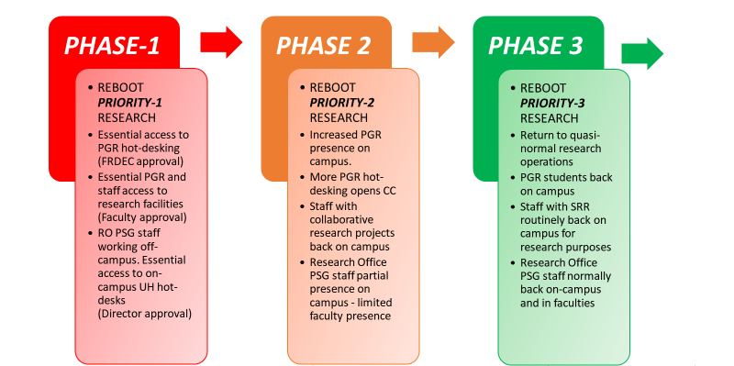
Figure 1: Phased Approach to Restarting Research On-Campus
While a progressive easing of on-campus restrictions on research and researchers in subsequent phases is anticipated, this is entirely dependent on the progress of the pandemic and prevailing government guidance.

Phase 1 Semester 2 Priority Access Requests
During Phase 1, only PGRs judged by the Faculty Research Degrees and Environment Committee (FRDEC) to have a Priority 1 need will be permitted to request booking of a hot-desk in the PGR hot-desking facilities or to request strictly limited and controlled access to essential on-campus research facilities.
Priority 1 is defined as:
“Situations where a PGR student is unable to continue to research off-campus due to an essential need to access specialist on-campus research facilities or for any limitations imposed by their home working environment, domestic circumstances, IT provision, mental-health or well-being”
PGR students may make an application using this form to their faculty Research Degrees and Environment Committee (FRDEC) for consideration as a Priority 1 case for a limited return to campus in Phase 1 of Semester 2.
Hot-Desk Access: Only PGR students assessed by their FRDEC as having a Priority 1 need will be able to request booking of a desk space in the PGR hot-desking facilities on City Centre and City South campuses.
Research Facilities Access: Only PGR students whose research cannot continue without access to on-campus specialist research facilities will be authorised by their FRDEC to access on-campus research facilities. This will require the approval of relevant PVC / Executive Dean and a full Health and Safety and technical assessment before access can be permitted.
IMPORTANT NOTES: Phase 1 (until mid-February 2021 at the earliest)
- The only on-campus office space accessible to PGR students will be available for Priority 1 cases only by pre-booking into C219 and SCT237.
- No general access by PGR students to IT suites or library study spaces will be allowed. Please note that the Library has currently suspended the click-and-collect service.
- No access to campus by research participants will be possible during Phase 1 and internet-mediated research should replace face to face data collection wherever possible.
- Where access for a named PGR is granted during Phase 1, it may be necessary to limit access to designated times to comply with social distancing measures and to manage demand.
- Not all research facilities may be accessible during Semester 2, for logistical, health and safety, technical or other reasons.
Once completed and endorsed by their supervisors, the application for Priority 1 access will be reviewed by the relevant FRDEC and will require further approval by the relevant PVC / Executive Dean before access to on-campus research facilities can be granted.
Priority 1 cases only will be able to request booking of a hot-desk in the PGR hot-desk provision in City Centre and City South campuses

RETURNING TO CAMPUS
Any PGRs granted Priority-1 who return to campus will need to follow the guidance on iCity concerning 2-metre social distancing and the mandatory wearing of 3-layer face covering. Furthermore, they are strongly recommended to take a laminar-flow Covid-19 test. Please refer to details of health and safety requirements here.

Please do not complete this form unless your research is reliant on access to specialist facilities and / or you are unable to continue to work from home.

Postgraduate Research Student Priority 1 Campus Access Request
Following completion of this form, your Director of Studies should email it to your local Faculty Doctoral Research College Office for review and decision by FRDEC.
Q1 | Forename
Q2 | Surname
Q3 | Student Number
Q4 | BCU Student Email Address
Q5 | Faculty
 | ADM: Arts, Design & Media inc. Royal Birmingham Conservatoire | ☐
 | BLSS: Business, Law & Social Sciences | ☐
 | CEBE: Computing, Engineering and Built Environment | ☐
 | HELS: Health, Education & Life Sciences | ☐
Q6 | Programme Type
 | PhD: Doctor of Philosophy | ☐
 | EdD: Doctor of Education | ☐
 | DBA: Doctor of Business Administration | ☐
Q7 | Mode of Study
 | Full-time | ☐
 | Part-time | ☐
 | Part-time Distance Learning | ☐
Q8 | Programme Start Date | Click or tap to enter a date.
Q9 | Current Programme End Date | Click or tap to enter a date.
Q10 | External funding | Is your research full / part funded by external sources, e.g. UKRI, business, charity, etc
 | Yes | ☐
 | No | ☐
Q11 | I have previously been granted Priority-1 access during Semester 1
 | Yes | ☐
 | No | ☐
Q12 | I am applying to FRDEC for Priority 1 during Semester 2 to access:
 | PGR Hot-Desk Booking ONLY | ☐
 | On-campus research facilities ONLY | ☐
 | BOTH PGR Hot-Desk & on-campus research facilities | ☐
Q13 | If you are requesting access to a PGR hot-desk booking, please explain why continuing to work off-campus is not possible and why you need access to PGR hot-desk booking during Semester 2.  (300 words maximum)
Q14 | If you are requesting access to on-campus research facilities, please describe the specific on-campus facilities to which you are requesting access during Semester 2. Please provide building, room designation and room number wherever possible. (300 words maximum)
Q15 | If you have completed Q14 please outline any health and safety, lone-working or control of substances hazardous to health (COSHH) considerations that will need to be met in the facilities identified in Q13 (300 words maximum)
Q16 | Director of Studies
Q17 | Supervisory Team Justification  (300 words maximum) | Your supervisory team should add their comments here. These should justify why you have an exceptional Priority 1 requirement to access PGR hot-desk and / or on-campus research facilities during Phase 1.
Q18 | Signature of Director of Studies
Q19 | Date of Meeting | Click or tap to enter a date.
Q20 | Applicant Declaration | ☐ I confirm that the information I have provided in this form and which I shared with my supervisors is true to the best of my knowledge.
 | Applicant Signature
 | Date submitted by applicant | Click or tap to enter a date.
Q21 | Date considered by FRDEC | Click or tap to enter a date.
Record of FRDEC Decision
F1  F2 | FRDEC Decision Date  OUTCOME | Click or tap to enter a date.  ☐ Upheld: Priority 1 Hot-Desk booking access. Permit PGR hot-desk bookings in Phase 1  ☐ Upheld: Priority 1 Facilities access.  Consider for research facilities access Phase 1 subject to H&S and technical considerations. PVC / Exec Dean approval  ☐ Not Supported.
F3 | Justification of FRDEC decision  (300 words maximum)

