Rapid Improvement Targets (RIT) Process and Documentation
2026-2027

How to use this document:
- The first section (pages 1 – 4) outlines the RIT process so that all Associate Teachers, School Mentors and Tutors/Lead Mentors understand the process.
- The second section (pages 5-8) contain the RIT information relevant to the Associate Teacher, including their targets, reviewing of the targets and the outcomes.

Aims of the Rapid Improvement Targets Process
The Rapid Improvement Targets Process is initiated after a discussion between a School Mentor, BCU Leader Mentor and the Associate Teacher. The RIT process will ensure that all Associate Teachers are supported and offered intervention where necessary to make satisfactory progress in line with the BCU ITE Assessment Tracker.

Rapid Improvement Targets can be initiated at any stage of the ITE programme and can…
- …relate to an Associate Teacher’s engagement with, and attendance, at the taught elements of the programme.
- …be initiated if an Associate Teacher fails to demonstrate high standards of personal or professional conduct (see page 4 for examples).
- …relate to specific aspects of the Associate Teacher’s teaching practice and preparation and be characterised by a lack of expected pupil progress (see page 4 for examples).
- …identify gaps in performance aligned against the BCU ITE Assessment Tracker and/ or the Initial Teacher Training and Early Career Framework (DfE, 2024).
- …be initiated if Associate Teacher’s teaching, for any reason, is not developing as expected; for example, if an Associate Teacher ‘plateaus’ and there is no evidence of further progress or development in the impact of their teaching.
- …be initiated if Associate Teacher has not received the necessary support from the placement school, at which point the University will intervene and offer additional support.
- …be initiated if an Associate Teacher needs support with well-being or workload management.

Rapid Improvement Targets can be initiated by either a School Mentor or a BCU Lead Mentor. Subject Mentors, Class Teachers and Professional Mentors can and should raise concerns aligned to the process with the BCU Lead Mentor and will share specific areas of weakness ahead of any formal meeting. Associate Teachers should be given the opportunity to informally address any concerns raised before the RIT process is initiated.

Rapid Improvement Targets will:
- outline the concerns,
- set clearly articulated and precise targets aligned to the BCU ITE Curriculum,
- outline concrete actions for the Associate Teacher to achieve,
- identify which stakeholder is responsible for monitoring each target,
- identify intervention strategies,
- signpost training needs,
- explain existing support strategies, and
- agree review deadlines.

In Rapid Improvement Target meetings:
- the Associate Teacher must attend
- the Subject Mentor / Class Teacher and/or Professional Mentor will attend
- the process will be overseen by the BCU Lead Mentor responsible for quality assuring the Associate Teacher’s progress, with support from school mentors in helping to monitor the targets.

The Rapid Improvement Target Process is an intervention strategy and will result in an agreed increase in school and / or University support and monitoring to ensure the Associate Teacher has an opportunity to address the targets requiring immediate action.

If a placement breaks down within a RIT period the BCU Tutor or Lead Mentor will be required to complete the RIT review and the Placement Review Process.

Rapid Improvement Target Process
The Rapid Improvement Target Process (RIT) has been simplified into a flow chart and can be found on the next page:

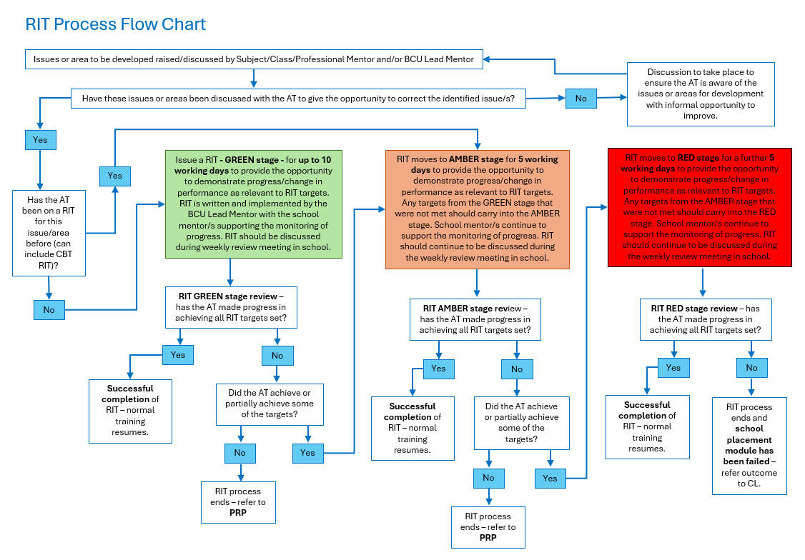

Please note, as per the flow chart above, if an Associate Teacher is going through a RIT process for the second time and the concerns raised are based around the same BCU ITE Curriculum themes from a previous RIT, the Associate Teacher will begin their second RIT from Stage Amber. If an Associate Teacher is going through a RIT for the third time and the concerns raised are the same curriculum themes from a previous RIT, the Associate Teacher will begin their third RIT from Stage Red.
Examples:

Rapid Improvement Targets will be issued when:
- An Associate Teacher does not make the expected progress – e.g.:
  - Not establishing purposeful learning relationships with pupils
  - Not using Behaviour for Learning policy appropriately
  - Inadequate subject knowledge
  - Inadequate pedagogical knowledge
  - Inadequate lesson planning practices
  - Inadequate resource creation within teaching contexts
  - Poor pace within a lesson
  - Inadequate assessment practices
  - Failure to use pupil data appropriately to plan lessons
  - Failure to adapt school lesson plans to meet the needs of pupils in their classroom
  - Insufficient knowledge of adaptive teaching strategies

- An Associate Teacher fails to demonstrate high standards of personal and professional conduct - e.g.:
  - Poor punctuality
  - Poor attendance
  - Inability to use identified absence procedures appropriately
  - Unprofessional dress
  - Failure to engage in set independent learning tasks
  - Plagiarism
  - Inability to meet deadlines aligned to BCU ITE expectations – such as submitting lesson plans 48 working hours ahead of lessons to be observed
  - Failure to complete set tasks within the course – such as Progress Journal completion and meeting assignment deadlines
  - Failure to respond to feedback from expert colleagues
  - Disrespectful behaviour in any training context
  - Discriminatory comments in any training context
  - Poor email communication etiquette
  - Poor organisation which impacts on personal and pupils’ progress

RIT Overview
Associate Teacher Name: | Placement School: |  | ITE Course and Placement/Phase: | Date:
 |  |  | Choose an item. | Click or tap to enter a date.
Person completing form: | Role of person completing form: | School Mentors (identify the mentors in school supporting the AT):
Please use this section to highlight which are the most significant BCU ITE Curriculum areas of concern:
- Associate Teacher uses critical enquiry and research informed practice to develop their understanding of effective teaching and learning.
- Associate Teacher’s classroom practice establishes effective behaviour management using high expectations and awareness of pupil wellbeing.
- Associate Teacher knows more, remembers more, and applies subject knowledge and subject specific pedagogy to impact on pupils’ progress.
- Associate Teacher uses knowledge about how pupils learn to plan and assess learning to ensure that all pupils make progress.
- Associate Teacher implements effective adaptive teaching approaches to meet all learners’ needs, including SEND (Special Educational Needs and Disability) and EAL (English as an Additional Language) learners.
- Associate Teacher demonstrates professional behaviours and contributes effectively to the wider life of the school.

RIT GREEN Stage – up to 10 working days
GREEN Stage start date: | Click or tap to enter a date. | GREEN Stage review date: | Click or tap to enter a date.

Relevant BCU ITE Curriculum Theme Linked to Target | SMART Target: |  | Identified strategies to support the Associate Teacher: | Actions to achieve: | Person responsible to support and monitor target: | Progress review outcome for target:
Choose an item. |  |  |  |  |  | Choose an item.
Choose an item. |  |  |  |  |  | Choose an item.
Choose an item. |  |  |  |  |  | Choose an item.
RIT GREEN Stage Review Meeting Discussion:
Confirmation of those in attendance for RIT GREEN Stage Review Meeting:
Review Meeting Outcome: |  | Choose an item.
Date of Review Meeting: |  | Click or tap to enter a date.

RIT AMBER Stage – 5 working days
The AMBER Stage should only be initiated if targets were partially achieved at the GREEN Stage. The same targets should be in place from the GREEN Stage but the identified strategies and actions can be updated and reviewed for the AMBER Stage.
AMBER Stage start date: | Click or tap to enter a date. | AMBER Stage review date: | Click or tap to enter a date.

Relevant BCU ITE Curriculum Theme Linked to Target | SMART Target: |  | Identified strategies to support the Associate Teacher: | Actions to achieve: | Person responsible to support and monitor target: | Progress review outcome for target:
Choose an item. |  |  |  |  |  | Choose an item.
Choose an item. |  |  |  |  |  | Choose an item.
Choose an item. |  |  |  |  |  | Choose an item.
RIT AMBER Stage Review Meeting Discussion:
Confirmation of those in attendance for RIT AMBER Stage Review Meeting:
Review Meeting Outcome: |  | Choose an item.
Date of Review Meeting: |  | Click or tap to enter a date.

RIT RED Stage – 5 working days
The RED Stage should only be initiated if targets were partially achieved at the AMBER Stage. The same targets should be in place from the AMBER Stage but the identified strategies and actions can be updated and reviewed for the RED Stage.
RED Stage start date: | Click or tap to enter a date. | RED Stage review date: | Click or tap to enter a date.

Relevant BCU ITE Curriculum Theme Linked to Target | SMART Target: |  | Identified strategies to support the Associate Teacher: | Actions to achieve: | Person responsible to support and monitor target: | Progress review outcome for target:
Choose an item. |  |  |  |  |  | Choose an item.
Choose an item. |  |  |  |  |  | Choose an item.
Choose an item. |  |  |  |  |  | Choose an item.
RIT RED Stage Review Meeting Discussion:
Confirmation of those in attendance for RIT RED Stage Review Meeting:
Review Meeting Outcome: |  | Choose an item.
Date of Review Meeting: |  | Click or tap to enter a date.

