Summary of Workshops

Overall Thoughts
The theme of improving information exchange in order to maximise decision making seemed a key issue across all workshop discussions.
The issue of defining the right level of decision making was key and recognition that local was conditional on working with and between other levels.
One final contribution was powerful in suggesting that people generally did not understand sufficiently the rural urban fringe as a space in its own right which created difficulties in identifying suitable mechanisms to solve the problems. Indeed one response indeed questioned whether there actually a problem with the RUF and the extent to which it currently served well its current function.
Collectively this suggests the need for a more effective piece and research that uncovers the nature and issues within the fringe.
Is there a role for the WMRAF in leading this debate given the range and scale of interests involved.

Question 1 How can we best use Green belt and other policy tools to protect the RUF against undesirable development while allowing diversification that can benefit the public as well as farmers.
Suggested answers collected from all attendees
- In 1938 when my family moved to our farm it was not on the RUF. The RUF came to us.
- Define undesirable uses. Who decides this? Where else can they go (e.g. sewage works are essential uses) Need to be clear on options/alternatives and mitigation and what we need to protect and why
- Is the development intrinsically undesirable or is it a function of the RUF that makes it undesirable
- Planners need to avoid being overly influenced by NIMBYism
- Development allowed where local stakeholders and community support is evident and benefits to local community made clear
- Abandon designations
- Farmers, rural residents and parish councils should be involved in the forward planning process
- Preferential targeting of stewards hip schemes into green belt areas
- Current planning restrictions in green belt can and do affect the ability of farmers to make a viable living in a very difficult environment. Sensitive diversification needs to be encouraged
- Need to have reform of green belt policy so RUF does not become stagnated. Allow a bottom up approach to development in these areas.

Summary of discussion

- The role of the green belt in the RUF
- There was concern that we should look at the whole fringe and not just ‘bits’ within it. The green belt receives attention but there is the wider buffer zone which perhaps needed clearer identification in policy. The idea was advanced of a SPZ but was rejected.
- The public understand the green belt but in many ways that understanding is based on outdated ideas and a strictly preservationist ethic. This raises real issues with community referendums and could fossilise large amounts of land which by definition is not sustainable.
- Concern expressed about the way planning uses a one size fits all approach to green belt policy given the diversity and challenges across the GB area.
- Examples given of farmyards seen as green field and sustainable developments refused simply due to green belt location
- Agreed that there was a need for adaptation and change based on a clearer understanding and better evidence of contemporary pressures, trends and impacts
- Important that there is an informed debate to consider the purposes in light of emerging evidence. Need to get away from a one size fits all.
- This draws on a participative approach to strategic planning here. Whilst idea of abandoning designations was deemed unworkable the idea of flexibility for local circumstances was deemed useful.
- It was felt that too many agri environment schemes needed to build on farmer –resident exchange in the RUF. Here the adopt a farmer scheme was seen as one way to build bridge and understanding through a whole series of events.
- The agri-environment schemes could be adapted to allow for more resident use of farmland for growing local food etc. This would reinforce the partnership idea and improve awareness and community support. However this could also be extended to other community activities and uses subject to individual circumstances.
- The situation with a farm shop was used as an example to illustrate that under new community referendums the developments of a cafe and extra business development might had been resisted but actually now that these developments were thee they were really appreciated and used by the local community. Key issue is to develop tools that allow people to see the impact of change in a place covering economic, social and environmental aspects.

Suggested mechanisms

Is there scope for more locally led identification of valued green space incorporating stakeholders rather than top down designations? This can stem from parish plans or forthcoming neighbourhood plans maybe?

Adopt a farmer scheme

The use of agreements to reward farmers for opening up their land for wider community uses (including growing food)

Clear participative review of green belt and how it should adapted to be a more resilient tool.

- Undesirable uses
- The question of what is meant by the term ‘undesirable’ was key and in particular who actually defines something as undesirable and how that might differ according to different publics. The current agenda would lead to many areas rejecting such undesirable uses based on community support. The idea of incentivising such developments was discussed but no clear mechanisms identified.
- The political dimension of this made life difficult. A councillor had a duty of responsibility to the electorate whilst the planner could operate in a freer mode. This difference created a tension at times and made decision making overtly political. Are these the best long term decisions?
- The key issue of level was raised as it was clear that certain items of infrastructure had to be delivered through government and that this could not/should not be left to community levels. This led to the proposition that clear boundaries needed to be identified within which communities operated and made decisions. These levels were currently unclear with the perception that if everything went down to the community level alone there would be a real problem.
- The need for proper identification of levels and decision making was key set within the need to provide clear, factual information that enabled people to make good decisions.
- The need to have more joined up policy decisions was highlighted building on virtuous circles. For example a biomass plant could be to an anaerobic digester and other developments which maximised the development in a particular place. This was not universally supported but the principle of multifunctionality was wherever possible.
- The issue of looking at effective incentivising was also seen as key
- The importance of following a plan-led culture was seen as important here as it prevented a simple nimby approach being taken. This could equally apply to neighbourhood plans or the new local development plans. It was questioned the extent to which we were and had actually used a plan-led approach as the rhetoric suggested.
- The issue of involving local stakeholders was seen as key with the emphasis being on strategic planning. Yet there were limited ideas identified as suitable mechanisms. One view argued that parish councils might be a useful bridging agency.

Suggested mechanisms
Could communities/neighbourhoods be given the concept of participatory planning whereby they had to have in their areas a range of essential uses. In this way the community could not just dump them on other areas. Not suggested in seminar but a possible idea?
Developing a sound evidence base and information to improve decision making at the appropriate level.
The more rigid focus on adopting a plan led culture in order to prevent ad hoc planning decisions
- Other issues
- The group stressed the overall importance of providing and using good information about what was going on. Too many debates were informed on emotion and limited understandings of all the issues and implications.
- The need for greater farmer resident interaction was a common theme and in particular the opportunities for diversification were seen as good in the RUF if each case was considered on its sustainability credentials. Here the idea of a blanket restrictive policy was seen as an anathema to the further development of the RUF as a place in its own right.

Question 2 How do we bring together the people involved in the RUF so that we can get a meaningful and long term solution?

Suggested answers collected from all attendees

- Use community led planning mechanisms to engage local stakeholders in identifying spatial planning priorities.
- The local community need to be part of the solution when developing new areas. There needs to be a bottom-up approach encouraging people to get involved. Local people need to know that their ideas matter.
- Work through local schools, involving a cross section of the community.
- Collate examples of good/innovative planning and management of the RUF and sue this as a catalyst to bring stakeholders and communities together.
- Adopt a farmer scheme.
- Better or more coherent parish planning.
- Exchange best practise through PURPLE network and EU funding.
- Strict application and enforcement of planning laws within the Green Belt to prevent speculative land ownerships.
- Bring together economic interdependencies across the RUF as much as possible – jobs, produce, markets, workforce, services, and increase the understanding of these interdependencies.
- Communities/councils should consider renting fringe areas for amenity use.

Summary of discussion

- Planning
- Often planners will agree a concept, but don’t deal with the detail and the interlocking pieces – e.g. fragmentation caused by roads.
- Community led planning within the RUF is ill-defined. Communities can produce their own plans for their places, but they’re impacted by higher authorities. Increasing necessity for parish and town councils to work together and across different scales. No real mechanisms for this.

- Functions and perceptions of the RUF
- Transition or boundary space.
- Parish councils and vocal community members in local RUFs would regard themselves as rural, and don’t want development – defence of rurality. Need to unpack and challenge notions of rurality and what they mean and look at needs
- So is it rural, is it urban? Is it a problem? And if yes who is currently defining the problem and who is managing it? And who is excluded?
- Opposing perceptions: dormitory villages for middle classes working in Birmingham wanting a country home, vs people who are part of the working countryside.
- Constraints upon farmers – rural economy needs more flexibility in the planning system.
- Threat of vandalism for farmers, vs opportunities for play for community members.
- Place for jobs? Unemployed vs conservationist.
- A contested resource, what is the RUFs function? Recreation agricultural or both?
- Who are the community?
- ‘Community’ means all things to all men; sociological/geographic/legal communities, communities of interest.
- Problem of power concentrating in the hands of unelected people.
- Problems of ownership – farmers, corporations, speculators, multiple ownership of land as it is let and sublet and sublet again.

Possible mechanisms (some editorial license used here )

Need for groups across the hierarchy of levels to co-operate. Is the WMRAF a useful body to capture this range of levels?

Need for examples of good practice to show the way forward here.
Improve the quality of debate about rurality and what it means in contemporary England

Improve the linkages between farmers and residents through changes to existing agri-environment schemes allowing more recreation and education activities.

Improving decision making for the sustainable management of the rural-urban fringe
Notes from group work - Question 3
Given the change in planning how can we ensure the community and economic benefits associated with high quality environments are given appropriate weight in land use decisions?
Suggested answers collected from all attendees (similar answers have been grouped)
- There will be a ‘presumption in favour of sustainable development’, so;
  - Essential to argue our definition of ‘sustainable’ development, and
  - Essential that local community economies and environmental benefits are protected in local plans.
- When the public purse is being used to develop the fringe, fragmentation occurs as money saving measures cut lanes and reduces bridges, separate parishes and communities thereby creating fragmentation.
- We all need to understand each other better – public need to understand where farmers are coming from and vice versa and the public need to understand where planners are coming from and vice versa.
- Local Authorities and Parish/Town Councils need to be involved in planning of problem areas.
- Ensure communities and local wildlife groups work with councils
- Community land trusts take over all RUF and then you get buy-in from communities. Issue of community management and ownership is a powerful mobilising force.
- Consultation with communities, TPC’s and partners, under new ideas - neighbourhood plans will need to be taken into account.
- Positive Local Authority support for acceptable and legal uses of green belt.
- Long term (100 years plus) strategic planning is essential; yet little discussion on how this might be achieved.
- More emphasis on green infrastructure planning in National Planning Policy Statements. Strategic Green Infrastructure modelling at regional level. Here Green infrastructure plans for “landscape-scale” areas i.e. crossing administrative boundaries.
- Use of best practice exemplars: In the West Midlands two “flagship” projects highlighted:
  - Green Arc Partnership – a series of projects mitigating the impact of the M6 Toll construction and surrounding land use
  - National Forest – 200 square miles encompassing many RUF communities
- Ensure that evidence on the cultural ecosystem services of the urban fringe is valued and utilised in land use decision making.
- Parish councils will play an important mediation role in the new planning system, skills training and a recognised evidence base will be important to allow them to do this effectively.

Key notes taken during the discussion;
- The importance of informed decision making was stressed, to inform this an evidence base is required. Evidence bases exist at national and local level, however at local level there are inconsistencies and little overall coordination. The cultural dimension is difficult to assess.
- Economic values are difficult to assess but also critical. How do we assess Local vs. National e.g. TESCO superstore vs. The local corner shop.
  - Advantage West Midlands have attempted to do this as part of their Regional Economic Strategy and there is potential for this to be similarly applied to RUF
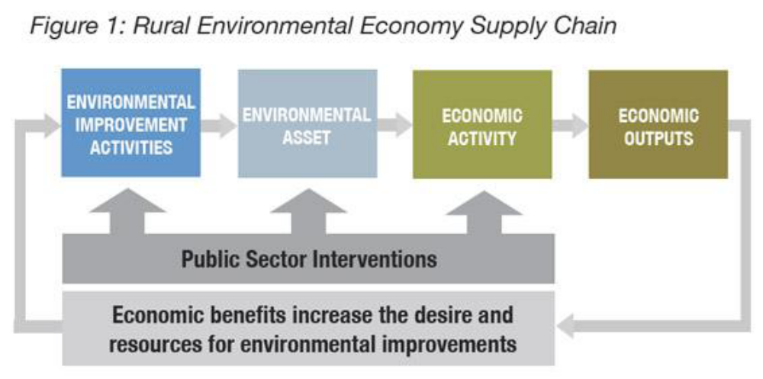
Image supplied courtesy of Sarah Roberts WMRA

- CPRE lobbies the case for no urban sprawl, Greenfield land should be retained and urban expansion should jump the gap and create a new settlement.
- Enforcement measures by local councils are critical in ensuring development is correctly managed. The RUF may benefit if tighter enforcement occurred there.
- The importance of Green Infrastructure was mentioned, there is a potential for LEP’s to cross traditional sectoral boundaries (Parish, Town and County Council) to ensure the GI principles are used on a significant scale, but knowledge of the principals is essential for this to occur.
- LEP’s could be too economically focussed (there is a danger of this creating a ghettoisation), perhaps a Local Environment Partnerships should run alongside.
- Planners could be too focussed on development; the need for a greater knowledge/input in to cultural and economic factors is required.
- Need for skills training and capacity building amongst policy and decision makers at all levels

Suggested mechanisms
Potential for an evidence base, or criteria for evidence bases to inform a local level
Improved mechanisms for understanding and undertaking information exchange not just consultation.
A need for examples of good practice to show the way forward.
Skills training and capacity building amongst policy and decision makers at all levels, particularly given the growing importance of local and parish councils.

