SafeZone App – How to Guide
SafeZone app is a free, location-based safety app that students and staff can download to connect directly with the Security team. It enables them to quickly request emergency, first aid and non-urgent assistance easily via the app.

Contacting Security
There are 3 main buttons for contacting Security.
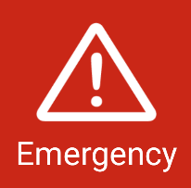 | Press Emergency, for when you need urgent assistance or feel threatened. The Security team will contact you either by mobile or chat within the app to find out more details.
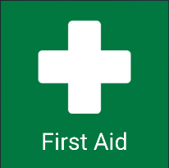 | Press First Aid, for when you need medical assistance.  The Security team will contact you either by mobile or chat within the app to find out more details.
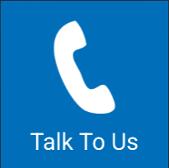 | Press Talk to Us, for when you need non-emergency assistance.  You will have option to Call Security.

Cancelling an Alert
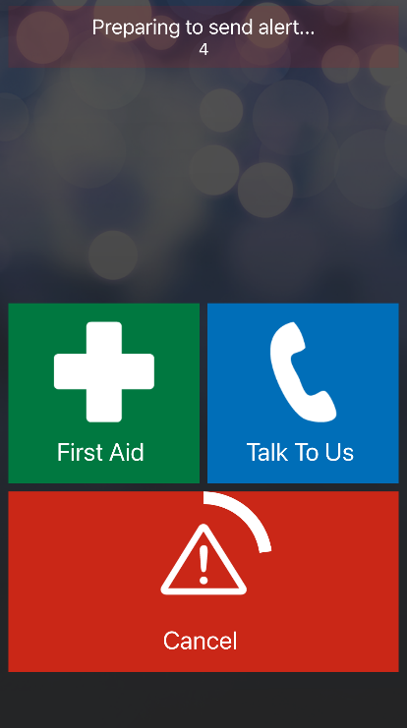 | If you accidently raise an alert, you will have 5 seconds to Cancel and there will be a message showing the countdown time.  To cancel an alert, Press Cancel.

Options after raising an Alert
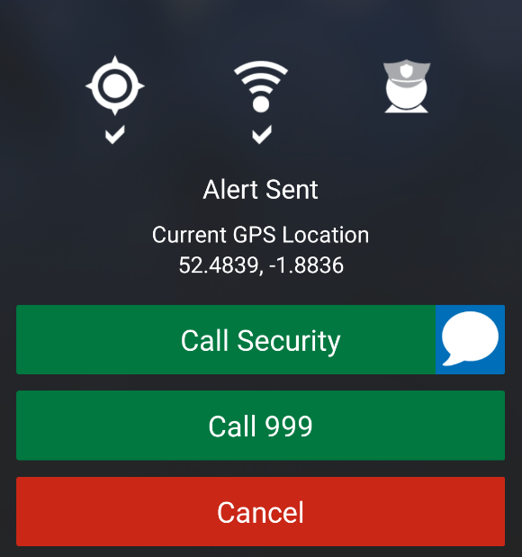
When you raise an alert, it will show Alert Sent and give you several options.
It will also show your Current GPS Location.

Press Call Security
OR Press Chat, if you want to send a message to Security team.

Press Call 999 for emergency services outside of BCU.

Press Cancel, if you accidently raised an alert.

Alert Notifications
There are notifications within the SafeZone app to make you aware of the status of your alert.
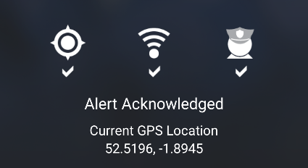 | Alert Acknowledged means your alert has been received by the Security team.
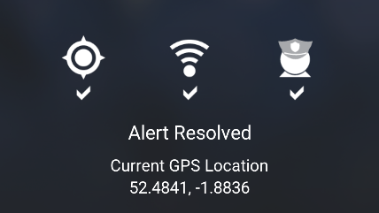 | Alert Resolved means your alert has been resolved by the Security team.
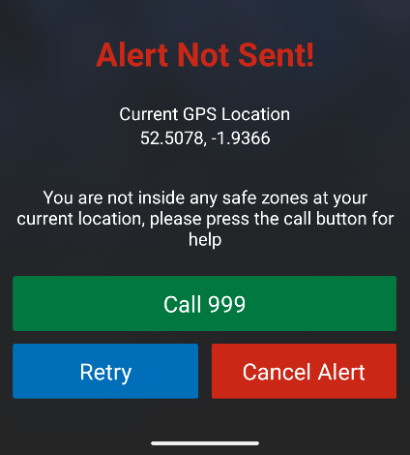 | Alert Not Sent means your alert has not been sent to the Security team.  Note: You cannot send alerts outside of BCU SafeZone locations.  There are several options available when you cannot send an alert:  - Call 999 to contact Emergency Services.  - Retry to try again in case of signal issues.  - Cancel Alert if you no longer want to raise an alert.

Other Useful Features
At the top of the SafeZone app there are further features that are available:
- Non-Urgent Reporting
- Check In Timer
- Check In

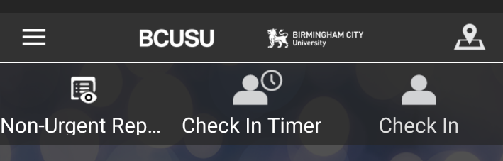

Non-Urgent Reporting
This allows you to inform Security of something you want to report, for example, suspicious activity, theft. When a non-urgent report is sent it raises an alert with the BCU Security team and they will contact you.
You can also raise a Non-Urgent Report anonymously if you wish to make Security aware of something, but do not want to be identified.

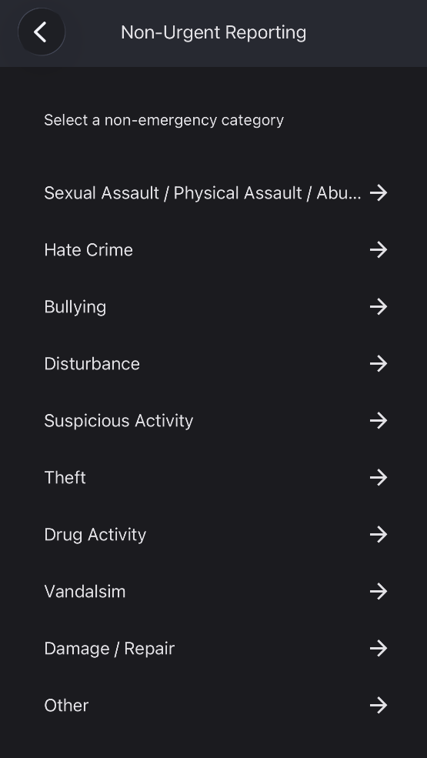 | To raise a non-urgent report, select Non-Urgent Reporting.  Choose one of the options from the drop-down menu.  - Sexual Assault / Physical Abuse / Abuse  - Hate Crime  - Bullying  - Disturbance  - Suspicious Activity  - Theft  - Drug Activity  - Vandalism  - Damage / Repair  - Other
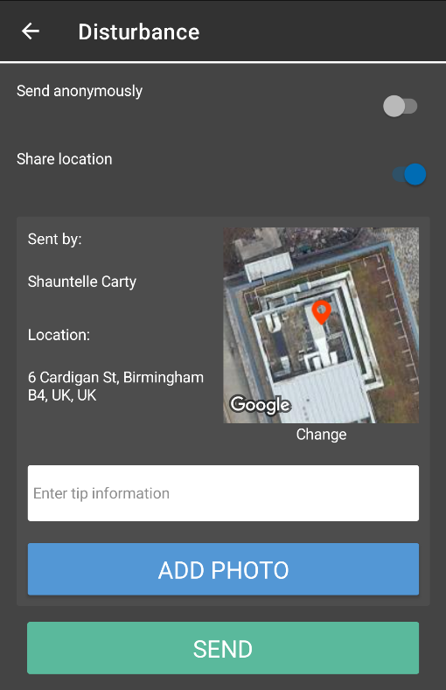 | You will then see the options:  - Send anonymously (This is switched off by default, so you will need to switch on if you wish to send anonymously)  - Share location (This is switched on by default, so you will need to switch off if you do not want to share your location)  Enter tip information in the field box.  You also have the option Add Photo.  Click Send, to share information with Security.

Check In
The Check In feature can be used to make Security aware of your location when you are on campus. When used it does not raise an alert with BCU Security team.
The Check In feature is not available outside of SafeZone designated areas. If you try and check in outside of a SafeZone area, you receive a message saying No Check In.
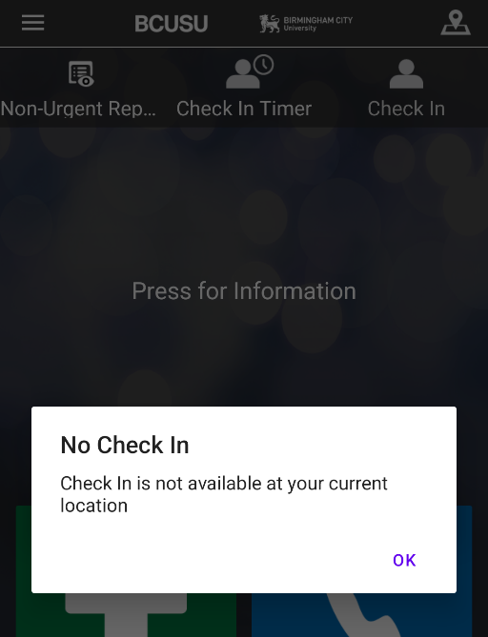

Check In Timer
The Check in Timer allows you to put a timer on if you are in high-risk working areas. An automatic emergency alert is raised with BCU Security team when the timer runs out before it is cancelled.
You can set a timer for up to 24 hours in advance.
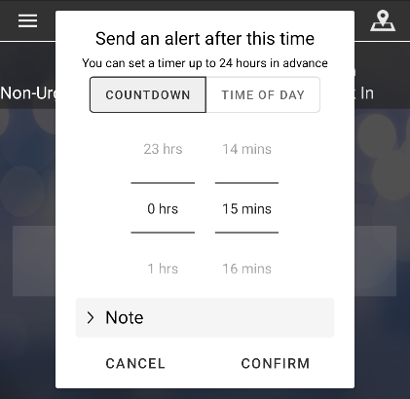  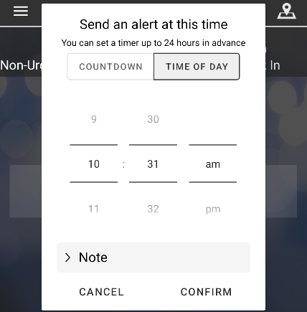 | To use the Check In Timer, select Check In Timer.  You will be given two timer setting options:  - Count Down allows you to set the timer to count down after a set period within 24 hours window.  - Time of Day allows you to set the timer for a specific time during the day.  You can also add a Note, for example, the exact location and nature of work.  Click Confirm to start the timer.

SafeZone Alliance
The SafeZone Alliance consists of organisations that have partnered to provide mutual safety support via the SafeZone app to students and staff when they are working remotely, traveling, or visiting member institutions.
Birmingham City University is a member of the SafeZone Alliance, so BCU students and staff have the option to sign up to be receive support from SafeZone Alliance partners.

How to Sign Up
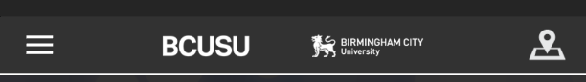 | Open to the SafeZone App  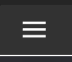  Select the menu option at the top left-hand side of the app screen.
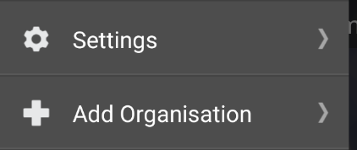 | Select Add Organisation
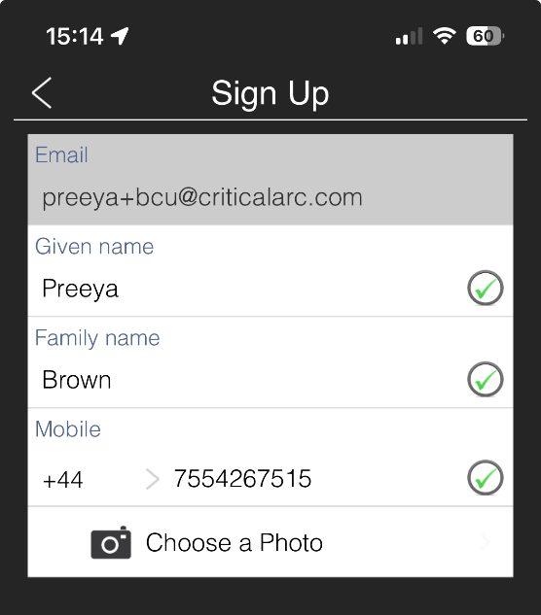 | Complete the mandatory Sign Up fields:  - Given Name  - Family name  - Mobile  Adding a photo is optional.  - Click Choose a Photo, if you wish to upload and add a photo to your profile.
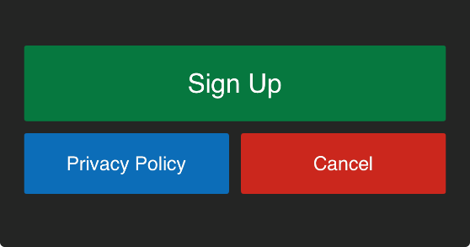 | You can view and read the Privacy Policy.  Once you are ready to sign up, click Sign Up.  If you no longer wish to sign up, click Cancel.

Settings
To view Settings and other options within the SafeZone app
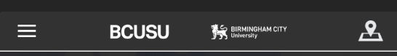 | Open to the SafeZone App  Select the menu option
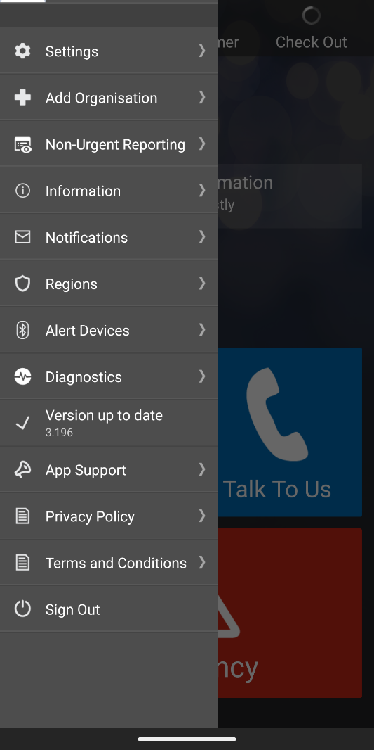 | You will see several options:  - Settings  - Add Organisation  - Non-Urgent reporting  - Information  - Notifications  - Regions  - Alert Devices  - Diagnostics  - Version up to date  - App Support  - Privacy Policy  - Terms & Conditions  - Sign Out  To sign out of the SafeZone app, go to menu option and select Sign Out.

Further Information
Please visit SafeZone App : Birmingham City University for further information and FAQs

