
UG Secondary Physical Education with QTS
Year 1 - Placement Assessment Document 1
Know and understand the professional responsibilities of a teacher

Associate Teacher Name:
Associate Teacher’s Subject:

How to use your Placement Assessment Document (PAD)
Your placement for school-based training 1 is split up into two halves, and you will have one PAD per half of your placement. Your PAD should be stored in your OneDrive during your placement and then uploaded to the relevant submission point in Moodle at the end of the placement.
Your PAD will be used and updated weekly to capture the targets you have been set for your professional practice in school as well as your own reflections of your progress. Any boxes that you type in on the PAD will expand so please do not limit your responses to the size of the box.
The PAD is chronologically organised to guide you through each phase and PADs will include the following as relevant to each Phase:
- Phase attendance log
- Pen Portrait – PAD1 only.
- Reflection on your module learning and how you intend to apply this into your school-based training.
- Reflection and Progress Meeting Records (meetings with your mentor).
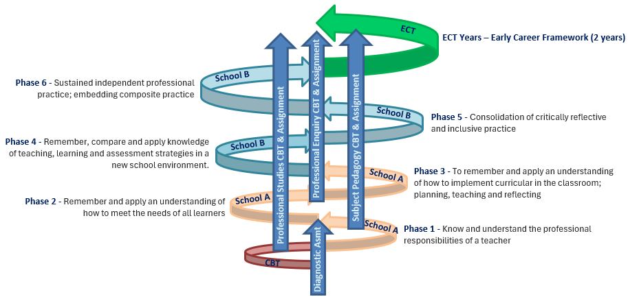
- ITaPs (Intensive Training and Practice) week critical reflections
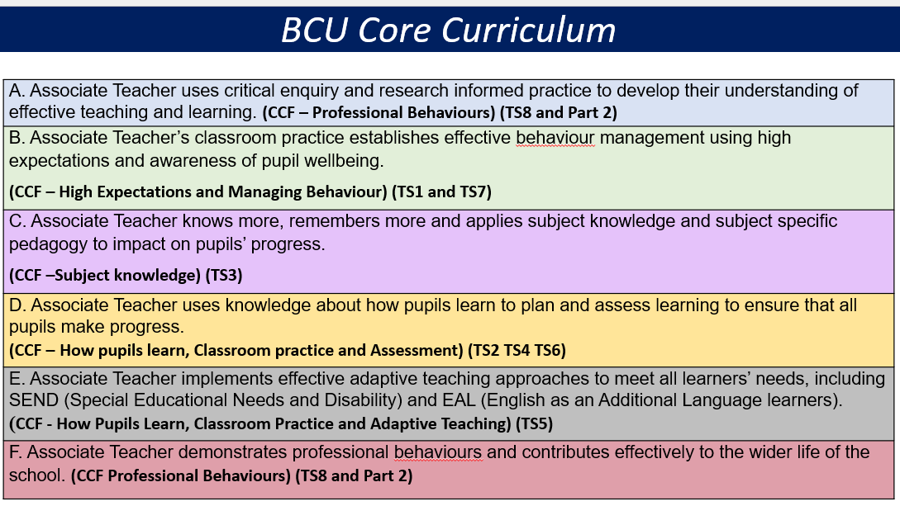

Placement 1 Attendance Log
You must keep your attendance log up to date to reflect your attendance to School-Based Training (placement).

Key for completion of log: Example:
Present | / or \
Absent | O
Attendance not required | X
Week beginning | Monday |  | Tuesday |  | Wednesday |  | Thursday |  | Friday
Week beginning | am | pm | am | pm | am | pm | am | pm | am | pm
9th September | / | \ | / | \ | / | \ | o | o | / | \
16th September | / | \ | / | \ | / | \ | / | \ | X | X

Week beginning | Monday |  | Tuesday |  | Wednesday |  | Thursday |  | Friday
Week beginning | am | pm | am | pm | am | pm | am | pm | am | pm
11th November
25th November
2nd December
9th December
16th December
6th January
13th January

Total half days present for this phase:
Total half days absent for this phase:

Lead Mentor confirmation of accuracy of attendance record: [Name/Signature/Date]
School Mentor (SM or PM) confirmation of accuracy of attendance record: [Name/Signature/Date]

Associate Teacher Pen Portrait
This pen portrait is completed at the start of your UG Secondary Education course and will be seen by your Lead Mentor and School Mentors. The pen portrait is a helpful way to introduce yourself to your placement school and will support with the writing of your reference at the end of the course.
Photo
Please upload your ID card photo from Moodle before your PAD is shared with your school placement
Associate Teacher Name:
Specialist Subject:
Previous Education Institution:
Other qualifications (include academic and other relevant qualifications, e.g. first aid)

Previous relevant experience (classroom experience, employment, leading, teaching, coaching, etc.):
Areas of subject expertise or strength (base this on your qualifications and subject knowledge audit):
Other relevant information (interests, other skills, anything that might be helpful for school placements to know):
Areas for particular support or consideration:
Associate Teachers are invited to note down any areas where they feel they would benefit from particular help and support from mentors in school. For example:
- specific help with aspects of spoken or written English for Associate Teachers with English as an additional language
- specific input on educational culture, climate or systems for Associate Teachers whose own education was outside England or Wales or on exam systems
- a request for the opportunity for religious observance where possible (maximum of two days) (http://www.bbc.co.uk/religion/tools/calendar/
Early identified areas for development – Subject (based this on your qualifications and subject knowledge audit. Aim for three areas that need to be prioritised:
1)
2)
3)
Early identified areas for development – The BCU ITE Curriculum - Rank the six curriculum themes below from 1 to 6 with 1 being your most confident area based on your previous experience and 6 being your least confident area.

BCU ITE Curriculum Themes | Rank from 1 to 6 with 1 = most confident and 6 = least confident
- Critical enquiry and research-informed practice
- Behaviour and wellbeing
- Subject knowledge and subject pedagogy
- Planning and assessment
- Adaptive teaching
- Professional behaviours
For the Theme that you identified as ‘6’ (i.e. the least confident), specify 3 aspects of this theme that you think you will need the most support within your early stages of the course:
1)
2)
3)

Module: EDU4169 The Emerging Teacher
Reflection and Progress Record (CBT)
Reflect upon your own learning for this module to date and set your own targets for school based training. You may want to use the Curriculum Map and resources on Moodle to help you.
Associate Teacher Reflection
Key learning points from taught sessions during this module so far (please refer to specific sessions):

Key learning points from your reading and research during this module (please refer to specific literature and research):

How do you intend to apply the content learnt on this module within your teaching practice in Phase 1 of your placement?

Module: EDU4171 Introduction to Secondary PE
Reflection and Progress Record (CBT)
Reflect upon your own learning for this module to date and set your own targets for school based training. You may want to use the Curriculum Map and resources on Moodle to help you.
Associate Teacher Reflection
Key learning points from taught sessions during this module so far (please refer to specific sessions):

Key learning points from your reading and research during this module (please refer to specific literature and research):

How do you intend to apply the content learnt on this module within your teaching practice in Phase 1 of your placement?

Module: EDU4172 The Physically Educated Child
Reflection and Progress Record (CBT)
Reflect upon your own learning for this module to date and set your own targets for school based training. You may want to use the Curriculum Map and resources on Moodle to help you.
Associate Teacher Reflection
Key learning points from taught sessions during this module so far (please refer to specific sessions):

Key learning points from your reading and research during this module (please refer to specific literature and research):

How do you intend to apply the content learnt on this module within your teaching practice in Phase 1 of your placement?

Day 4: Monday 9th December 2024
Reflection and Progress Meeting Record (SBT)
Alongside this document use the Assessment Tracker and recent LORs to inform targets. AT to complete sections 1 and 2 prior to the meeting with the Mentor. Mentor and AT to complete the targets in sections 3 & 4 together.
- Associate Teacher’s reflection of key learning this from Day 1 to Day 4:
Key learning linked to the subject curriculum map activities (please reflect on the directed activities for this window):

Key learning from School-Based Training this week (this can include CPD and other training and support you have received in school):

- Associate Teacher’s observation of an expert colleague during this window:
Subject: | Class:
Identify the focus area you observed: | How did this focus aligned to last week’s target/s?:
What notable teaching and learning strategies, related to your target/s, did the teacher use?

I have learnt that: | I have learnt how to:

- Previous targets
Target No. | BCU ITE Curriculum Theme (A-F) | Previous target | Review of this target (highlight as appropriate) |  |  | Reflections and evidence in relation to each target (completed by Mentor & AT together)
1 |  |  | Not achieved (carry forward – see below) | Partially achieved (carry forward – see below) | Achieved
2 |  |  | Not achieved (carry forward – see below) | Partially achieved (carry forward – see below) | Achieved
3 |  |  | Not achieved (carry forward – see below) | Partially achieved (carry forward – see below) | Achieved

- New/updated targets
Previous targets not achieved or partially achieved should be carried forward below. Partially achieved targets should be re-focused where necessary to support the AT in achieving the target in time for the next meeting.
Target No. | BCU ITE Curriculum Theme (A-F) | Subject-focused and professional targets  (use the Assessment Tracker and LORs to inform targets) | How will the target be met?
1
2
3

Date: Monday 16th and Tuesday 17th December 2024
Intensive Training and Practice (ITaP) – Critical Incident Analysis
Part A
Which ITaP are you completing?
Rules, Routines and Relationships | Language for Learning in your Subject

Based on the title of this ITaP…
…identify your strengths and/or areas of experience. | …what are you looking forward to exploring further?

Part B
What is a critical incident?
A critical incident is an event or situation within your teaching practice that forces you to reflect on what happened and your response. McAteer et al (2010, p.107) suggest that a ‘critical incident is one that challenges your own assumptions or makes you think differently’. Therefore, the critical incident you reflect upon does not necessarily need to be a ‘negative’ scenario; it could be a time when a teaching strategy worked well or had a positive impact on pupils. Alternatively, you could reflect on a time where something didn’t quite work, or your actions did not have the intended impact you desired.
Think back over your experience throughout this time of intensive training and practice and identify a memorable, surprising or interesting moment to explore further. The incident you select will become critical due to this analysis.
What was the critical incident? Prompt questions: What happened, where and when? How does this relate to the focus of this ITaP? What were your immediate thoughts and responses to the incident? (around 200 words)
Why is this incident important? Prompt questions: What research-informed strategies did you use or could you have used in response to the incident? What impact did this have on pupil engagement, behaviour or learning? What are your current thoughts about the incident, and how has this changed since it happened? (around 200 words)
How has this incident changed your practice? Prompt questions: How has your practice developed in this area of professional practice since the incident? What might you do differently if presented with the same scenario again? Think about conversations you have had, what you have experienced in school, teachers you have observed and sources you have read. What else might you do to continue to develop in this area? (around 200 words)

Part C
SMART target setting: Targets should be relevant to the focus of the ITaP, please write two targets, at least one of these to be subject based.

Specific Target  What are you aiming to change in professional practice? | Measurable  How will you measure your success in reaching this target? E.g. pupil data, evaluation, mentor feedback. | Achievable  What needs to happen for this target to be met? E.g. what support, opportunity or additional research do you need? | Relevant  How will achieving this target support your professional progress? | Time scale  Deadline by which you review whether you have met this target. E.g. in two weeks, by half term or by the end of the placement.
Date of targets being set:
SMART Target review: When you reach the deadlines set for these targets review your progress, reflecting up on the steps you have taken to develop your teaching practice and the impact this has had on pupil behaviour, engagement, and learning.

What supporting evidence do you have to demonstrate progress in this area? Learning observation records, notes from BCU sessions or School training sessions, lesson plans; resources; lesson reflections, weekly targets, assessment tracker? Please make sure that these are accessible in your OneDrive folder.

Date: Week beginning 6th January 2025
Reflection and Progress Meeting Record (SBT)
Alongside this document use the Assessment Tracker and recent LORs to inform targets. AT to complete sections 1 and 2 prior to the meeting with the Mentor. Mentor and AT to complete the targets in sections 3 & 4 together.
- Associate Teacher’s reflection of key learning this week:
Key learning from Centre-Based Training sessions this week (please refer to specific sessions, literature and research):

Key learning from School-Based Training this week (this can include CPD and other training and support you have received in school):

- Associate Teacher’s observation of an expert colleague this week:
Subject: | Class:
Identify the focus area you observed: | How did this focus aligned to last week’s target/s?:
What notable teaching and learning strategies, related to your target/s, did the teacher use?

I have learnt that: | I have learnt how to:

- Previous targets
Target No. | BCU ITE Curriculum Theme (A-F) | Previous target | Review of this target (highlight as appropriate) |  |  | Reflections and evidence in relation to each target (completed by Mentor & AT together)
1 |  |  | Not achieved (carry forward – see below) | Partially achieved (carry forward – see below) | Achieved
2 |  |  | Not achieved (carry forward – see below) | Partially achieved (carry forward – see below) | Achieved
3 |  |  | Not achieved (carry forward – see below) | Partially achieved (carry forward – see below) | Achieved

- New/updated targets
Previous targets not achieved or partially achieved should be carried forward below. Partially achieved targets should be re-focused where necessary to support the AT in achieving the target in time for the next meeting.
Target No. | BCU ITE Curriculum Theme (A-F) | Subject-focused and professional targets  (use the Assessment Tracker and LORs to inform targets) | How will the target be met?
1
2
3

Date: Week beginning 13th January 2025
Reflection and Progress Meeting Record (SBT)
Alongside this document use the Assessment Tracker and recent LORs to inform targets. AT to complete sections 1 and 2 prior to the meeting with the Mentor. Mentor and AT to complete the targets in sections 3 & 4 together.
- Associate Teacher’s reflection of key learning this week:
Key learning from Centre-Based Training sessions this week (please refer to specific sessions, literature and research):

Key learning from School-Based Training this week (this can include CPD and other training and support you have received in school):

- Associate Teacher’s observation of an expert colleague this week:
Subject: | Class:
Identify the focus area you observed: | How did this focus aligned to last week’s target/s?:
What notable teaching and learning strategies, related to your target/s, did the teacher use?

I have learnt that: | I have learnt how to:

- Previous targets
Target No. | BCU ITE Curriculum Theme (A-F) | Previous target | Review of this target (highlight as appropriate) |  |  | Reflections and evidence in relation to each target (completed by Mentor & AT together)
1 |  |  | Not achieved (carry forward – see below) | Partially achieved (carry forward – see below) | Achieved
2 |  |  | Not achieved (carry forward – see below) | Partially achieved (carry forward – see below) | Achieved
3 |  |  | Not achieved (carry forward – see below) | Partially achieved (carry forward – see below) | Achieved

- New/updated targets
Previous targets not achieved or partially achieved should be carried forward below. Partially achieved targets should be re-focused where necessary to support the AT in achieving the target in time for the next meeting.
Target No. | BCU ITE Curriculum Theme (A-F) | Subject-focused and professional targets  (use the Assessment Tracker and LORs to inform targets) | How will the target be met?
1
2
3

