**Secondary PGCE**

**Subject Mentor Information Pack –2021**



**Contents**

|  |  |
| --- | --- |
| **The BCU Trained Teacher** | **3.** |
| **PGCE Secondary Leadership Team and the Partnership Team** | **4** |
| **Partner School Commitments:**   * The role of the Professional Mentor * The role of the Subject Mentor | **5** |
| **PGCE Overview** | **7** |
| **School Based Training (SBT) Overview:**   * Additional SBT expectations * School based Training Progression | **8** |
| **Mentor CPD** | **12** |
| **BCU ITE Curriculum**   * BCU Core Themes * Subject Pedagogy Priorities | **13** |
| **Progress Journal** | **16** |
| **BCU Partnerships Webpages** | **17** |
| **BCU Recruitment Processes** | **18** |
| **Supporting struggling trainees:** Rapid Improvement Target process | **18** |
| **School Based Training Placement Timetable** (Core PGCE) | **19** |
| **School Based Training: Payments to Schools** (Core PGCE) | **20** |
| **Appendices** | |
| **Internal mentor Moderation form**  **Safeguarding letter (to be updated)** | **21**  **23** |
| **BCU ITE Trainee Teacher Code of Conduct (to be updated)** | **27** |
| **BCU ITE Partnership Mentoring Policy** | **28** |
| **SEND Partnership for secondary PGCE** | **29** |
| **Example Progress Journal Pages** | **36** |
| **BCU ITE Mentor Tracker** | **TBC** |
| **Aide Memoire For PGCE Professional Mentors** | **44** |
|  |  |

**The BCU Trained Teacher**

A BCU trainee teacher will have signed a commitment to uphold professional conduct when on the PGCE course – you can view this agreement online at: www.bcu.ac.uk/secondary-partnerships.

In addition, trainees will be guided throughout the BCU PGCE course to embody our four professional core values: committed, creative, confident and collaborative. As a school, supporting teacher training in partnership with BCU, you can expect to work with individuals who are:

**Committed to:**

* Being outstanding teachers
* Creating a vibrant learning environment in which all learners will thrive
* Addressing the needs of all learners and their communities
* Taking responsibility for their own professional development and learning
* Developing excellent subject and pedagogical knowledge

**Creative in:**

* Engaging, inspiring and motivating all learners
* Informing learning and teaching through research and evidence
* Overcoming disadvantage and barriers to learning
* Reflecting on the impact of their professional practice

**Confident to:**

* Act as leaders of learning
* Respond flexibly and proactively to change
* Communicate effectively with all partners in learning
* Accept responsibility and be accountable for their professional actions and decisions

**Collaborative by:**

* Understanding that authentic and effective collaboration is an essential element of professional practice
* Working effectively with expert teachers across partner organisations
* Working with peers and subject / phase experts to develop effective curricula
* Embody the ethos and vision of partner organisations in their professional role
* In-practice discourses which develop and deepen critical reflection within a community of professional learning

We believe that through these principles, which underpin our programmes, we can equip beginning teachers to be both aspirational in their professional goals and well-prepared to manage the complexity of demands faced within secondary teaching.

**Professional Expectations**

In addition to having high aspirations for BCU trained teachers, the university will ensure that all Suitability to Teach checks, safeguarding checks[1] and contracts of professional expectations[2] are confirmed upon enrolment.

**PGCE Secondary Leadership Team**

**and the Partnership Team**

|  |  |  |  |  |
| --- | --- | --- | --- | --- |
| **Name** | **Role** | | | **Contact** |
| **Kelly Davey Nicklin** | Course Lead for Secondary PGCE | | | [Kelly.DaveyNicklin@bcu.ac.uk](mailto:Kelly.DaveyNicklin@bcu.ac.uk) |
| **Fiona Darby** | Deputy PGCE Course Lead: Secondary PGCE | | | [Fiona.Darby@bcu.ac.uk](mailto:Fiona.Darby@bcu.ac.uk) |
| **Kerry Taylor** | Deputy PGCE Course Lead: Secondary PGCE | | | Kerry.Taylor@bcu.ac.uk |
| **PGCE Course Leadership Team central email address** | | pgcesecondaryslt@bcu.ac.uk | | |
| **Amanda Brougham** | Academic Lead for Secondary Partnerships | | | [Amanda.Brougham@bcu.ac.uk](mailto:Amanda.Brougham@bcu.ac.uk) |
| **Craig Davis** | Education Partnerships Lead | | | [Craig.Davis@bcu.ac.uk](mailto:Craig.Davis@bcu.ac.uk) |
| **Education Partnership central email address** | | | [Education.Partnerships@bcu.ac.u](mailto:Education.Partnerships@bcu.ac.u) | |

**Partner School Commitments:**

Schools will identify a Professional Mentor who overseas ITE trainee programmes in their school. They liaise with Departments to identify where schools have the capacity to train ITE students.

**Professional mentors will:**

* Review and adhere to the BCU Mentor Policy[3],
* Identify an experienced colleague in the trainee’s specialist subject who will be their subject mentor over the training year,
* Ensure that the BCU Partnerships Team have a current name and email address for all subject mentors working with BCU trainees,
* Prepare an induction for incoming trainees which covers Safeguarding requirements and core school policies (BfL, assessment, Teaching and Learning),
* Create a timetable for the BCU trainee in line with Phase expectations,
* Identify dates for additional SBT experience (SEND[4], Primary Experience and Post 16 experience) during the trainee’s home school placement,
* Ensure that subject mentors have a protected 1 hour slot for their mentor meetings with the trainee,
* **Complete an online Quality Assurance survey from BCU at the start of the SBT placement**
* Attend termly BCU Mentor CPD Events,
* Ensure all subject mentors attend BCU Mentor CPD Events,
* Be familiar with the BCU ITE curriculum and how it is used to assess the development of BCU trainees,
* Ensure subject mentors access and use the BCU tracker and all current BCU paperwork, to record lesson observations and assessment points
* **Quality assure all individual subject mentor observations and assessments at least once in the academic year – we suggest a paired observation or observed mentor meeting as a strategy to do this and supply a QA form to be submitted to BCU.**
* Support the trainee with any requests relating to their training and QTS evidence over their training year,
* Monitor BCU trainees’ progress termly,
* **Notify BCU PGCE Leadership Team of any well-being or performance concerns relating to their BCU trainee.**

***The BCU Partnerships Team will:***

* *Maintain contact with Professional Mentors to establish and maintain all aspects of the SBT placement,*
* *Provide effective online Mentor CPD Events,*
* *Maintain communications – including the updating resources on the BCU Partnership Webpages,*
* *Provide Professional Mentor updates on all BCU processes, or individual trainee concerns in a timely manner*
* *Manage the payments to schools process.*

**Subject mentors will:**

* Guide and support the trainee’s professional development and subject specific pedagogical knowledge in line with the BCU ITE curriculum,
* Attend termly BCU Mentor CPD and at least 2 subject mentor drop ins over the training year,
* Use the BCU Mentor Handbook as a guide to their role,
* Access PGCE paperwork related to the role from the BCU Secondary PGCE Partnership Webpages,
* Meet with the trainee for one hour a week,
* Observe the trainee teaching twice each week and provide written formative feedback,
* Review planning, Progress Journal reflections and address assessment requirements with the trainee weekly,
* Liaise with the trainee’s subject tutor – conducting joint observations and joint mentor meetings whenever possible,
* **Update the school’s professional mentor on the trainee’s progress each half term,**
* Complete formative and summative assessments aligned to the BCU ITE Curriculum.

***BCU Tutors will:***

* *Maintain contact with the subject mentor and discuss any issues regarding SBT in a timely manner,*
* *Organise face to face and online visits to school, and maintain an email link with subject mentors,*
* *Develop a good working relationship with the trainee and subject mentor,*
* *Signpost all BCU Mentor CPD Events and subject mentor drop-in sessions to support mentors’ practice,*
* *Confirm that times for the Weekly Professional Development Discussions have been negotiated,*
* *Confirm that there is a schedule of formal observations of the trainee’s teaching carried out by the subject mentor,*
* *Guide trainees and mentors through the ITE Core Curriculum delivery and assessment,*
* *Signpost all relevant BCU ITE resources for the trainees and mentors to use during the training year,*
* *Meet with the trainee during the assessment period to discuss and evaluate progress,*
* *With reference to SBT reports manage the formative and summative assessment points for the trainees.*
* *Liaise over decisions about the trainees’ attainment and support the subject mentor in his/her role as supervisor and assessor through email or online call contact,*
* *Observe the trainee teaching at least once. Discuss evaluations of their teaching and the impact on learners’ learning; identify further professional development as required,*
* *If issues or concerns have been raised by school staff, keep a written record to provide information should a placement end prematurely,*
* *Inform the Course Leadership of any trainee who is a cause for concern,*
* *Work with the subject mentor to tailor a support package for any trainee who is a cause for concern,*
* *Assist in the organisation of any visits by External Examiners and moderators.*

# **Planning for your PGCE Year[5]**

You are studying for a Postgraduate Certificate in Education (Secondary) in your specialist subject. You will be studying at Masters’ Level (Level 7) and will be expected to complete modules at this level over the year. The PGCE Secondary course is made up of five modules. **All must be successfully completed for the award of PGCE with recommendation for QTS.**

To help you plan for what is to come over a very intense training year please make a note of the following dates and deadlines:

|  |  |  |  |
| --- | --- | --- | --- |
| Module Title | Aims | Key dates | |
| **Diagnostic Task**  *Internal academic baseline assessment*  0 credits | This task requires you to research into your aspirations as a teacher and compose a short written critical reflection. This is an opportunity to explore and demonstrate that you understand the academic requirements for this level of study. There will be online guides and tutorials to support the task. Outcomes will determine what additional support you may need to access to support your studies. | **Launch to trainees** | **Submission deadline** |
| 6th September 2021 | 15th October 2021 |
| Module EDU7344  **School Based Training Experience 1**  0 credits | This module encompasses your first period of School Based Training in your placement school. During this experience, you will demonstrate that you are beginning to understand core elements and applications of teaching your subject in your placement school and department. | **Starts** | **Ends** |
| 19th October 2021 | 18th February 2021 |
| Module EDU7343  **Professional Studies**  20 credits at Level 7 | You will undertake a series if sessions and reading to explore core aspects of knowledge and practice such as how to plan, assess, manage behaviour, meet the needs of different pupils etc. Then you will be asked to demonstrate further research to develop your knowledge and understanding of these aspects of a teacher’s role in a formal written task. | **Launch to trainees** | **Submission deadline** |
| 11th October 2021 | 4th January 2022 |
| Module EDU7346  **Subject Pedagogy**  20 credits at Level 7 | This core module runs for the full academic year. You will work with subject experts to understand the content and research-led pedagogies appropriate to your specialist subject. Then in the summer term you will research a subject specific pedagogy to address a common mis-conception in your context in order to plan, deliver and evaluate a series of lessons using this teaching approach. | **Launch to trainees** | **Submission deadline** |
| 22nd November 2021 | 6th June 2022 |
| Module EDU7342  **Professional Enquiry**  20 credits at Level 7 | This module requires you to critically reflect on a significant incident during your teaching experience. You will use research to explore the context and professional considerations exposed by the incident. You will then identify ways in which this incident has consolidated your professional aspirations and understanding of yourself as a teacher. | **Launch to trainees** | **Submission deadline** |
| 17th November 2021 | 25th April 2022 |
| Module EDU7345  **School Based training Experience 2**  0 credits | This module encompasses your second period of School Based Training in your placement school. During this experience your will demonstrate that you have consolidated further understanding and application of core elements of teaching your subject in your placement school and department. | **Launch to trainees** | **Submission deadline** |
| 1st March 2021 | 30th June 2022 |

**School Based Training (SBT) Overview**

BCU teacher training placements are referred to as blocks of **School Based Training** (SBT) and categorised as **Phase 1**, **Phase 2** and **Phase 3** episodes in school to align with the academic terms in the school year.

PGCE partner schools commit to the full academic year within the BCU SBT partnership.  They will be allocated **Home School trainees** – who will complete their training in their school during:

* **Phase 1 – autumn term 2**
* **Phase 2 – spring term 1**
* **Phase 3 – the summer term**

Schools within the partnership will agree to host a different trainee within the same subject and allocated to the same subject mentor for **a contrasting school** **SBT Placement[6]** part way through the academic year (**i.e. Phase 2- spring term 2).**

Professional mentors will arrange the timetables for the visiting trainee **by / on 14 February 2022** – in most cases this should be a direct swap with the Home School trainee’s timetable (with an additional hour of teaching allocated and less support teaching)

Allocations for the contrasting school SBT placement will be made in the autumn term. Professional mentors will be notified of their contrasting school trainee by the Education Partnerships Team by 30 November 2021.

BCU allocates SBT Placements based on availability and location.  Very occasionally, a school’s location may prevent a Phase 2 contrasting school SBT Placement allocation being made easily. If a SBT Placement swap cannot be made within the locality we will seek a different school within commuting distance for the trainee.  In these circumstances, BCU will communicate the alternative plan and any payment alteration to the home school at the earliest possible point during Phase 1.

**Additional SBT expectations:**

**Second subject:** Trainees will observe and contribute to elements of teaching in an identified second subject during Phase 1 and Phase 3 of their SBT placements.  This requirement does not apply to trainees on a Science or Design Technology route, who teach across disciplines within their subject as a core requirement.

**SEND experience:** The SEND[7] placement will consist of a 4 day period of close working with the School Based Training (Home School) school’s SENDCo - we prefer this to be arranged a block of time to allow the trainees to be immersed in strategic and operational adaptive teaching and learning - but we understand the need for flexibility and will support different models for the 4 days’ SEND experience. Professional mentors will set up the placement and direct the experience to include:

* reviewing identified pupils’ needs across the school, and
* learning how teachers and support staff adapt practice to support the learning of individuals.

**Primary Day:** Professional Mentors will make arrangements for their trainee to spend the equivalent of one day in a primary school. This will provide opportunities for them to develop their understanding of the expectations, typical curricula and teaching arrangements in the key stage prior to those they are training to teach. Trainees can visit individually or as a pair.

**Post 16 Experience:** Where schools have a post-16 department and offer post-16 qualifications in the trainee’s subject area, we would strongly encourage the trainee to gain some experience supporting and teaching post-16 classes. If your school does not have a post-16 department, our tutor team will work with mentors and trainees to spend some time in a local provider of post 16 provision during the School Based Training Phase 3.

**Trainee Assessment:**

Trainees will work with a named **Subject Mentor** in their curriculum area and will meet weekly with these expert colleagues to guide their professional understanding and development. Subject mentors attend termly Mentor CPD events, led by the BCU Partnership Leads. In addition, mentors will have the opportunity to informally meet BCU subject leads online at regular intervals over the academic year to support their role within the training process, to ensure they are well informed around subject specific content, and other issues as they arise.

Professional mentors are responsible for quality assuring the assessment s made by their subject mentors. Professional mentors should have an overview of the **BCU ITE Core Curriculum** **Themes.**   Subject mentors work closely with BCU subject tutors to assess trainees’ progress against the BCU ITE Core Curriculum Themes and provide opportunities for trainees to explore the BCU subject pedagogy priorities in a practical setting.  In the final term of the school year – during School Based Training Phase 3 - trainees will be assessed against the DfE Teachers’ Standards to be awarded QTS.

**School Based Training Progression:**

BCU trainee teachers will gradually take on all elements of a teaching role within their nominated subject as they progress from Phase 1 to Phase 3.

**Phase 1, Part of Phase 2 and Phase 3 are undertaken in the trainees’ Home Schools.**  This SBT attachment allows trainees and their subject mentors to build a sense of collegiality and deeper understanding of the home school’s context.

**During Phase 1 and the first part of Phase 2:**

* Trainees build up to solo teaching 7 hours a week and support a further 6 hours within their subject across Key Stages 3, 4 and where possible, 5.
* **Trainees meet with their subject mentors for 1 hour each week**
* Trainees are **observed twice a week** and Lesson Observation Records are stored in a shared online folder (shared with the subject mentor, professional mentor and the subject tutor)
* Trainees plan 2 lessons a week on the BCU lesson planning templates and share these with subject mentors 48 hours in advance of any lesson
* **Trainees are directed for 1 hour a week to complete their Progress Journal tasks as preparation for their mentor meeting**
* Trainees will shadow their subject mentor undertaking school duties
* Trainees will be attached to a form group and learn about pastoral responsibilities from an expert colleague.

**Part of Phase 2 is a short contrasting school SBT placement *and is effectively a short swap of School Based Training Placement within the cohort.***

This short SBT placement provides trainees with a contrasting context for their teaching and provides subject mentors and BCU tutor with an opportunity to quality assure the trainee’s progress.

**During this second part of Phase 2:**

* Trainees solo teach 8 hours across Key Stages 3 and 4 and actively observe between 2-4 lessons per week (as advised by their subject tutor), delivered by expert teachers within their department.
* Trainees meet with their subject mentors for 1 hour each week
* Trainees are observed twice a week and Lesson Observation Records are stored in a shared online folder (shared with the subject mentor, professional mentor and the subject tutor)
* Trainees plan 2 lessons a week on the BCU lesson planning templates and share these with subject mentors 48 hours in advance of any lesson
* **Trainees are directed for 1 hour a week to complete their Progress Journal tasks as preparation for their mentor meeting**
* Trainees will shadow their subject mentor undertaking school duties
* Trainees will be attached to a form group and learn about pastoral responsibilities from an expert colleague.

**Trainees return to their home school for Phase 3**.

**During Phase 3:**

* Trainees will build up to solo teaching 14 hours across Key Stages 3, 4, and where possible 5, and will be involved in 2 lessons related to their second subject – the 14 hour expectation should only start after May half term and for the final weeks of their placement.
* **Trainees meet with their subject mentors for 1 hour each week**
* Trainees are observed twice a week and Lesson Observation Records are stored in a shared online folder (shared with the subject mentor, professional mentor and the subject tutor)
* Trainees plan 2 lessons a week on the BCU lesson planning templates and share these with subject mentors 48 hours in advance of any lesson
* **Trainees are directed for 1 hour a week to complete their Progress Journal tasks as preparation for their Mentor meeting**
* Trainees will undertake duties in line with ECT expectations.
* Trainees will assume greater responsibility of form teacher duties.

**Mentor CPD**

Mentors are encouraged to access the **BCU Mentor Handbook**[8], which is available on the PGCE Partnerships Webpages. This publication is intended as a generic guide to the principles of effective mentoring as well as a reference to BCU specific requirements.

All Mentor Training will be held online and accessed via MS Teams Links available on the BCU Secondary Partnership Webpages from the start of the academic year.

**Core Mentor CPD Events** will be at the start of each term. These are designed to support Professional Mentors and Subject Mentors in their practice aligned to the BCU Core ITE Curriculum. Each Core Mentor CPD Event will have 2 alternative dates and times to ensure that as many mentors as possible have the opportunity to attend these as live events.

|  |  |  |
| --- | --- | --- |
| Term 1 |  |  |
| Option 1: | 28 September 2021 | 3.30 – 5.30pm |
| Option 2: | 7 October 2021 | 4.30 – 6.30pm |
| Term 2 |  |  |
| Option 1: | 18 January 2022 | 3.30 – 5.30pm |
| Option 2: | 1 February 2022 | 4.30 – 6.30pm |
| Term 3 |  |  |
| Option 1: | 4 May 2022 | 3.30 – 5pm |
| Option 2: | 9 May 2022 | 4.30 - 6pm |

Within Core Mentor CPD 1 mentors will be introduced to the **BCU Mentor Tracker[9]** which will be used to audit their existing skills and experience and guide the Strategic Partnership Lead in designing bespoke future Mentor CPD events.

Mentors are expected to attend all Core Mentor CPD Events, if they are unable to do so the Professional Mentor in the school will share resources from the event with them and confirm that they have been reviewed with the BCU Education Partnerships Team.

**Subject Mentor Drop-Ins** have been added to calendars this year as a core strategy to develop stronger communities of practice within each subject discipline. These meetings will again be an online event and will have a mixed format – they will start with a CPD focus, looking at elements of research being used to guide trainees in their BCU Subject Pedagogy sessions, with further opportunities to discuss mentoring practice and raise any questions about the BCU assessment processes. Subject leads will canvas subject mentors on suitable times for these meetings through Subject Mentor Newsletters and email communication. There will be 4 Subject Mentor Drops in over the year and these are timed to coincide with key events within the BCU PGCE calendar.

There is a further fully funded **Level 7 Mentor CPD** opportunity offered to partnership schools. Further details of how to enrol for this opportunity will be shared at Mentor CPD 1.

**BCU ITE Curriculum**

The BCU ITE Curriculum aligns with the DfE (2019) ITT Core Content Framework. Our ambitious curriculum is designed within a spiral curriculum model, which constitutes of an iterative revisiting of identified topics, subjects, and themes throughout all BCU secondary QTS courses.

Start of ITE journey



SBT with expert colleagues in partnership schools

Pedagogical knowledge development within ITE modules

**QTS**

This spiral curriculum is not simply the repetition of any topic taught. It also requires the deepening of it, with each successive encounter building on the previous one. Each module within the Secondary ITE Curriculum ensures that trainees acquire research-led pedagogical and curriculum knowledge, and moreover, develop a clear insight into how to implement this knowledge as they develop their teaching skills with the support of expert colleagues across the BCU regional partnership.

**BCU ITE Curriculum Themes** ensure that BCU trainees know:

1. **How to use critical enquiry and research informed practice to develop an understanding of effective teaching and learning.**
2. **How classroom practice establishes effective behaviour management using high expectations and awareness of pupils’ well-being.**
3. **How knowledge and understanding of the curriculum, subject knowledge, pedagogy and how pupils learn impacts on pupils’ progress and well-being.**
4. **How to plan and assess learning to ensure that all pupils make progress.**
5. **How to implement effective adaptive teaching approaches to support all learners, including SEND and EAL learners.**
6. **How to develop professional behaviour and contribute effectively to the wider life of the school.**

Each secondary PGCE subject has also developed a set of ambitious subject pedagogy priorities, which will shape the content of subject specific pedagogy throughout their training year.

Art and Design:

* Equality, diversity and inclusion in Art and Design
* Teaching as artistic practice
* Critical thinking in lesson planning for Art and Design
* The art and the design in Art and Design
* Drawing to learn not learning to draw
* Innovative post-pandemic Art and Design:

Business Studies and Social Sciences (SD only):

* Pedagogies to support independent learning
* Adaptive pedagogies to support the subject/s
* Dialogic pedagogies in practice
* Linking subject to relevant social contexts
* Subject assessment priorities

Computer Science:

* Developing logical thinking and research skills through creative problem solving
* Exploring the domain of computer science and IT
* Evaluating computer science and IT pedagogy
* Planning and structuring learning in computer science
* Creative, innovative and inclusive practice through computer science projects
* Developing as a subject professional

Design Technology:

* Teaching iterative 21st century concepts for modern technologies and careers
* STEM ambassadors for collaborative working in schools.
* Applying Health and Safety effectively in the workplace
* Being an active researcher within subject demonstrating creative approaches to pedagogies
* Working effectively with other adults, stake holders and Industry
* Adaptive approaches for inclusivity, specific to the teaching of DT

Drama:

* Understanding of the relationship between drama content and form- becoming an artful teacher
* Process drama- developing the pro-social aspects of drama
* Linking drama education research and practice
* Assessment, progression and differentiation in drama
* Approaches to drama texts

English:

* Creative pedagogies for teaching English
* Exploring diversity in the English curriculum
* Critically engaging with English pedagogies for adaptive teaching
* Exploring and practising the writer's craft
* Ensuring breadth and depth within the English curriculum
* Promoting oracy in the English classroom

Geography:

* The Geography curriculum: a lifelong ‘conversation’ about the earth
* Geographical enquiry: using Big Geography questions
* Geographical skills, digital Geography, GIS and fieldwork.
* Planning Geographical learning: First, Second & Third Space & decolonisation
* Geography for all: Inclusion and adaption

History:

* Substantive knowledge in History – securing knowledge for the classroom
* Disciplinary knowledge in History – developing as historians
* The nature of progression in History
* Access, engagement and understanding through adaptive teaching strategies
* The wider community within History education, including academic historians
* Historical enquiry and diverse curriculum design

Mathematics

* Using assessment in Mathematics to gauge understanding and address misconceptions.
* Subject knowledge development in Mathematics (across all phases).
* Developing conceptual understanding in the Mathematics classroom.
* Lesson planning incorporating fluency, reasoning and problem solving.
* Developing subject pedagogy that fosters the belief that all pupils can achieve in Mathematics.
* Critically reflect on research led Mathematics practice.

Modern Foreign Languages:

* Creative and engaging ways of teaching and improving grammar.
* Effective ways of learning and retaining vocabulary.
* Cognitive processes involved in learning a language and how all four skills can be best taught (use of phonics, song and rhyme and ICT) .
* Use of target language to achieve language confidence and mastery
* Access and engagement through adaptive pedagogies.
* Promoting cultural awareness to increase cultural capital and improve learners’ motivation

Music:

* Linking music education research and practice
* Linking high musical expectations to high BFL expectations
* Musical teaching and pupils’ musical responses
* Breaking barriers to musical learning
* Contributing to the wider musical life in school

Physical Education:

* Meaningful PE
* Health & Safety in PE
* Rich & Varied Delivery of PE
* Healthy Active Lifestyles
* Issues around Social and Cultural Diversity in PE
* Character development

Religious Education:

* Religion and worldviews agenda
* Exploring sources of wisdom and authority
* Discourse around ethical issues
* Access and engagement through adaptive pedagogies
* Progression for learners within the subject curriculum
* Principles of character education

Science:

* Developing secure subject knowledge beyond science specialism
* Developing learners as scientists
* Creative and research based pedagogies for the science classroom
* Assessment for understanding and application
* Purposeful practical work

**Progress Journal**

The BCU PGCE Secondary Progress Journal is a core element of the trainee’s course. The journal is designed to collect appropriate evidence of professional development in all areas of the BCU ITE Core Curriculum.

The Progress Journal is an online document and should be stored in the trainee’s BCU One Drive account and shared with professional mentors, subject mentors and subject tutors. All trainees will have received clear guidance on how to manage their Progress Journals in BCU taught sessions – the session will be recorded and stored on the Moodle Platform for further reference during the year.

Trainees should be allocated an hour a week during their SBT to complete their weekly reflective tasks within the Progress Journal and subject mentors should review these tasks weekly in the mentor meeting. Subject tutors are responsible for supporting the subject mentor in maintaining the trainee’s quality of work within the Progress Journal.

Subject mentors should maintain oversight of their trainee’s Progress Journal in each weekly mentor meeting and should update development targets and the trainee’s progress in meeting these targets, weekly. Subject mentors are requested to set a weekly subject specific target to ensure that their trainee gains a secure insight into Theme C - How knowledge and understanding of the curriculum, subject knowledge, pedagogy and how pupils learn impacts on pupils’ progress and well-being.

Subject tutor will also maintain oversight of the trainees’ journals throughout the year and will liaise with the subject mentor should they feel the need to review any specific areas of practice relating to the use of the Progress Journal as the key tool in monitoring your trainee’s progress within the BCU ITE Curriculum.

Professional mentors should also review the Progress Journals as part of their Quality Assurance tasks at the end of each Phase of the SBT – we expect this to occur at least once per trainee over the academic year, but of course best practice is that this happens termly (we know that managing workload with a large cohort of trainees can be demanding thought!).

**Contents of the Progress Journal:**

* Reflective Journal Tasks (4 per term) to review elements of practice and support the trainee’s contextual understanding of schools and the complexity of the teacher’s role
* Weekly reflective reviews of progress
* Subject Pedagogy reflections – to be undertaken after all subject pedagogy sessions (whether these are at BCU or in School Direct sessions)
* Subject Knowledge Audit Tracker
* The BCU Tracker
* Progress Review Meeting Agendas and records of meetings

**BCU Partnership Webpages**

All documentation relating to School Based Training are openly available to school partners on the PGCE Secondary Partnership webpages:

<https://www.bcu.ac.uk/education-and-social-work/partnerships-and-collaborations/secondary-partnerships>

Subject mentors should refer to these pages throughout SBT as a source of key materials and guides relating to the BCU Secondary PGCE.

**BCU Recruitment Processes**

Within the BCU recruitment process for the PGCE we robustly check an applicant’s:

* Qualifications appropriate to the course and subject applied for
* Understanding of education and the professional responsibilities of a teacher
* References that support the application
* Declaration of safeguarding requirements for working in schools

We invite partnership mentors to be involved in some recruitment interviews over the year (usually through members of the Secondary PGCE Strategic Partnership Committee which meets termly to review the course). Interested Subject Mentors, willing to support our recruitment process should contact their subject tutor.

As stated earlier, placements are most often allocated on geographical location aligned to Partnership School SBT offers.

Trainees are responsible for supplying their allocated Home and Contrasting Schools with an up-to-date Pen Portrait as a reference for mentors regarding their background and experience.

**Supporting Struggling trainees: Rapid Improvement Targets (RIT) process**

Sometimes trainees encounter challenges during their training. When concerns are identified Subject Mentors should notify the BCU Subject Tutor in the first instance and inform their Professional Mentor of this action.

If the subject team feel that the trainee would benefit from a targeted support plan, they will initiate a **Rapid Improvement Targets** (RIT) process. Professional and subject mentors should be involved in these conversations and provide access to any appropriate departmental and wider support available to the trainee in the school; these could involve:

* A reduced teaching load
* Targeted support from expert colleagues
* Additional mentor support / supervision

RIT plans are specific SMART targets aligned to areas of the BCU ITE curriculum within which the trainee is experiencing difficulties. There are set forms and timescales for this process.

If trainees do not improve practice within the designated timescales they will fail their SBT module. In these circumstances, in accordance with university regulations, the trainee has the right to re-sit the SBT module. We will usually negotiated a move to a different Home School for this purpose. The transfer will be heavily supported by the BCU Subject Tutor to ensure the trainee understands clearly the areas of practice within which they must improve.

**School Based Training Placement Timetable** (Core PGCE)

**School Based Training Phase 3**

26 Apr- 1 Jul: Trainees return to their Home School and progress to

* Planning and adapting teaching to the specific needs of pupils
* By 6 June, build up to 14 hours solo teaching across KS3/4/ 5 (if available/ appropriate)
* Undertake a range of duties expected of a qualified ECT (form tutor tasks, duties, reporting to and meeting parents etc.)
* Directed tasks in the PGCE Progress Journal to gather of evidence of their achievement as outlined in the BCU ITE curriculum and the ability to meet all aspects of the Teachers’ Standards in evidence

SMs will have opportunities to work with BCU subject leads and conduct regular formative reviews of progress with trainees using the BCU ITE curriculum. PMs will ensure that SMs submit End of Phase Progress reports to BCU.

**School Based Training Phase 2**

4 Jan – 18 Feb: Trainees progress to

* Planning and adapting teaching to the specific needs of pupils
* 7 hours solo teaching across KS3/4/ 5 (if available/ appropriate)
* 6 hours active classroom support in main and second subject
* Directed tasks in the PGCE Progress Journal to gather of evidence of their achievement as outlined in the BCU ITE curriculum

SMs will have opportunities to work with BCU subject leads and PMs will ensure that SMs submit end of Phase Progress reports to BCU.

***After the February half term trainees resume their teaching experience with a 6 week placement in a different school within the BCU Partnership (SBT 2B)***

14 Feb: Induction day at Second School. The PM will ensure they get a clear introduction to:

* The second school’s operational requirements for staff and students
* Key policies for teachers and access to pupil data
* A programme of structured observations of expert colleagues in the trainees’ subjects
* An timetable for teaching
* Opportunities for trainees to meet and start subject preparation tasks with their SM

1 Mar- 8 April: Trainees start teaching their Second School and start to work within their subject departments with their SM. Expectations for trainees are that they:

* Plan teaching episodes aligned to Dept. schemes and specific needs for pupils
* Within 2 weeks build up to 8 hours solo teaching across KS3/4
* Spend up to 4 hours undertaking structured observations of expert colleagues within the Dept.(directed by PM/ SM)
* Directed tasks in the PGCE Progress Journal to gather of evidence of their achievement as outlined in the BCU ITE curriculum

SMs will have opportunities to work with BCU subject leads and conduct regular formative reviews of progress with trainees using the BCU ITE curriculum. PMs will ensure that SMs submit End of Phase Progress reports to BCU.

These notes provide a brief overview of SBT placements to assist mentors in delivering BCU teacher training in 2021/22.

**School Based Training Phase 1**

19 Oct – 22 Oct: Trainees attend induction in the Home School. The PM will ensure they get a clear introduction to:

* The Home School’s operational requirements for staff and students
* Key policies for teachers and access to pupil data
* A programme of structured observations of expert colleagues in the trainees’ subjects
* An initial phase 1 timetable for teaching
* Opportunities for trainees to meet and start subject preparation tasks with their SM

2 Nov- 17 Dec: Trainees start to work within their subject departments with their SM. Expectations for trainees are that they:

* Plan teaching episodes aligned to Dept. schemes
* Spend 6 hours supporting in lessons with expert colleagues
* Build up to 5 hours solo teaching of classes across KS3/4
* Complete directed tasks in the PGCE Progress Journal to gather of evidence of their professional development as outlined in the BCU ITE curriculum

SMs will have opportunities to work with BCU subject leads and conduct regular formative reviews of progress with trainees using the BCU ITE curriculum. PMs will ensure that SMs submit End of Phase Progress reports to BCU

|  |  |  |
| --- | --- | --- |
| **Week** | **Mon** | **Tuesday -Friday** |
| 30-Aug-21 |  |
| 06-Sep-21 | Initial School Engagement Week | |
| 13-Sep-21 | BCU | |
| 20-Sep-21 | Intro Review Meeting | BCU |
| 27-Sep-21 | BCU | |
| Mentor CPD 1 |
| 04-Oct-21 | BCU | |
| 11-Oct-21 | BCU | |
| 18-Oct-21 | BCU | SBT Phase 1 Induction |
| 25-Oct-21 | Half-term / Reading Week | |
| 01-Nov-21 | BCU | SBT Phase 1 |
| SM drop in |
| 08-Nov-21 | BCU | SBT Phase 1 |
| 15-Nov-21 | BCU | SBT Phase 1 |
| 22-Nov-21 | BCU | SBT Phase 1  SBT Phase 1 |
| 29-Nov-21 | BCU | SBT Phase 1 |
| 06-Dec-21 | Review Mtg 1 | SBT Phase 1 |
| 13-Dec-21 | BCU | SBT Phase 1 |
| SM drop in |
| 20-Dec-21 | Christmas Break | |
| 27-Dec-21 | Christmas Break | |
| 03-Jan-22 | Bank Holiday | SBT Phase 2 (A) |
| 10-Jan-22 | BCU | SBT Phase 2 (A) |
| 17-Jan-22 | BCU | SBT Phase 2 (A) |
| 24-Jan-22 | BCU | SBT Phase 2 (A) |
| 31-Jan-22 | BCU | SBT Phase 2 (A) |
| Mentor CPD 2 |
| 07-Feb-22 | Prog M 1 | SBT Phase 2 (A) |
| 14-Feb-22 | **SBT Phase 2 (B)** induction | SBT Phase 2 (A) |
| 21-Feb-22 | Half-term / Reading Week | |
| 28-Feb-22 | BCU | SBT Phase 2 (B) |
| 07-Mar-22 | BCU | SBT Phase 2 (B) |
| SM drop in |
| 14-Mar-22 | BCU | SBT Phase 2 (B) |
| 21-Mar-22 | BCU | SBT Phase 2 (B) |
| 28-Mar-22 | BCU | SBT Phase 2 (B) |
| 04-Apr-22 | Review Mtg 2 | SBT Phase 2 (B) |
| 11-Apr-22 | Easter Break | |
| 18-Apr-22 | Easter Break | |
| 25-Apr-22 | BCU | SBT Phase 3 |
| 02-May-22 | BCU | SBT Phase 3 |
| Mentor CPD 3 |
| 09-May-22 | BCU | SBT Phase 3 |
| 16-May-22 | BCU | SBT Phase 3 |
| 23-May-22 | Prog M 2 | SBT Phase 3 |
| 30-May-22 | Half-term / Reading Week | |
| 06-Jun-22 |  | SBT Phase 3 |
| 13-Jun-22 |  | SBT Phase 3 |
| SM drop in |
| 20-Jun-22 |  | SBT Phase 3 |
| 27-Jun-22 |  | SBT Phase 3 |
| 04-Jul-22 | Prog M 3  (QTS) | BCU / Enrichment Week |

**School Based Training: Payments to Schools** (Core PGCE)

For each trainee, schools will be paid:

|  |  |
| --- | --- |
| **Phase 1 and 2(A)** | **Phase 2(B) and 3** |
|  |  |
| £350 | £650 |

Payment to schools will be made after the scheduled end date for the placement.

Payment will be made electronically into your school’s bank account when the relevant documentation is submitted by email.

Relevant documentation will include the following documents:

* Completed and signed ***End of Placement Report*** for each trainee from Birmingham City University attending the school for a placement.
* Completion of the ***online mentor survey*** (an online survey link is sent out towards the end of each placement).

**Payments Process**

Existing school partners receive a Purchase Order Number - sent to your finance officer - once end of placement documentation is received.

If you are a new school partner, or one who has not supported BCU trainees for the last two academic years, we will need the following documentation in order to organise payment. Please submit these in advance of the end of each School Based training Experience / Phase:

* A completed ‘New Supplier Form’ (available on the BCU PGCE Partnership Webpage)
* A copy of the school bank details (Sort Code/Account Number) on a letter-headed document.
* A copy of the school’s public liability insurance.

Once you are registered as a supplier for BCU, the Education Partnerships Team will issue your PO no. when the listed requirements above are submitted.

All the above documents should be returned to [**education.partnerships@bcu.ac.uk**](mailto:education.partnerships@bcu.ac.uk)

Upon receipt of the PO no. you then need to send an invoice to the finance team using the email  [i**nvoice@bcu.ac.uk**](mailto:invoice@bcu.ac.uk)

* The invoice must have the PO reference number.
* The invoice must be in PDF format.
* The invoice must have the school's own reference.
* The invoice must have a date

## Internal Mentor Moderation form

***This form is to be used in Part 1 of Phase 2 (between January and February half term) as a record of internal school moderation of trainee teachers. Moderation should be conducted by the Professional Mentor or a mentor from a different subject area in discussion with the Subject Mentor with responsibility for the trainee.***

|  |  |  |  |
| --- | --- | --- | --- |
| Trainee name | Click or tap here to enter text. | School | Click or tap here to enter text. |
| Subject | Click or tap here to enter text. | Class taught | Click or tap here to enter text. |
| Date | Click or tap to enter a date. | Subject mentor | Click or tap here to enter text. |
| Moderating mentor | Click or tap here to enter text. | Role | Choose an item. |

**Key points raised by the Moderating Mentor:**

Click or tap here to enter text.

**Subject Mentor’s comments on the above points** (refer to a wider range of evidence where necessary):

Click or tap here to enter text.

**BCU ITE Curriculum areas observed during the lesson:**

|  |  |
| --- | --- |
| **ITE Curriculum Theme** | **Agreed formative feedback for the BCU ITE Tracker** |
| A. Using critical enquiry and research informed practice to develop understanding of effective teaching and learning. | Choose an item. |
| B. Use classroom practice to establish effective behaviour management through the use of high expectations and awareness of pupil wellbeing. | Choose an item. |
| C. Knowledge and understanding of the curriculum, subject knowledge, pedagogy and how pupils learn and its impact on pupils’ progress and wellbeing. | Choose an item. |
| D. Planning and assessing learning to ensure that all pupils make progress. | Choose an item. |
| E. Implement effective adaptive teaching approaches to support all learners, including SEND and EAL learners. | Choose an item. |
| F. Develop professional behaviours and contribute effectively to the wider life of the school. | Choose an item. |

**Agreed Targets for Trainee:**

|  |  |  |
| --- | --- | --- |
| **No.** | **BCI ITE Curriculum Theme** | **Targets** |
|  | Choose an item. |  |
| Actions to achieve: |
|  | Choose an item. |  |
| Actions to achieve: |
|  | Choose an item. |  |
| Actions to achieve: |

|  |  |  |  |  |  |  |
| --- | --- | --- | --- | --- | --- | --- |
| ***I support the subject mentor’s judgements.*** | |  | |  | |  |
|  |  |  | |  | |  |
| Signed: | Click or tap here to enter text. | Moderating Mentor | Date: | | Click or tap to enter a date. | |
|  |  |  |  | |  | |
| Signed: | Click or tap here to enter text. | Subject Mentor | Date: | | Click or tap to enter a date. | |
|  |  |  |  | |  | |
| Signed: | Click or tap here to enter text. | Trainee | Date: | | Click or tap to enter a date. | |

**Where there is disagreement notify: Professional Mentor and University Tutor immediately**

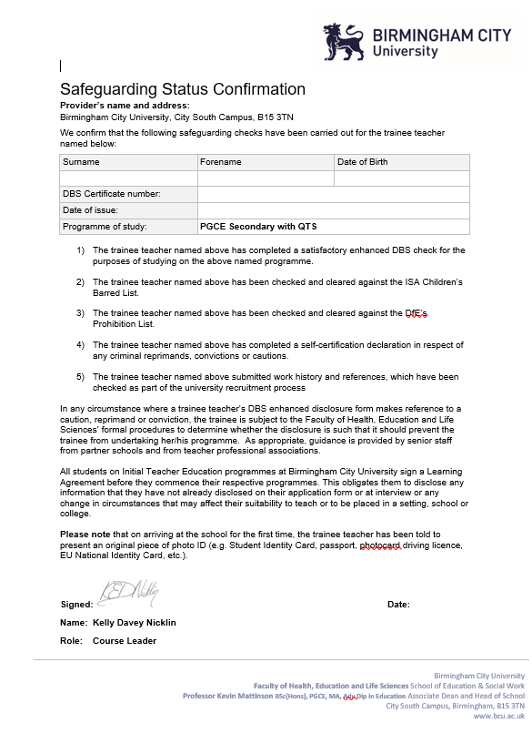

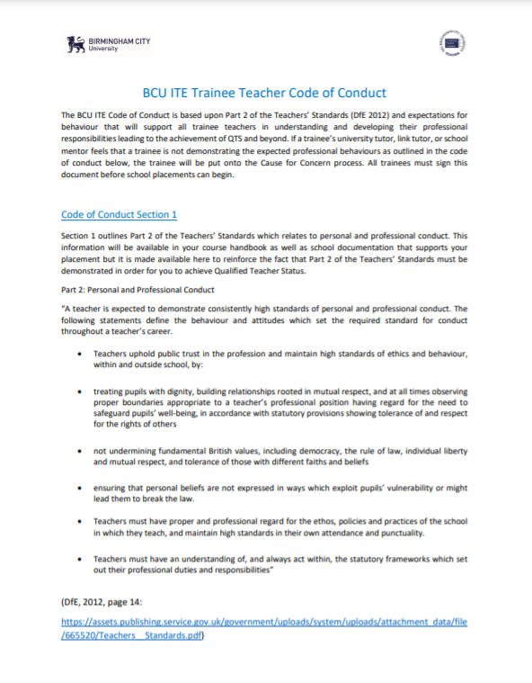

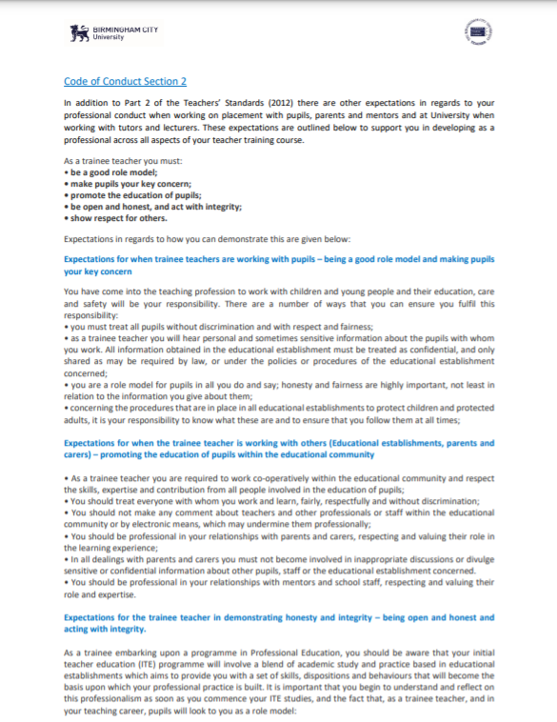



**BCU ITE Partnership Mentoring Policy**

Strategic Lead for Secondary Partnerships - Amanda Brougham [Amanda.Brougham@bcu.ac.uk](mailto:Amanda.Brougham@bcu.ac.uk)

Strategic Lead for Primary Partnerships – TBC

Lead for Post 16 Partnerships – Stuart Mitchell [Stuart.Mitchell@bcu.ac.uk](mailto:Stuart.Mitchell@bcu.ac.uk)

BCU Strategic Leads for Partnerships quality assure the role of Mentors across the BCU ITE Partnership all school-based training. Mentors will undergo the outlined stages of training below within a given academic year.

**To ensure a high quality of school-based training mentoring across the BCU Partnership’s schools / colleges are required to ensure that all mentors understand the following requirements as being central to their role.**

1. **Lead mentors in a school / college will provide the BCU Education Partnerships Team with up-to-date details of all mentors involved in training BCU trainee teachers before any Mentor Training Events** - this includes:
   1. The name and contact details for the Lead Mentor,
   2. Each class / subject mentor’s full name,
   3. Each class / subject mentor’s role in the school/ college,
   4. Each class / subject mentor’s email address.

This information is usually provided on the placement offer forms at the start of each academic year– but it should be noted that lead mentors are responsible for notifying the BCU team of any updates or changes of mentors as they occur during the year.

1. **All mentors download and review the phase specific BCU Mentor Handbook** – available on the BCU Partnership Webpages.
2. **All mentors attend designated Core Mentor Training Events[10]**:
   1. Class / subject mentors will usually have a choice of 2 dates for these events which are scheduled every term.
   2. Following each event Lead Mentors will be send an online form to confirm with the BCU Education Partnerships Team the names and dates that all their mentors attended.
   3. If a mentor is unable to attend any such event, the school / college’s Lead Mentor will ensure that the class / subject mentor actively reviews the training materials on the BCU Partnership Webpages.
3. **All mentors submit and save a copy of the BCU Mentor Tracker** at the end of the first Mentor Training Events in the autumn term.
   1. BCU Mentor Trackers will be emailed to all Lead Mentors and class / subject mentors immediately after the autumn Mentor Training Event.
   2. Each school-based mentor is requested to return their BCU Mentor Tracker within 10 working days to the relevant Strategic Lead for Partnerships.
   3. Upon receipt of BCU Mentor Trackers mentors will be issued with a ‘BCU Certificate of Attendance’ for their Introduction to BCU Mentor Training.
   4. BCU Mentor Trackers will be used by the BCU Strategic Lead for Partnerships to inform future Mentor Training Events over that academic year.
4. **Class / subject mentors attend at least 2 phase / subject specific mentor drop-in sessions**. These sessions are signposted on the BCU programme calendars and led by phase / subject leads. Sessions will:
   1. Reflect on phase / subject specific research to support their understanding of the BCU curriculum.
   2. Guide class / subject mentors around ways to use the BCU Curriculum themes and priorities within the context of a school-based training placement.
   3. Attend to specific issues relating to trainees in their context.
5. **All mentors submit an evaluation** relating to the impact of training and support to develop their mentoring of BCU trainees at the end of the academic year.

**Optional support for mentors is available at two levels:**

Mentors can review their BCU Mentor Tracker at the end of each terms’ Mentor Training Event.

1. They will be able to reflect on their practice and identify areas of development since the previous term’s submission.
2. Updated BCU Mentor Trackers will be emailed to the relevant Strategic Lead for Partnerships.
3. Upon receipt of BCU Mentor Trackers, participating mentors will be issued with a ‘BCU Certificate of Attendance’ for their Term 2 / 3 BCU Mentor Training.

**Level 2.**

Mentors can enroll on a fully funded BCU Master’s Module on Coaching and Mentoring (EDU7362).

1. This is an independent programme of study at Level 7 accessed on a BCU Moodle page.
2. Mentors review the context of Education Mentoring in current policy and practice and consider their practice with reference to the BCU Mentor Tracker; they critically reflect on academic research around the role of school-based mentoring; and then critically reflect on a critical incident within their mentoring and how research has informed their development in this context as a mentor.
3. The module is 20 credits towards a BCU Masters in Education.
4. Upon completion, Mentors will bank their credits and receive a BCU Mentoring and Coaching Certificate of completion.
5. Graduating mentors may be asked to commit to up to 3 hours further to support and lead other mentors undertaking this programme of study across the BCU ITE Partnership and will receive payment as a BCU Associate Tutor for this role.

Adopted September 2021

**SEND Partnership for secondary PGCE**

## In order to secure their knowledge of the factors and application of adaptive teaching pedagogies relevant to pupils with identified Special Educational needs and / or Disabilities all BCU trainees will complete a SEND placement as part of their School Based Training.

## Core Expectations for all PGCE trainees

Most PGCE trainees will complete a 4 day SEND placement in their home school during their PGCE School Based Training placement. The placement could be conducted as a paired experience to support the time demands placed on the SEND team.

This placement will involve:

* A meeting with the SENDCo to discuss the SEND Code of Practice
* A review of a pupil’s EHCP with the SENDCo – outlining the plan – do – review process
* A review of SEND needs within their classes with a SEND colleague (SENDCo or LSA)
* A chance to conduct SEND shadowing with a SEND pupil from one of their classes
* LSA shadowing – with a chance to discuss their role in supporting the class teacher to develop adaptive practices to meet individual pupil’s needs

## PGCE Trainees in partner schools hosting more than 5 trainees.

Some partner schools generously offer multiple School Based Training placements across a range of subjects – in those cases it would be challenging to expect an SEND team to host SEND placements for all trainees.

In these instances, the Professional Mentor in the identified partner school will liaise with the BCU Strategic Lead for Partnerships to allocate trainees to an external SEND placement in a specialist school / resource base. These external placements will be held on three named weeks within the BCU calendar. The Professional Mentor and the BCU Strategic Lead for Partnerships will ensure that the trainees are given plenty of notice around when and where their placement will occur,

This placement may differ in structure to the suggestions listed above but will still provide a worthwhile contrasting experience and insight into the complexity of SEND provision within the region.

BCU are responsible for funding these additional SEND placements.

## Monitoring the trainees’ knowledge and application of adaptive teaching

Following their SEND experience, all trainees will have a Contextual Task to complete within their Progress Journal and this will be reviewed with their Subject Mentor and BCU tutor as part of their formative review process.

**BCU ITE Mentor Tracker**

|  |  |  |  |
| --- | --- | --- | --- |
| **Standard 1:** **Establish trusting relationships, modelling high standards of practice, and understand how to support a trainee through initial teacher training** | | | |
| **Standard Prompts** | **Establishing Practice in ITE Mentoring** | **Embedding Practice in ITE Mentoring** | **Enhancing Practice in ITE Mentoring** |
| *Be approachable, make time for the trainee, and prioritise meetings and discussions with them* | * Reliably commit to review the trainee’s progress for an hour a week * Comment on progress in trainee’s progress journal weekly | * Guide the trainee to identify their strengths and areas for development in weekly meetings * Provide a brief overview of progress in the trainee’s Progress Journal | * Encourage the trainee to lead weekly mentor meetings * Check on the trainee’s well-being and progress briefly throughout the week – signposting additional support if required * Validate the trainee’s critical reflection in their Progress Journal weekly |
| *Use a range of effective interpersonal skills to respond to the needs of the trainee* | * Guide the trainee to identify no more than 3 priorities for the week ahead * Direct the trainee to relevant resources / support within the setting’s context * Discuss the trainee’ concerns around student or parent interaction | * Guide the trainee to identify appropriate targets for development during the week ahead * Model, alongside the trainee, conversations and meetings with staff who can signpost relevant resources or support, students or parents | * Ask open questions in order to coach the trainee to set their own developmental targets for the week ahead * Guide the trainee to hold conversations and meetings with staff across the school, students or parents |
| *Offer support with integrity, honesty and respect* | * Listen to professional concerns raised by the trainee * Offer support to resolve any relevant issues related to resources, students or curriculum structures | * Guide the trainee to identify weekly priorities * Critically reflect on strategies used in interactions with staff, students and parents during the week | * Ask open questions in order to coach the trainee in workload management strategies * Facilitate the trainee’s regular critical reflection of their impact in interactions within the setting |
| *Use appropriate challenge to encourage the trainee to reflect on their practice* | * Discuss elements of the Teachers’ / ETF Standards, related to the trainee’s practice, in mentor meetings. * Signpost areas of strength and concern in the trainee’s professional development throughout the placement | * Guide the trainee to reflect on areas of strength aligned to the Teacher’s / EFT Standards within their practice throughout the placement * Guide the trainee to identify some strategies to improve on areas for development within their practice | * Provide regular opportunities for the trainee to reflect critically on their professional development aligned to the Teachers’ / EFT Standards. * Facilitate the trainee to lead in identifying strategies to impact on their practice. |
| *Support the improvement of a trainee’s teaching by modelling exemplary practice in planning, teaching and assessment* | * Provide the trainee with access to the Dept.’s mid-term plans and resources * Ensure the trainee has access to the setting’s marking policy * Discuss the accredited assessment criteria in relation to KS4 planning in mentor meetings | * Model ways to apply the Department’s mid-term plans and marking policy in observed lessons and mentor meetings | * Ask open questions in order to coach the trainee in ways to apply the Department’s planning and marking policy to their teaching |

|  |  |  |  |
| --- | --- | --- | --- |
| **Standard 2: Support trainees to develop their teaching practice in order to set high expectations of all pupils and to meet their needs** | | | |
| **Standard Prompts** | **Establishing Practice in ITE Mentoring** | **Embedding Practice in ITE Mentoring** | **Enhancing Practice in ITE Mentoring** |
| *Support the trainee in forming good relationships with pupils, and in developing effective behaviour and classroom management strategies* | * Review the setting’s Behaviour Policy in the first meeting with the trainee and review its impact, based on observations, in the weekly mentor meeting – setting targets where required * Model effective whole setting strategies to implement effective BfL routines – e.g. seating plans, greet students at the threshold etc. * Model strategies to use praise and sanctions consistently within the classroom | * Regularly guide the trainee to apply aspects of the setting’s Behaviour Policy within their practice * Regularly review ways in which the trainees is effectively planning for effective BfL and set further developmental targets as appropriate * Reflect with the trainee on the impact of the ways in which they apply praise and sanctions within their practice | * Ask open questions in order to coach the trainee in developing effective strategies to create a positive and purposeful learning environment * In mentor meetings critically reflect on the impact of a range of BfL strategies, applied by the trainee within their practice |
| *Support the trainee in developing effective approaches to planning, teaching and assessment* | * Co-plan teaching backwards strategies within the BCU planning template * Model with the trainee ways to set effective learning objectives and tasks, which align within a learning sequence. * Model with the trainee ways to plan effective AfL strategies within a learning sequence. | * Regularly co-plan teaching backwards strategies with the trainee – moving from individual lessons to weekly plans * Guide the trainee to set effective learning objectives and tasks, which align to these within a learning sequence. * Guide the trainee to plan effective AfL strategies within a learning sequence. | * Move towards coaching the trainee to plan effectively and efficiently during the placement * In mentor meetings critically reflect on the impact lesson planning has on student’s learning outcomes. * Coach the trainee in researching and applying a range of AfL strategies. |
| *Support the trainee with marking and assessment of pupil work through moderation or double marking* | * Complete some co-assessment with the trainee in directed time * Facilitate an accredited moderation task at least once during the trainee’s placement * Set some targets aligned to assessment throughout the trainee’s placement | * Regularly co-assess with the trainee in directed time * Involve the trainee in regular reflections on ways to assess using accredited assessment objectives and mark criteria during their placement * Set regular bespoke targets to develop the trainee’s assessment practices during the placement | * Move towards coaching the trainee to assess effectively during the placement * Facilitate the trainee leading some accredited moderation with you and / or colleagues * Guide the trainee in collating evidence of effective assessment strategies within their practice * Coach the trainees to set targets to further develop their assessment practices |
| *Give constructive, clear and timely feedback on lesson observations* | * Schedule verbal feedback within 24 hours of a scheduled observation and provide written feedback at least 24 hours before the next scheduled mentor meeting * Feedback will identify at least 3 areas of strength, traction against previous targets and no more than 3 areas for further development | * With the trainee, reflect on the impact of their practice on the same day as the observation * Identify up to 2 high leverage targets with the trainee in the feedback discussion * Provide written feedback, aligned to the Teachers’ / EFT Standards | * Ask open questions to encourage a coaching conversation following the observation – within this conversation the trainee will identify strengths and, where they have built on previous targets and areas for further development * Co-construct written feedback with the trainee, aligned to the Teachers’ / EFT Standards |
| *Broker opportunities to observe best practice* | * Direct the trainee to weekly observations of excellent practice within the setting | * Observe excellent practice with the trainee and critically reflect on its impact and how this could link to the trainee’s practice | * Ask open questions in order to coach the trainee to identify foci within observations of peers and then critically reflect on ways to implement these in their practice |
| *Support the trainee in accessing expert subject and pedagogical knowledge* | * Share and discuss the setting’s Teaching and Learning Policy with the trainee in the first mentor meeting * Refer back to and review relevant aspects of the Teaching and Leaning Policy during the trainee’s placement * Identify ways in which this policy should link to the trainee’s current practice | * Discuss ways in which university sessions complement or contrast to the school’s Teaching and Learning Policy in at least 3 mentor meetings * Consider ways in which wider pedagogy could align to their current practice | * Guide the trainee to identify gaps in their own pedagogical knowledge * Collaboratively develop the trainee’s pedagogical knowledge through discussion of key papers within the subject specialism * Guide the trainee to consider ways in which this pedagogy could align to their current practice |
| *Resolve in-school issues on the trainee’s behalf where they lack the confidence or experience to do so themselves* | * Address any concerns identified on the trainee’s behalf and provide clear feedback on next steps within this context to the trainee | * Lead and model ways to address concerns identified with the trainee and secure clear feedback on next steps within this context for the trainee | * Rehearse conversations to address concerns with the trainee * Be present and encourage the trainee to lead conversations to address concerns * Step in to support when the trainee asks |
| *Enable and encourage the trainee to evaluate and improve their teaching* | * Review evaluated lesson plans before weekly mentor meetings * Identify clear targets based on evaluated plans | * Discuss evaluated lesson plans in weekly meetings * Identify with the trainee clear targets based on evaluated plans | * Critically discuss evaluated lesson plans in weekly meetings * Guide the trainee to set development targets based on this conversation |
| *Enable the trainee to access,*  *utilise and interpret robust educational research to inform their teaching* | * Know what research the trainee is accessing at university * Discuss findings from university-led research in some mentor meetings – signposting ways in which this could link to the trainee’s current practice | * Guide the trainee to share key messages from their university taught sessions or research they are undertaking for their assignments * Discuss ways in which this research could be used within the trainee’s current practice | * Collaboratively review key research aligned to the trainee’s assignments * Discuss with the trainee ways in which this research could support their planning * Critically reflect on the impact of research within the trainee’s practice |

|  |  |  |  |
| --- | --- | --- | --- |
| **Standard 3: Set high expectations and induct the trainee to understand their role and responsibilities as a teacher** | | | |
| **Standard Prompts** | **Establishing Practice in ITE Mentoring** | **Embedding Practice in ITE Mentoring** | **Enhancing Practice in ITE Mentoring** |
| *Encourage the trainee to* *participate in the life of the school and understand its role within the wider community* | * Assign the trainee as an observer to a tutor group * Signpost extra-curricular opportunities to the trainee and encourage them to undertake at least one such opportunity during their placement * Provide an opportunity for a trainee to attend a parent’s evening / meeting alongside an experienced member of staff | * Involve the trainee in leading some aspects of form tutor duties * Involve the trainee in any extra-curricular activities you lead, modelling aspects of Health and Safety this might involve * Guide and involve the trainee in discourse with parents | * Critically reflect on their future role as a form tutor within some mentor meetings * Discuss the impact extra-curricular activities can have on outcomes for both teachers and students * Critically reflect on the impact of discourse with parents |
| *Support the trainee in developing the highest standards of professional and personal conduct* | * Clarify professional expectations, duties and other additional responsibilities to the trainee * Introduce the trainee to the SENDCo and discuss his/ her role and support for classroom practice * Monitor perceptions of the trainee’s professional conduct within the setting and address any concerns within a timely fashion - notifying the university of any actions taken | * Discuss with the trainee his/ her professional conduct within the setting regularly – identifying strengths and setting targets where needed * Guide the trainee to liaise with the SEND team to plan for Wave 1 interventions within his / her practice * Raise professional concerns in a timely fashion with the university and develop a shared intervention | * Critically reflect on the impact of the trainee’s professional conduct within the setting * Critically reflect on the impact of Wave 1 interventions within the trainee’s practice * Raise professional concerns in a timely fashion with the university and develop a school-led intervention |
| *Support the trainee in promoting equality and diversity* | * Signpost the setting’s Equality Policy with the trainee during induction * Discuss aspects of inclusion within day to day practice – aligned to the Teachers’ / EFT Standards | * Discuss with the trainee opportunities within lessons to promote equality and diversity * Develop specific inclusion targets for the trainee within their day to day practice | * Critically reflect with the trainee on lessons to promote equality and diversity * Critically reflect with the trainee the impact inclusion strategies have on learning outcomes |
| *Ensure the trainee understands and complies with relevant legislation, including that related to the safeguarding of children* | * Check that the trainee has a university safeguarding letter when s/he arrives on the placement * Ensure the trainee undertakes the setting’s safeguarding training * Signpost the DSLs within the setting to the trainee | * Discuss with the trainee the role of effective safeguarding practices within the setting * Review and clarify the trainee’s understanding of safeguarding within your setting | * Critically reflect on a safeguarding case study with the trainee |
| *Support the trainee to develop skills to manage time effectively* | * Identify how the trainee should use their non-contact time effectively to meet the requirements of the placement | * Guide and monitor the impact of how the trainee can use their non-contact time effectively to meet the requirements of the placement | * Use open questions to coach the trainee in developing a strategy to manage their time effectively during the placement |

|  |  |  |  |
| --- | --- | --- | --- |
| **Standard 4: Continue to develop their own professional knowledge, skills and understanding and invest time in developing a good working relationship within relevant ITT partnerships.** | | | |
| **Standard Prompts** | **Establishing Practice in ITE Mentoring** | **Embedding Practice in ITE Mentoring** | **Enhancing Practice in ITE Mentoring** |
| *Ensure consistency by working with other mentors and partners to moderate judgements* | * Conduct a joint observation with an academic lead from the university – agree the trainee’s strengths and development targets collaboratively * Review your mentoring practice with peers within your setting – agree a trainee’s strengths and development targets collaboratively | * Conduct a joint observation with an academic lead from the university –lead discourse on the trainee’s strengths and development targets collaboratively * Review your mentoring practice with peers within your setting –lead on a trainee’s strengths and development targets | * Conduct a joint observation with an academic lead from the university –lead discourse on the trainee’s strengths and development targets collaboratively * Critically reflect on the impact of mentoring across your setting – lead a development plan to enhance impact * Support and guide new mentors within your setting |
| *Continue to develop their own mentoring practice and subject and pedagogical expertise by accessing appropriate professional development and engaging with robust research* | * Attend at least 2 university mentor training / CPD events * Track performance aligned to the ITE Mentor Standard tracking document | * Work with university leads to develop input on mentor training / CPD * Identify areas for development within the ITE Mentor Standard tracking document * Plan to develop further research into mentoring | * Lead mentor training / CPD university sessions * Complete outstanding areas for development within the ITE Mentor Standard tracking document * Pursue further Level 7 study incorporating this field of practice. |

*Sources:*

National Standards for school-based initial teacher training (ITT) mentors (July 2016): <https://assets.publishing.service.gov.uk/government/uploads/system/uploads/attachment_data/file/536891/Mentor_standards_report_Final.pdf>

Early Career Framework (January 2019):

<https://assets.publishing.service.gov.uk/government/uploads/system/uploads/attachment_data/file/773705/Early-Career_Framework.pdf>

Eliminating unnecessary workload around marking (March 2016): <https://assets.publishing.service.gov.uk/government/uploads/system/uploads/attachment_data/file/511256/Eliminating-unnecessary-workload-around-marking.pdf>

Eliminating unnecessary workload around planning and teaching resources (March 2016): <https://assets.publishing.service.gov.uk/government/uploads/system/uploads/attachment_data/file/511257/Eliminating-unnecessary-workload-around-planning-and-teaching-resources.pdf>

Eliminating unnecessary workload associated with data management (March 2016): <https://assets.publishing.service.gov.uk/government/uploads/system/uploads/attachment_data/file/511258/Eliminating-unnecessary-workload-associated-with-data-management.pdf>

UCL Verbal Feedback Report (August 2019):

<https://www.teachertoolkit.co.uk/2019/09/28/verbal-feedback-report/>

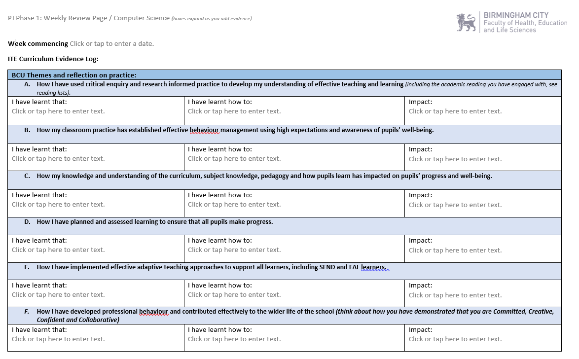

**Example Progress Journal Pages**

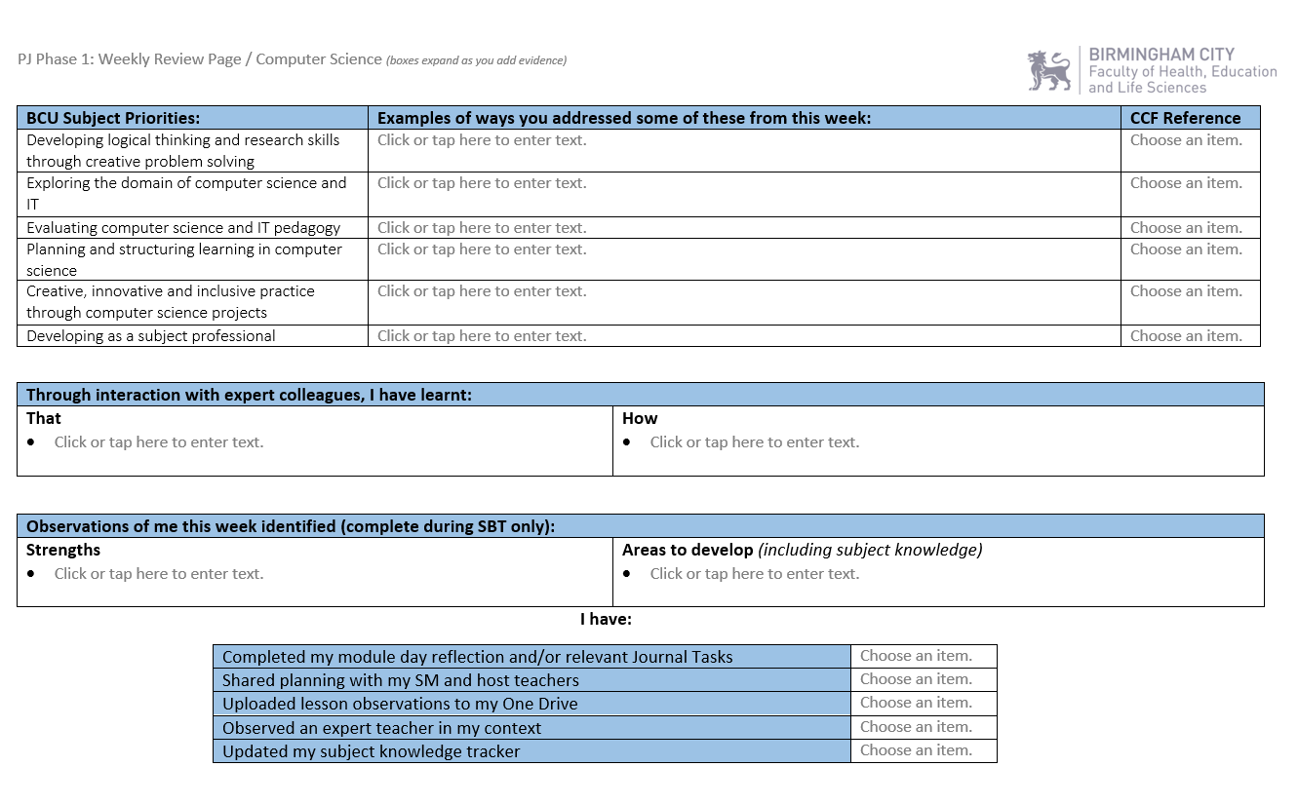

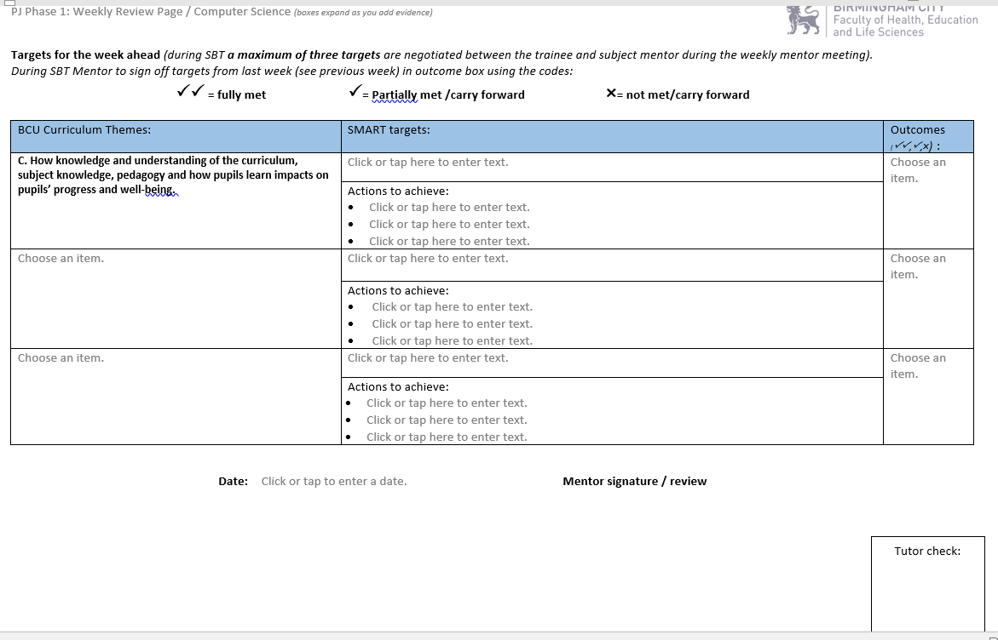

**An example Progress Journal entry**

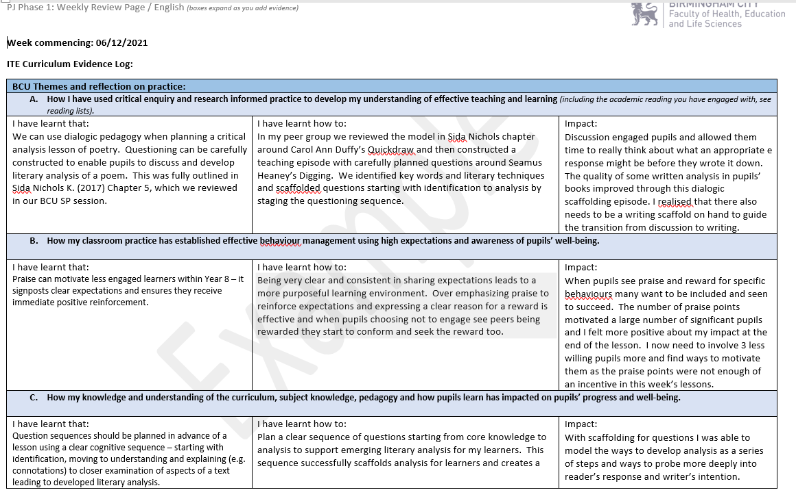

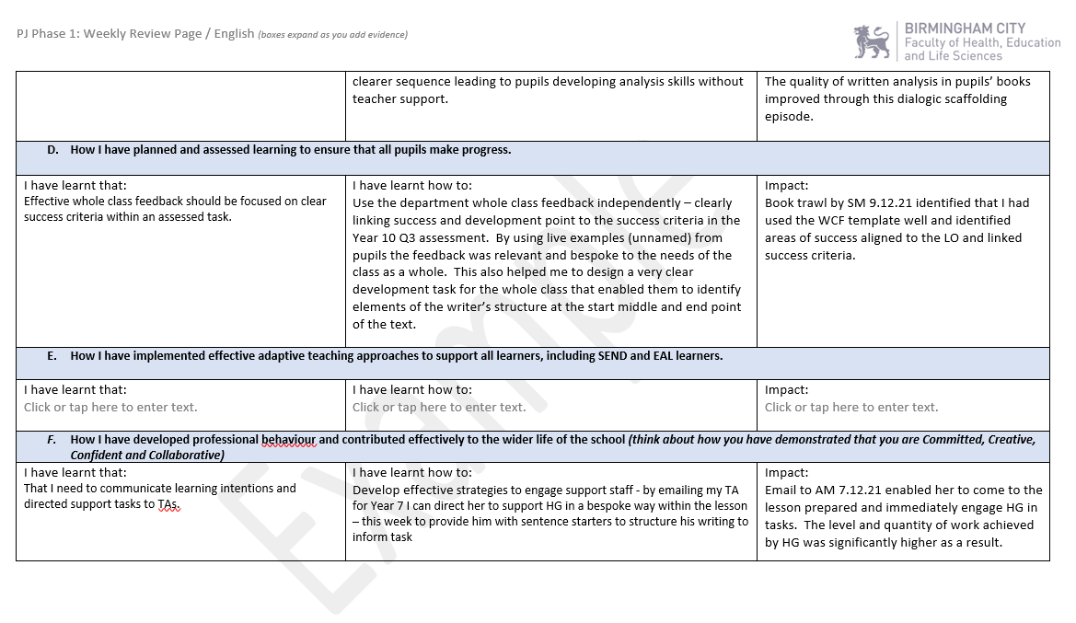

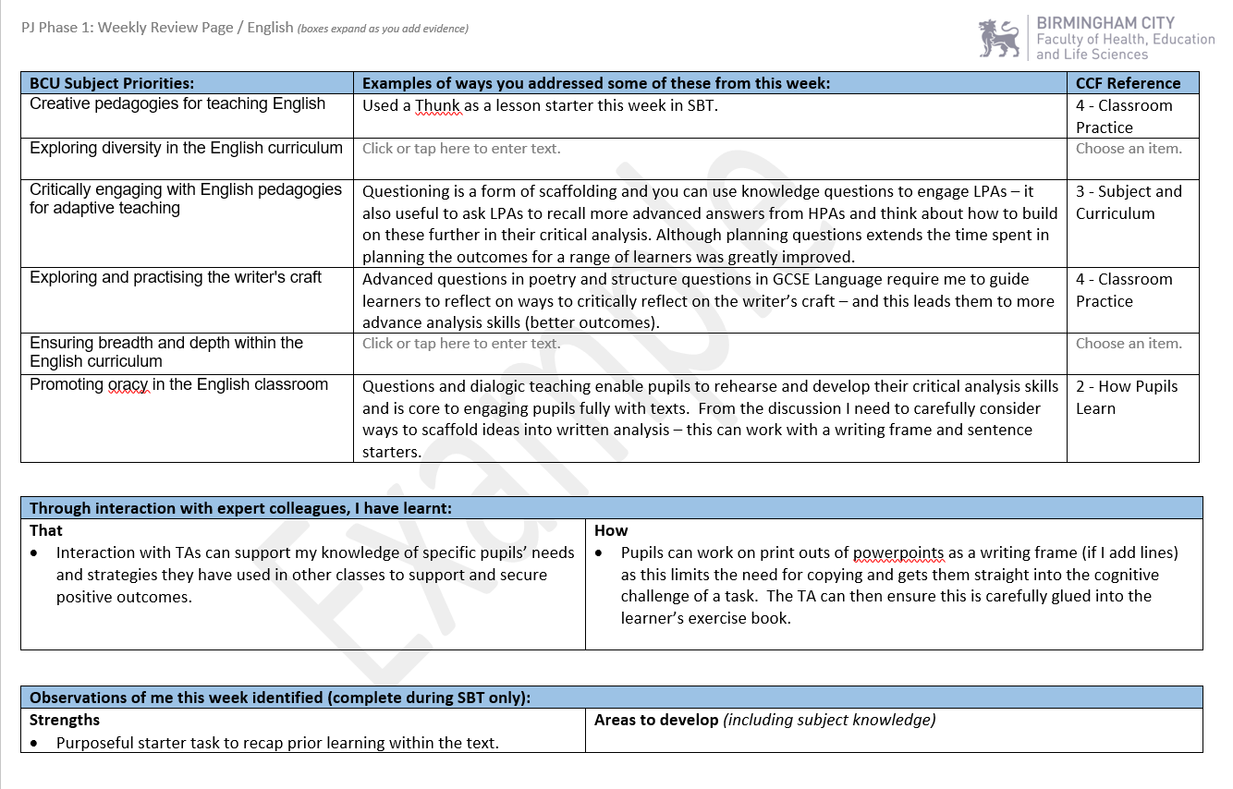

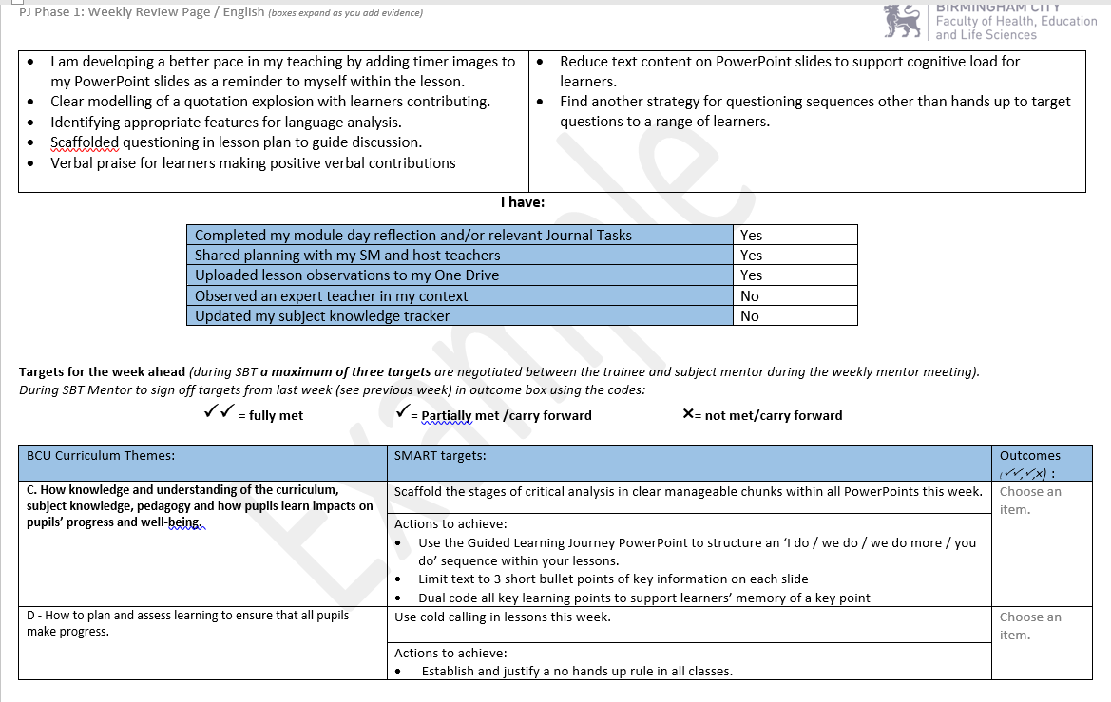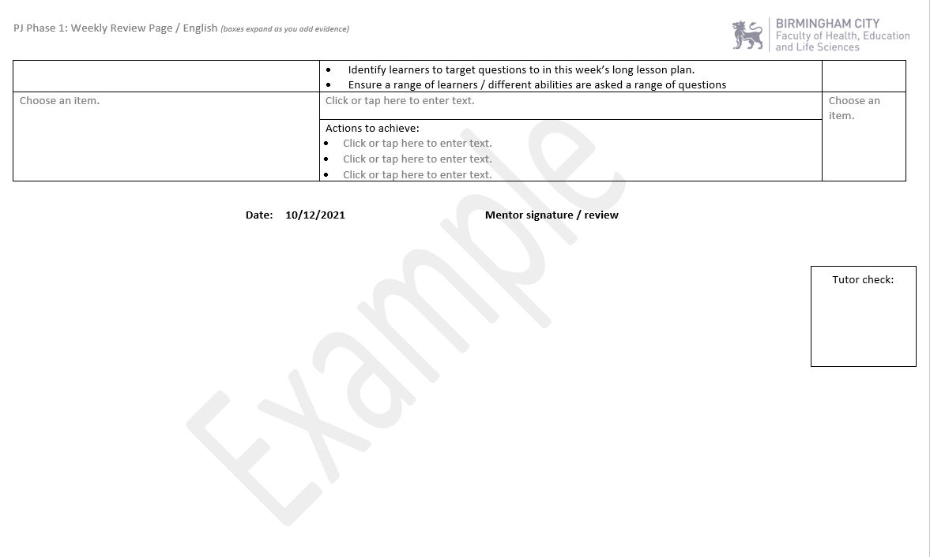

**Aide Memoire For PGCE Subject Mentors:**

|  |  |
| --- | --- |
| In September 2021 | |
| Liaise with school PM to confirm SBT offers and allocated Subject Mentors |  |
| Confirm subject mentors internally |  |
| Review BCU PGCE Secondary Partnership Webpages with professional mentor |  |
| Review BCU ITE Curriculum and paperwork with professional mentor |  |
| Attend Mentor CPD 1 Event |  |
| Complete BCU Mentor Audit and have forwarded them to Education Partnerships |  |
| After Mentor CPD1 | |
| Prepare an Dept. Induction Pack for BCU trainees |  |
| Confirm trainee timetables and secure mentor meeting time |  |
| Liaise with Professional Mentor to identify weeks for SEND, primary and post 16 experiences. |  |
| Review trainee’s Pen Portrait and make email contact ahead of induction week |  |
| Review trainee’s shared One drive documents – specifically their Progress Journal entries to date |  |
| Welcome trainees (core and other SD routes) |  |
| Facilitate observation schedule during Induction Week |  |
| Hold first weekly mentor meeting and set introductory development tasks for the start of SBT (e.g. reviewing Units of Work and school curriculum materials) |  |
| Home School SBT Placement 1 (autumn term 2 and spring term 1) | |
| Start observing trainee – twice a week using LOR form |  |
| Engage with the BCU Tracker in weekly meetings – underlining where the trainee is meeting expectations. |  |
| Update Professional Mentor on how trainee has settled into the first weeks of SBT |  |
| Liaise with subject tutor to set up a QA visit / joint observation and review of mentor meetings |  |
| Keep records for trainee progress up to date and prepare for trainee’s review meetings |  |
| Attend Subject Mentor Drop in sessions and maintain contact with your subject tutors |  |
| Attend Mentor CPD2 |  |
| Support preparation of trainee’s Phase 1 Review (Learning Event) aligned to trainees’ Progress Journals and LOR evidence |  |
| Complete Phase 1 Progress Reviews (end of autumn term 2) ensuring judgements are aligned to trainees’ Progress Journals and LOR evidence |  |
| Prepare for contrasting school trainee induction day schedule, class lists / data and timetables |  |
| Facilitate contrasting school Induction day – pass on all related materials to the trainee to enable a smooth transition to their placement. |  |
| Contrasting School SBT Placement (spring term 2) | |
| Begin working with contrasting school trainees – 2 weekly observations and weekly mentor meeting. |  |
| Continue to attend Subject Mentor Drop-in sessions |  |
| Monitor progress and well-being of contrasting school trainees |  |
| Support preparation of trainee’s Phase 2 Review (Learning Event) aligned to trainees’ Progress Journals and LOR evidence |  |
| Complete Phase 2 Progress Reviews aligned to trainees’ Progress Journals and LOR evidence |  |
| Home School SBT Placement 2 (autumn term 2 and spring term 1) | |
| Issue new Home School Phase 3 timetables – ensure there is opportunity to extend to 14 hours teaching w/c 6 June 2022 |  |
| Continue to attend Subject Mentor Drop-in sessions |  |
| Attend Mentor CPD3 |  |
| Support preparation of trainee’s Phase 3 Review (Learning Event) aligned to trainees’ Progress Journals and LOR evidence |  |
| Complete Phase 3 / QTS Progress review aligned to trainees’ Progress Journals and LOR evidence |  |
| Complete an online BCU evaluation at the end of the academic year |  |

**Notes**:

1. Safeguarding letter is posted in the appendices
2. Professional Behaviour contract is posted in the appendices
3. Available in this briefing paper
4. SEND expectations available in their briefing paper
5. A copy of the form to be shared with trainees at the start of their PGCE year
6. Contrasting school placement timings will vary in School Direct Partnership and lead schools will advise of specific alterations to timings within their partnership.
7. Details of the SEND placement are included in this document
8. Updated annually on the BCU Partnership Webpages
9. A Copy of the BCU Mentor Tracker is included later in this document
10. For Undergraduate mentors this is modified in terms of class/ subject mentors attending one core Mentor Training Event relating to the cohort the school / college has committed to on their SBT offers forms. For PGCE class/ subject mentors this will be three core Mentor Training Events – one for each term.